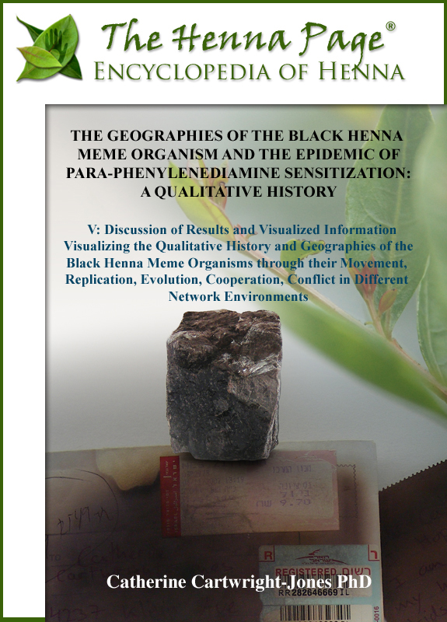

CHAPTER V: RESULTS AND INFORMATION VISUALIZATION
Visualizing the Qualitative History and Geographies of the Black Henna Meme Organisms through their Movement, Replication, Evolution, Cooperation, Conflict in Different Network Environments

The Archaeology of Knowledge and Memes
The quantitative history of the epidemiology of PPD sensitization can be discovered by uncovering the replication and evolution of the black henna meme organism. Foucault argued that there is an archeology of knowledge, that there is a field of discourse from which a new idea erupts, and knowledge is created through this discontinuous evolutionary process. This processes occurs at all times and places, and creates a potentially infinite array of knowledges in a potentially infinite array of discursive fields. It is possible to restate, diagram, and map Foucault’s process through memetics based on Blackmore, Schifman, Paull, and Coscia. The approach through memetics allows analysis to navigate through culture, hegemony, uneven development, orientalism, diaspora, economics, law, age, gender, and authenticity and focus on the movement of memes while avoiding some of the murkier verbiage of post-structural academic writing.
Memes are units of culture, units of the knowledge that exists in people’s minds. Blackmore argues that memes are replicators: a replicator’s single purpose is to replicate. Memes replicate through space into people’s minds through thoughts, actions, and artifacts. By extension, Blackmore argues that a henna meme replicates from one person’s mind to another person’s mind. The henna meme is a replicator, and must replicate. It may replicate by direct imitation through observation, through text or photographs in periodical publications or online, or through products with instructions. In the case of henna, if one person does henna and other people watch, the henna praxis meme has an opportunity to replicate into their minds. If one person has henna on their hands, a henna body art meme may replicate to an onlooker, but praxis and materials will not replicate until further information is accessible.
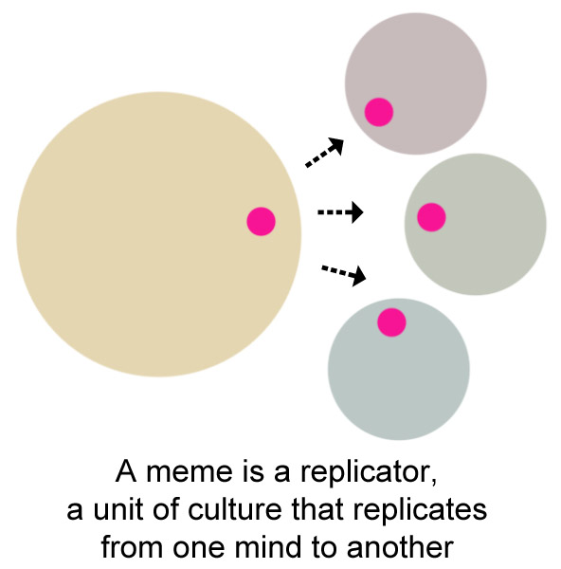
Diagram of a henna meme replicating from one mind to another

Schifman demonstrated that memes will replicate to the extent of a boundary and that boundary may be defined by social or physical access. The henna meme replicates through a social group of people who have seen or read about henna and may replicate more effectively if people have access to the plant material, otherwise the henna meme is decontextualized and theoretical. The henna meme can replicate within a boundary of henna resources, either real henna or a substitute. The available resource base affects the nature in which a meme will replicate. The henna body art meme is more likely to replicate as a physical manifestation where people can purchase henna locally A meme will not replicate outside of a boundary of information, demonstration and supply into a group, so henna meme organisms have limited ability to replicate into people who have never read about henna and who do not have access to henna. If other body marking memes, such as tattooing, exist in a person, then henna meme organisms may replicate based on those previously held body art memes, and the person may conflate henna with tattooing.
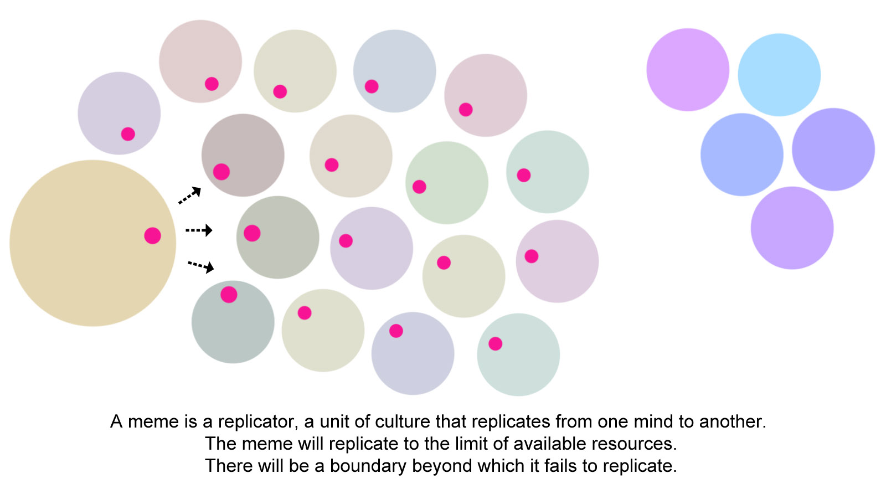
Diagram of henna meme organisms replicating through a social network environment to the limit of the network boundary.

As henna memes replicate from one person to another, the web of their connections tends to be follow their social network. Each person in a social group shares memes with rest of the group. If a henna meme replicates into one person in a social group, the henna meme may gradually replicate across a whole group, evolving as necessary to best inhabit the greatest number of minds in the group.
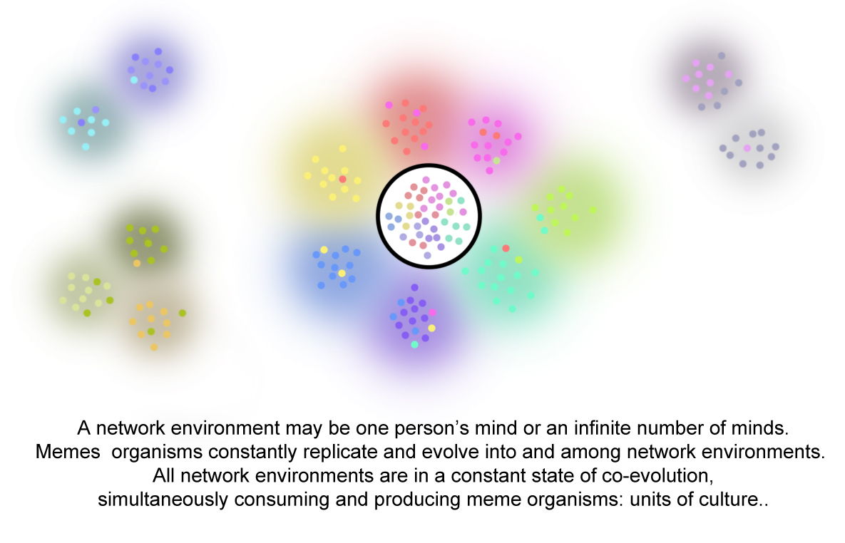
The smallest unit of a network environment is one person’s mind. Henna memes replicating from other network environments compete, collaborate, and evolve to maintain the space in that mind and in the larger network environments.

A network environment has no given size, it may a network of one or many minds; the network environment may be stable for a moment, but is in a state of constant evolution as memes replicate, evolve, collaborate, compete, or become extinct within that network. Henna meme organisms will replicate into any available mind, and will compete and collaborate with other meme organisms for the available space. The smallest unit of network environment may be a single person’s mind and as brief as a single moment. A network environment may be infinitely large and could remain stable for an infinite period of time, but is unlikely to do so, as new memes evolve and attempt to replicate, and as situations change and require adaptation to comprehend. The henna bridal celebration meme organism has had an unusually long and stable replication since the Bronze Age and through many countries and civilizations.
A multi-person network environment has fuzzy boundaries, because people move in and out of the network, or may be involved in the network to a greater or lesser extent. A single person has a finite boundary; meme organisms within both large and small environments are in a constant state of flux. A person may be involved in many network environments at the same time. A henna artist in diaspora may be simultaneously consuming and producing memes from homeland, local peer group, and global network environments at once, or sequentially.
A henna meme becomes truthy when the network environment shares a meme organism and has participated in its evolution. The evolved form of a meme that is regarded by the network environment is regarded as ‘truth’ based on of the group’s participation in the evolution of that meme; any member of the group who questions or rejects the ‘truthiness’ of that meme risks social ties to that group. Therefore, a person whose economic or cultural group enjoys ‘black henna’ may reject claims of injuriousness, because that person is are socially invested in relationships with friends, family, colleagues, and employers who see ‘truth’ that ‘black henna’ as a beautiful, profitable art form that has minimal risk. A person who has been injured by ‘black henna,’ or who knows of people who have been injured, may be socially invested in a group of physicians, family, friends, and colleagues for whom the black henna warning meme organism has become truthy.
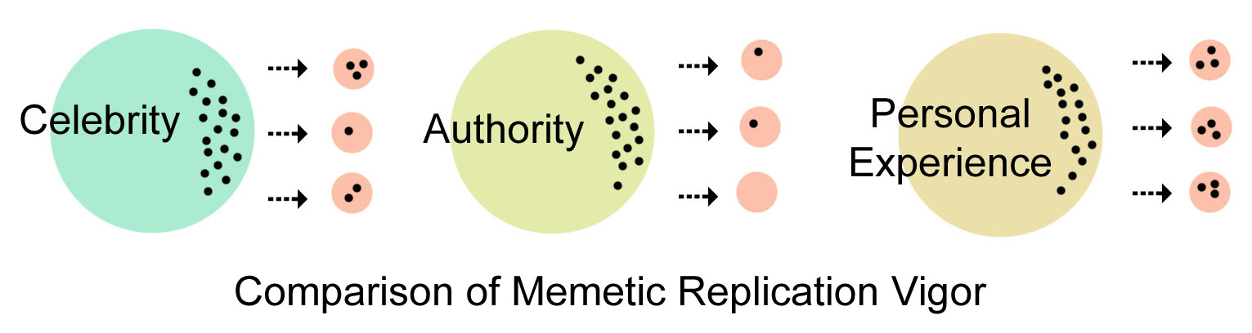
Diagram comparing celebrity, authority, and direct personal experience on meme replication.

Medically, the ‘truth’ that painting PPD on skin is highly sensitizing and may have life-long, even fatal, health consequences has been demonstrated through peer-reviewed medical journal articles, based on scientific method, case studies and clinical testing. In local network environments, cultural groups, the ‘truth’ of ‘black henna’ may be based on privileged first-person experience, as direct mimesis is a more reliable replication than mimesis through a distant source, such as text or reports from persons unknown to them. If a person sees benefit from ‘black henna,’ economic or social, has never seen a problem with ‘black henna,’ the black henna warning meme organism is unlikely to replicate. If a black henna warning meme organism comes from a source outside the social network that the person is bound to, the black henna warning meme organism may be vigorously rejected. This lack of memetic reproduction occurs when laws are passed banning henna; hopeful patrons and artists reject the law as being oppressive and unfair. This failure of replication also occurs when online western tourists scold ‘black henna’ artists. Black henna meme organisms replicated into the different networks and gradually evolved into irreconcilably opposing truthy memes.
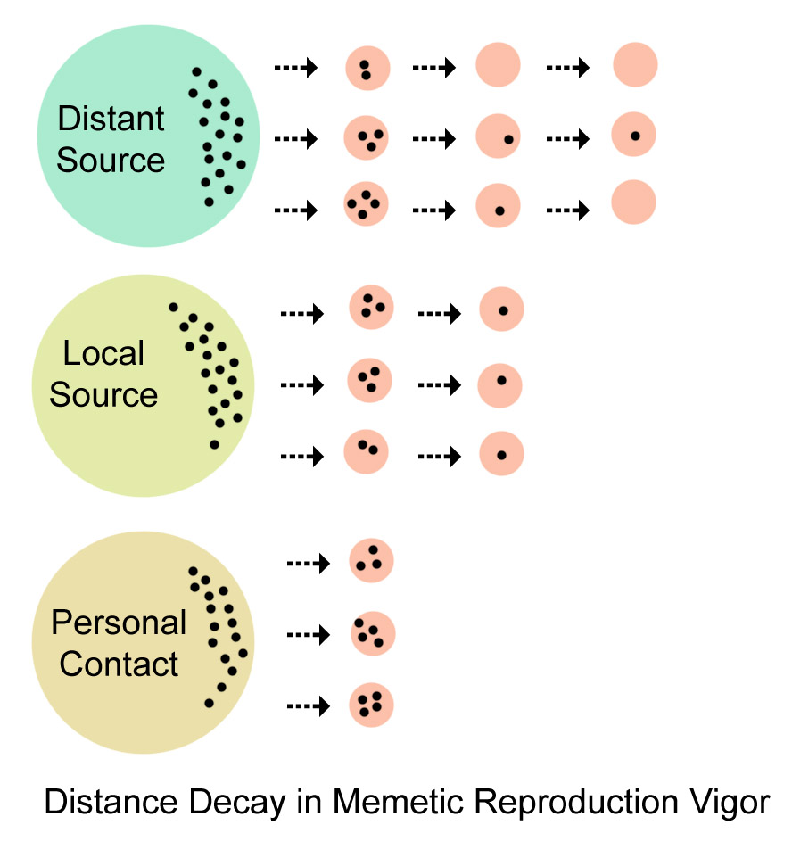
Diagram of proximity affecting memetic reproduction: distance from a contact diminishes memetic replication and may facilitate memetic evolutionary drift.

All memes replicate most vigorously from first-hand experience. First-hand experience is more enriched and direct mimesis has always worked to our evolutionary advantage. Memes replicate well through celebrity, as people will often imitate the person they believe is dominant in a group. If a person sees a line for clients getting ‘black henna’ and has seen celebrities with ‘black henna,’ the person is unlikely to be persuaded by a distant voice that ‘black henna’ is hazardous. A meme will replicate within a network environment before it will replicate from a distance: there is distance decay in memetic reproduction. Black henna warning meme organisms do not replicate as well through authority particularly when people resist or distrust authority, or if authority does not appear to be enforced. A law forbidding ‘black henna’ or a doctor’s black henna warning meme organism seems to elicit defiance more often than cooperation.
Global Henna Memetic Replication
Memes may replicate beyond local networks through trade and may become global. Artifacts such as products and their merchandising carry memes and memes can replicate from artifacts to people’s minds. When products are marketed in new countries, memes replicate into the consumers. It is not unusual for the meme organisms replicated from a product in one country to be different from the meme organisms replicated in another country. When memes cross boundaries through trade the meme organisms will evolve to best suit the new network environment. Henna meme organisms replicated beyond their indigenous network boundaries when trade carried henna out of its growing zone. The henna praxis memes did not replicate with the henna memes unless a person who was familiar with the craft traveled out of the growing zone with henna. Since the trade networks were largely dominated by males and henna was a women’s household craft, henna products and their attendant memes did not move out of tropical semi-arid zone as quickly products with higher profit margins and greater potential use such as sugar, oranges, and incense.

Memes may replicate globally through electronic media very quickly. The black henna warning meme organism replicated globally in the late 1990’s very quickly, accelerated by celebrity and globalized trade and facilitated by the rapidly increasing home PC market. In-person praxis could not instantly globalize but online English language discussions could carry the part of henna that could be communicated initially through text and later through and images and video. Increased online commerce facilitated henna globalization in the late 1990’s; henna sellers could communicate with henna buyers across the globe.
Memes may replicate globally through migration. People carry memes from one location to another location. A person who has recently migrated may carry memes very near to the home country memes, particularly if the maintenance of those memes is important to a sense of identity. A person who has lived for a while in a new location may have some evolved memes, and others may remain as they were; it may be important in some situations to display evolved memes to display integration, and it may be important in other situations to display original forms of memes to display authenticity. The memes in the second generation migrant will be further evolved if that person has had considerable contact with the new social networks. Meme organisms will replicate from the new environment and compete with previous memes.
In the case of black henna meme organisms, the memetic replications, evolutions, fossilizations, and extinctions were very rapid during the late twentieth and early twenty-first centuries. Some people who migrated from henna-using cultures ceased to use henna if they felt it hindered their access to the new cultural group. Some people continued to use henna and insisted on doing it just as their ancestors had done, when they felt it would preserve their culture and enhance their status of ethnicity and authenticity in their migrant group. Some people used henna in different ways, more stylish and accommodative to their new circumstances. Henna meme organisms also replicated from migrants to people in their new culture. Henna meme organisms replication, evolution, or extinction depended on the new country’s relationship to their migrant population.
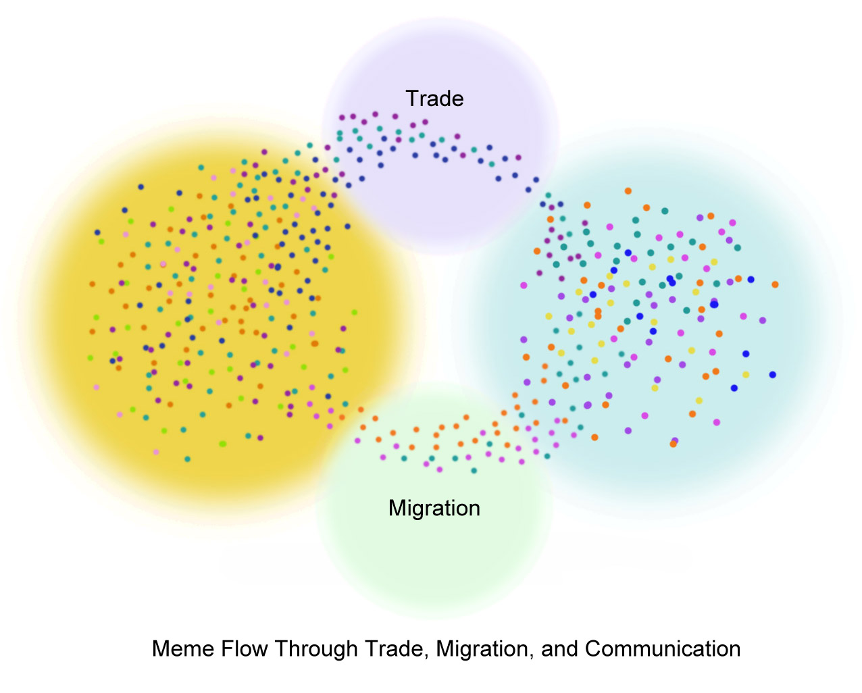
Diagram of globalizing memetic replication through trade, migration, and communication

The Internet changed the potential and nature of memetic replication. Memes flowed globally, rapidly, prolifically, but unevenly, because Internet connectivity tended to overlay colonial-based spaces of development. Many henna using cultures did not have widespread connectivity in the late 1990’s so some henna meme organisms did not replicate as easily as the henna meme organisms from more connected countries. Some governments firewalled their communication systems. Some infrastructures had less developed communications networks. Language and script barriers also slowed memetic reproduction through the Internet. Women’s henna meme organisms from Libya, Afghanistan, the Arabian Peninsula, Sudan, Somalia, had limited means of replicating online. Indian women’s henna meme organisms had better potential to replicate online to people on the English-speaking web. Indian henna commercial and merchandising meme organisms had a better chance of replicating online because English was a common language used for business communications. Indian corporations were more likely to have Internet access than Indian households.
As bandwidth and speed increase, henna meme organisms can replicate globally with greater complexity through the Internet each year. With the proliferation of cell phone video cameras, videos are easily uploaded live from a family ‘Night of the Henna,’ accessible to any other person who can access the web.
Online memes are limited by technologies. Touch, taste, and smell cannot be converted to a digital stream, and a camera only shows one view at a time. The henna meme organism inhabiting a person’s mind is a larger, more complex meme organism than can be transmitted in a digital stream, though the recipient of digitized henna meme organism is unaware of that has gone missing. The missing pieces will be reconstructed from the recipient’s memeplex. The received henna meme organism may be considerably different from what it was before transmission. Western henna, learned through proxies, cannot help but be different from village henna.

Memetic Replication in the Third Space of Tourism
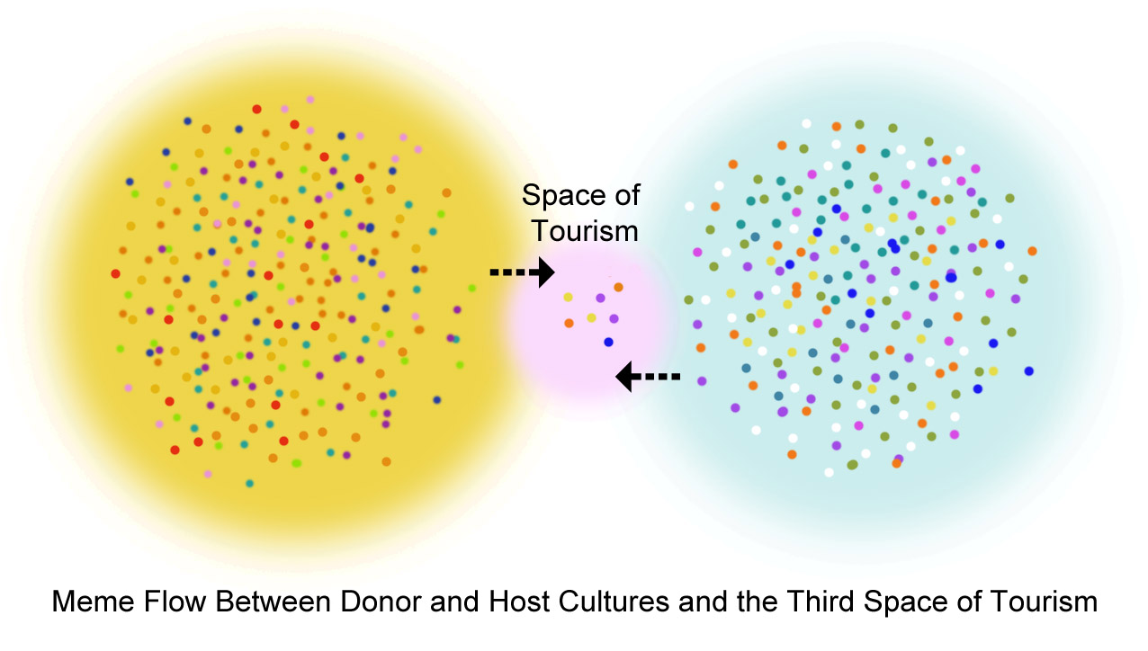
Diagram of memetic flow between donor and host in the specialized third space group of cultural understandings, co-constructed by both donor expectations of host culture and host ability to provide the culture in a consumable package.

Memes replicate in the third space of tourism. People travel from a donor country with the anticipation of acquiring the memes of the host country. Some travelers prefer a high level of predictability and similarity to their own memes; other travelers seek authenticity and are open to surprise. Both anticipate returning home having acquired new memes from their travel experience and the souvenirs that are artifacts of those memes. The host country constructs a third space where their memes may be offered to and consumed by the visitors. The memes do not exist in the third space as they actually exist in the host country; they are essentialized memes negotiated between the host and donor as exemplify the travelers’ expectations of the culture. Visitors do not continue their vacation behavior when they have left the third space if the exotic memes are not acceptable in their home country. They returned to their disciplined, industrialized bodies and habits. With ‘black henna,’ travelers purchased the transgressive experience of wearing an exotic tattoo as a part of the stellium of transgressive, socially inverting, or carnivalizing behaviors in the third space of tourism. ‘Black henna’ reproduced the meme that exotic, non-industrialized bodies have bold tattoos. The ‘black henna’ transgressed the meme that bold tattoos that are unacceptable on the disciplined and normalized bodies of the industrialized work force, the disciplining industries that provide the income for people to have a week’s vacation at the beach. The tourists expected the transgressive tattoo to disappear when they returned home to their jobs. The ‘black henna’ tattoos were a lucrative souvenir that was very easy to produce at a profit. Artists working in the third space of tourism assumed that the ‘black henna’ would disappear, and that the exchange would be to everyone’s mutual benefit.

Global Distribution Pathways of PPD, Warnings, and the Deniability of “Use Only as Directed”
PPD dye is understood at the industrial level to be highly sensitizing, and those sensitizations are life long and can be life threatening. The patent holder for PPD distances itself from any responsibility for ‘black henna’ injuries, “DuPont does not recommend and will not knowingly offer or sell p-phenylenediamine (PPD) for uses involving prolonged skin contact. Such uses may involve, but are not limited to, products formulated with henna for tattoo applications or other skin coloration effects. This use of PPD in prolonged skin contact application has the potential to induce allergic skin reactions in sensitive individuals.” DuPont is well aware that people use their product for ‘black henna’ and that it harms people, “Persons proposing to use PPD in any formulation involving any more than incidental skin contact must rely on their own medical and legal judgment without any representation on our part. They must accept full responsibility for the safety and effectiveness of their formulations.
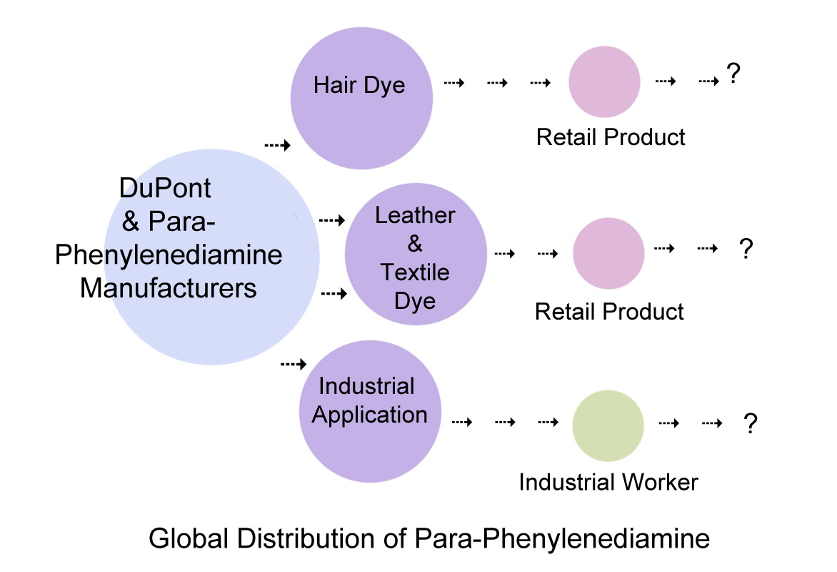
Diagram of the replication through global pathways of PPD, and the diminishing transmission of corporate warnings and responsibility at the end user level.

There may be warnings in industrial worker training, in OSHA and MSDS documents, and training, or protective clothing required in the workplaces where PPD is in the environment. The PPD warning memes are imperfectly communicated at the mid-level distribution point. Warnings are diminished to fine print at the retail level point, and may be misleading; Bigen lists PPD levels at 2.3% in dilution without specifying the percentage of dilution; Bigen powder is over 12%, a level illegal in the USA and EU.
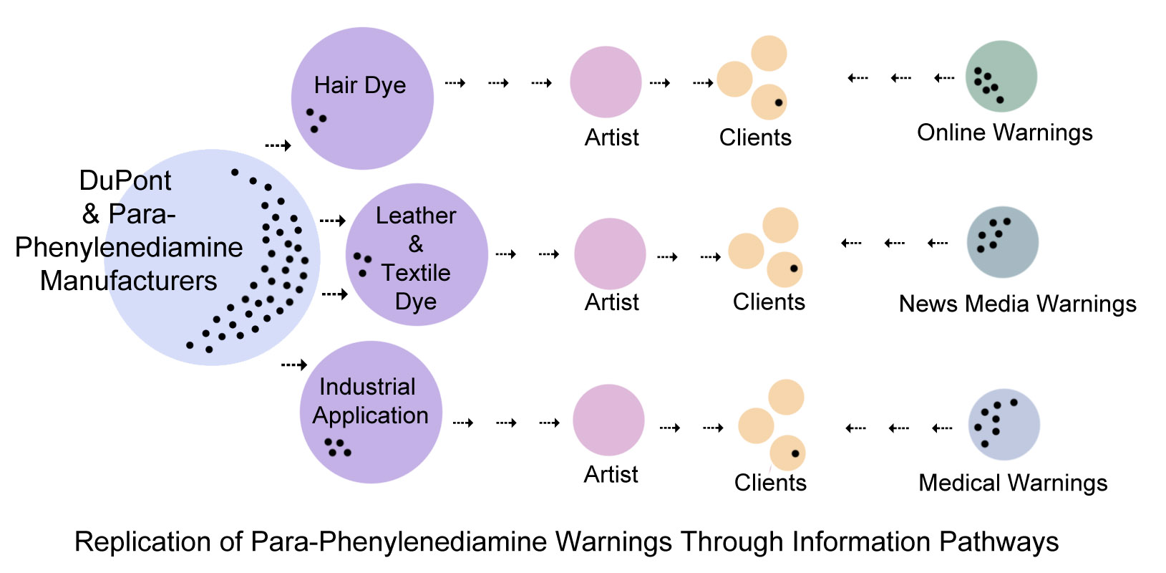
Diagram of distance decay in the replication of PPD warning memes through production, consumption, and end user spaces: meme integrity fades with each replication. Warnings are more likely to reach the client after the event when they become concerned about the allergic reaction.

One well-designed study with detailed exposure assessment observed associations between personal hair dye use and non-Hodgkin's lymphoma, multiple myeloma, acute leukemia, and bladder cancer, but other studies have been inconclusive. The problem of para-phenylenediamine sensitization is certain and life-long. PPD’s dangerousness is understood by many people who use it for murder, or ingest it for suicide in South Asia and Africa.
There is nothing to prevent misuse or misdirection of PPD-containing products, and no way for a consumer to estimate dangerousness if the product has no indication of PPD percentage. There is no PPD percentage available for henna stone when solid chunks of PPD are transferred from industrial use to artist’s use. Few hair dye products list the PPD percentage in their product. Sales of these items are unregulated. Once the PPD product is separated from warnings, neither artist nor client has information on the dangerousness of the skin paint and neither can make an informed judgment about whether not the health risk is acceptable.

The Replication and Evolution of Henna Meme Organisms
Memes compete more successfully for the limited space in people’s minds when they carry an array of attributes. These attributes help memes adapt into memeplexes as they may mirror meme organisms already existing in people’s minds.
The henna meme organism is replicated in traditional henna-using cultural areas among female kin and friends during household celebrations such as weddings, holidays and Eids. This mimesis is occurs on many levels: touch, sight, sound, smell, and motion memes replicate and are emotionally charged, so remain vivid in memory. This complex group of memes is reinforced through repetition of henna events during family weddings and holidays. When henna is learned by direct one-to-one imitation and horizontal replication in place the meme is replicated with full complexity of associated behaviors and concepts. These henna memes may be imitated imperfectly and they may evolve but respect for tradition may make that evolution fairly gradual. The emotional intensity of these events may account for rejection of different, foreign methods of learning as being inauthentic and unwelcome. Other people convinced that the understanding of henna in their network environment is equally truthy. The henna meme organisms co-evolving antithetically in the divergent network environments and are mutually rejected.
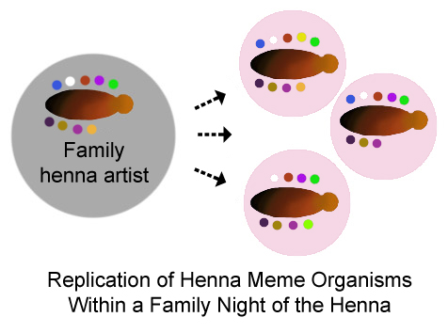
Diagram of the replication of henna meme organisms and praxis from a mother to daughters through family celebrations. This replication is infused with vivid emotions and memories. People who have experienced this kind of replication may regard other kinds of replication as inauthentic or inferior.

Language, ontology, epistemology, praxis, resource material, communication and artifacts, or a physical barrier circumscribe a memetic group boundary. Where a culture has henna plants and there is a well-established henna praxis such as ‘the night of the henna,’ the henna meme will replicate through social networks to the boundary of the group. Children watched women apply henna at family celebrations, and imitated them. This intimate learning gave people an emotional tie to henna and a sense of cultural ownership and authenticity. This form of mimesis is particularly rich and nuanced, vivid in people’s experience. Some people felt a sense of betrayal and loss when people from outside their group did henna.
The henna meme organism replicated poorly or not at all beyond local group boundaries until it arrived through diaspora, books, images and access to product, and discussions in a mutually understandable language. When the henna meme organism replicated beyond its indigenous boundaries into North America and Europe without praxis and without access to product, alternative praxis and materials were substituted including PPD dye. This was reinforced as ‘traditional’ by indigenous use of PPD as body art in Northeast Africa, the Arabian Peninsula, and South Asia.
One flow of henna meme organisms into western industrialized nations was through text and photography associated with travel and trade. Books, periodicals, and photographs replicated meme organisms in a ‘one-to-many’ dispersion. In a ‘one-to-many’ dispersion, the meme organisms are identically seen though they may not be identically understood because of the limitations of text and photographs. They memes may settle unequally into their new environment environments. The replication of henna meme organisms through mass-distributed text or photography is rapid and widespread, but incomplete. Mass media distribution of a meme cannot provide the nuance and vivid experience of one-on-one memetic transmission. Because of this, the people who have received these memes are often considered to have inferior or inauthentic memes, rather than simply being recipients of a different replication.
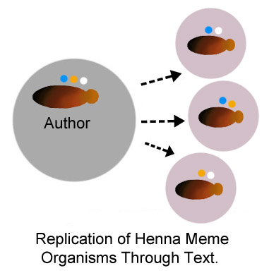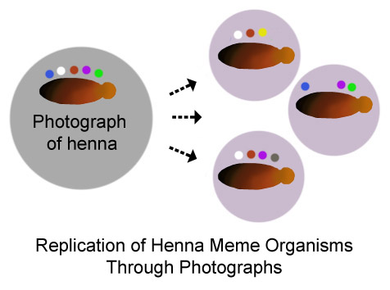
Diagram of the replication of henna meme organism replication through text and photographs: the replication may be imperfect compared to in-person mimesis. No sound, smell, or touch information replicates through a photograph. Motion may replicate through video images, but praxis is always incompletely replicated.

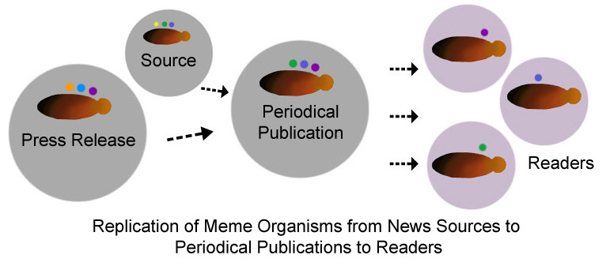
Diagram of the replication of a black henna meme organism replication through text and images in periodical publications. The sources and press releases may have rich, nuanced memes. The readers receive abbreviated and edited versions of the memes organisms.

Periodical publications replicate henna meme organisms but there are technical constraints inherent in replication processes. There may be many first-person sources of news memes. There may be press releases from agencies with a vested interest that are sources of memes. Writers and editors make economic and editorial choices about which aspects of henna memes are newsworthy. They construct a story that will disseminate the memes which will build readership and profits for the publication. These constraints and choices manipulate which aspects of memes are chosen for inclusion for publication, through which the memes are replicated. The readers receive memes abbreviated or adapted from the original sources; the readers read news stories as received truth, but the news stories never replicate the original meme organisms in their entirety.
‘Black henna’ vendors made assumptions about who their clients were and how best to convince them to purchase ‘black henna’ products. They disseminated black henna merchandising meme organisms that promised the satisfaction of what they assumed to be their clients’ desires. These memes addressed personal and social longings; fast, easy money with little effort, popularity, glamour, and connection with celebrity. In the case of several ‘black henna’ vendors that need was assumed to be a source of income with little investment or preparation, suitable for informal economies in the third space of tourism. ‘Black henna’ was well adapted to the economic niche. When consumers purchased a product they also emotionally invested in the memes associated with that product. These consumers were reluctant to betray that commitment when confronted with a black henna warning meme organism.
. 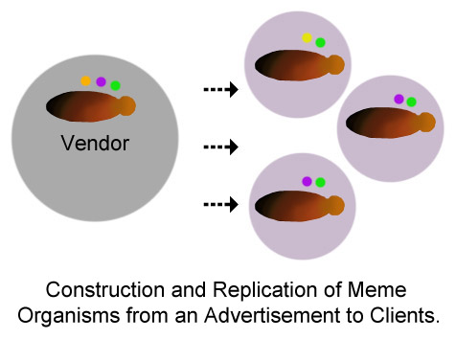
Diagram of the replication of vendors constructions of black henna merchandising meme organisms for the purpose of persuading people to purchase their merchandise.

Evolution of Black Henna Meme Organisms Online through Different Pathways
Publishing academic journal articles and medical articles requires a process of literature review, a hypothesis or case to be examined, methodology with independently verifiable results, and peer review with the intent of advancing previous understanding of the question or case. This process of memetic reproduction and evolution is slow because of the methodological research and review required and the time necessary for an article to come to publication and the memes may have a limited audience, depending on the readership of the particular journal. The memes replicated by academic journals are accorded authority because of the critical research process. News periodicals and policy makers may replicate the academic and medical memes further based on their authority. When a social network adopts these memes, the results they pronounce become personally relevant and replicate through social networks.
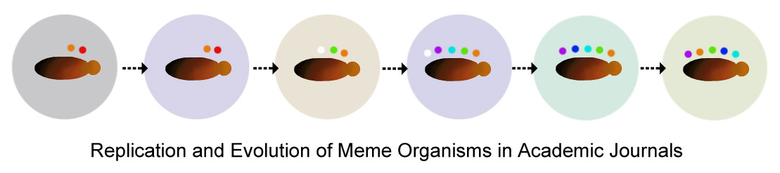
Diagram of the evolution of black henna meme organisms in academic and medical journal articles.
Medical journal network environments may evolve black henna warning meme organisms, newspaper articles or government agencies’ network environments may replicate the warnings, but the black henna warning meme organism will have limited potential for replication to people whose network environment has memes evolved of fashionable black body art, black stains at family events, or profit and happy customers. The medical journals become silos of memetic evolution, but the memetic dispersion outside that silo is constrained by the boundaries of the network environment.
A static source of information such as an academic journal article, book, article in periodical publication, or webpage will disperse memes. The replication of the memes through a static source is contingent upon the kind of data that can be propagated through the source’s structure, and what minds are able to assemble from the end product. If a static source has text, that text will replicate the author’s memes, but only those memes that the author places in the text. Readers who can receive the text will construct knowledge from what memes they have received. These will not be the total of the memes originally in the author’s mind.
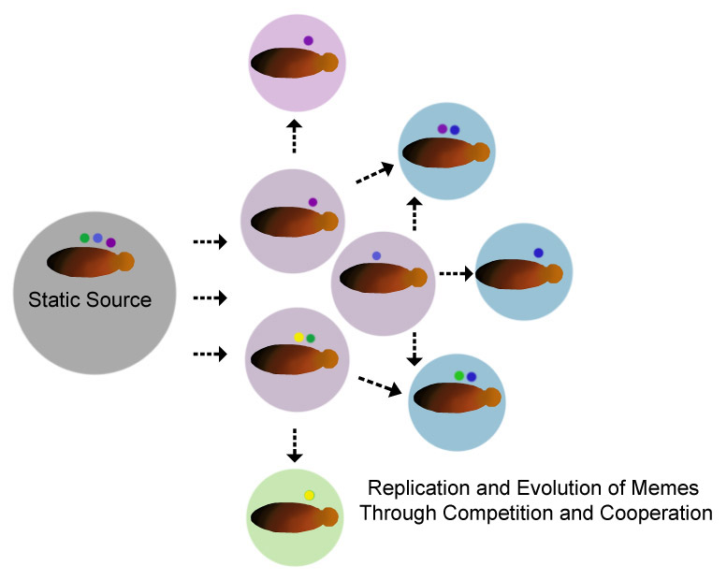
Diagram of the replication and evolution of henna meme organisms from a static source into a dynamic network environment.
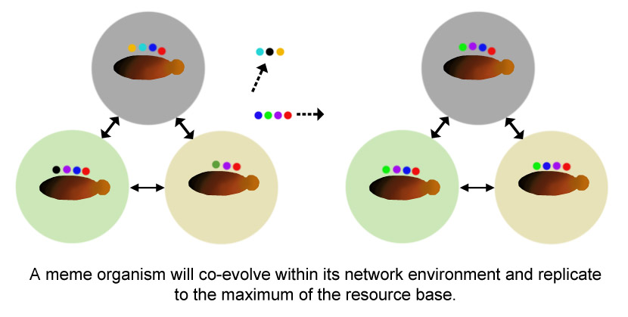
Diagram of the replication of henna meme organism evolution in a tightly bound network environment; some organism variants become extinct, while other variant organisms replicate until they have replicated to the boundaries of the group.

If readers discuss the text with their peers in a network environment, the received memes will co-evolve through their discussion to best adaptation and replicate into the new network environment; these evolved memes may reproduce exactly or diverge considerably from the author’s original memes. The Henna Page ‘Black Henna’ Warnings page replicated memes from academic and medical journal articles about PPD and into a static webpage of ‘black henna’ warnings. These black henna warning meme organisms were discussed, replicated, evolved, contested, and proliferated out through the web through copies and quotes of the information into advice sites, , personal web sites, groups with related interests, and into diaspora communities. The memes replicated, but replicated in different forms into different network environments.
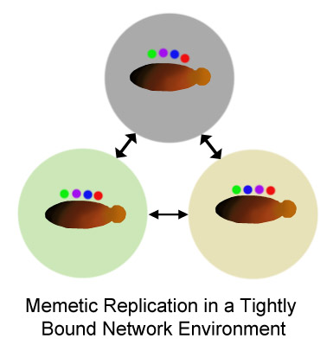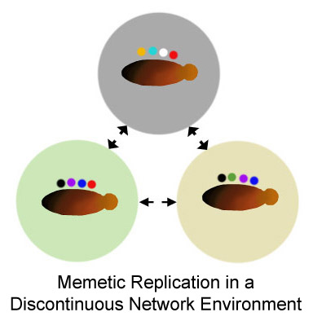
Diagram of the replication of henna meme organisms in a tightly bound network with consistent memes and meme organisms in a discontinuous network environment with diverse memes.

Meme organisms have replicated through host networks since species capable of mimesis evolved. When host networks are tightly bounded, they become a network environment within which memes evolve, and through which memes replicate efficiently, just as a virus replicates through a tightly connected host population. Online social networks are the first group in which this evolution can be easily observed and documented; until social media proliferated, human discussion was ephemeral and meme organism evolution untraceable. The more frequently a group interacts, and the more bounded the group, the greater the similarity of the memes. If a group does not interact consistently, and is non-cohesive, there may be greater individual variation in meme organisms as participants do not remain in the network environment long enough to participate in the replication/evolution process.
The cohesiveness of a network environment affects meme organism diversity within the environment. The Bali Travel Forum is discontinuous network, where people post a few questions and then do not return. Black henna warning meme organisms evolved slowly in this discontinuous environment, as different people were involved in discussions from vacation season to season, asking about ‘black henna.’ Black henna warning meme organisms replicated into the environment from other sources, such as news articles and other websites such as hennapage.com. In the Henna Page Discussion Forum black henna warning meme organisms evolved rapidly and replicated thoroughly in an interactive, cohesive online community, evolving to a stable black henna warning meme organism relatively quickly. The Trip Advisor Forums, a cluster of non-cohesive interactive groups bounded by destinations did not evolve black henna warning meme organisms. Instead, rather they replicated Black henna warning meme organisms from multiple sources, often priveleging sources considered authoritative, such as news articles and the hennapage.com ‘black henna’ warnings.
In 2014, blogs are increasing in potential volume as black henna meme organism dispersers, because of the advertising they carry. A blog may carry advertising, which pays the site owner per ‘hit.’ When the writer receives advertising revenue, the author is compensated for writing on topics that attract readership. As the posts are shared through other social media, the blog’s Alexa ranking goes up, the writer can demand more for advertising placement, and the memes replication further accelerate and disperse. The memes do not have to be factually correct to be popular, widespread, or influential, they simply have to replicate. Widely replicated memes may gain a potential for ‘truthiness’ in network environments. Some blogs have comment scripts, but these typically replicate the meme rather than evolving it. Blogs have featured both ‘black henna’ injuries and ‘black henna’ as an enjoyable souvenir. The author’s henna meme organisms were replicated to readers through blog posts, but do not seem to have replicated beyond the individual blogs’ readerships.
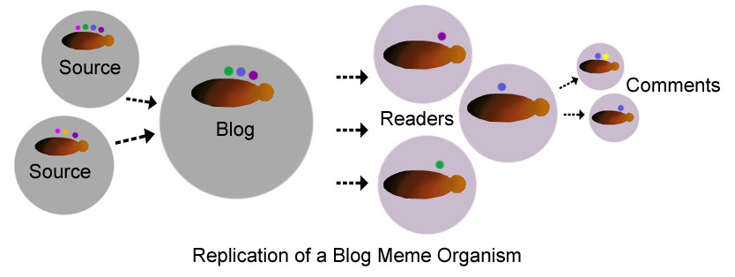
Diagram of henna meme organism flow through online blogs: the writer may construct information from one or more sources, and these are dispensed to readers through text and images. The reader may have the opportunity to comment and discuss a blog post.

When people had an itching, blistering reaction to ‘black henna,’ they searched for a trusted source of information. As the surge of ‘black henna’ in areas of tourism roughly coincided with the popularization of personal computers search engines, an online search was frequently the first place people looked. Google searches, through their mission statement of, “… organize the world's information and make it universally accessible and useful,” had the effect of elevating the webpages most frequently accessed for information in their search engines.
Because the Internet functions as a scale-free network, and Google’s rankings are based on the hubs in the network, higher ranking served to increase a pages’ likelihood of being accessed and further dispersing memes, and becoming a more connected hub in the scale free network. Gradually, the most commonly accessed pages on ‘black henna’ became the greatest dispersers of black henna meme organisms. The memes were in turn further replicated through blogs, forums, and static websites. The Henna Page ‘Black Henna’ Warnings pages have been at the top of google ‘black henna’ searches since they were written, and are followed by news media, Wikipedia, and FDA warnings. Among these highly ranked pages, the black henna meme organisms have evolved to a consistent and highly stable state.
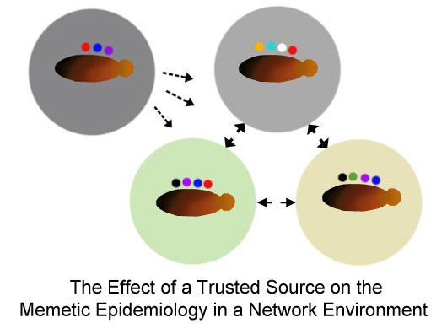
Diagram of the effect of a trusted source on replication of black henna meme organisms in a group

Google ranking is often conflated with authority, and the ‘black henna’ pages at the top of Google rankings will contain the most replicated black henna meme organisms through the Internet spaces of Google influence, with evolutions in different network environments. Of the first one hundred returns on a Google query of ‘black henna’ on November 17, 2013, seventy-seven contain fairly consistent variants of black henna warning meme organisms. Eight pages offer PPD ‘black henna’ hair dye for sale. Seven pages offer indigo, termed black henna, with instructions or products used to dye hair black. Four returns were images of artists who use ‘black henna;’ one of these pages was a Tumblr index of ‘black henna,’ a social network group of artists working in ‘black henna.’ This social network of ‘black henna’ artists appeared to be people from North and East Africa, the Arabian Peninsula, South and South East Asia, and people in diaspora wearing hijab. Three pages feature the pop music group “Black Henna.” One page listed black henna patterned iPhone covers. The memetic replication of black henna warning meme organisms online is prolific. There are other network environments where the black henna meme organism has evolved very differently.

An Idea Ruptures from a Discursive Field and Becomes Knowledge: a Meme Organism Replicates into a Complex Network Environment
According to Paull, there is a field from which a meme emerges, which can be mapped in time and space. This concept is very similar concept to Foucault’s archeology of knowledge, but with a geographic and memetic application. Coscia adds to this concept by demonstrating that meme organisms co-evolve with the new environment.
A meme does not emerge from a vacuum; it emerges from a field, a previously existing memeplex in an ideosphere. The movement of people, resources, artifacts, or innovations may cause a meme’s emergence into a new network environment; minds and artifacts are sources of memes, and they migrate from one geographic and cultural space to another.

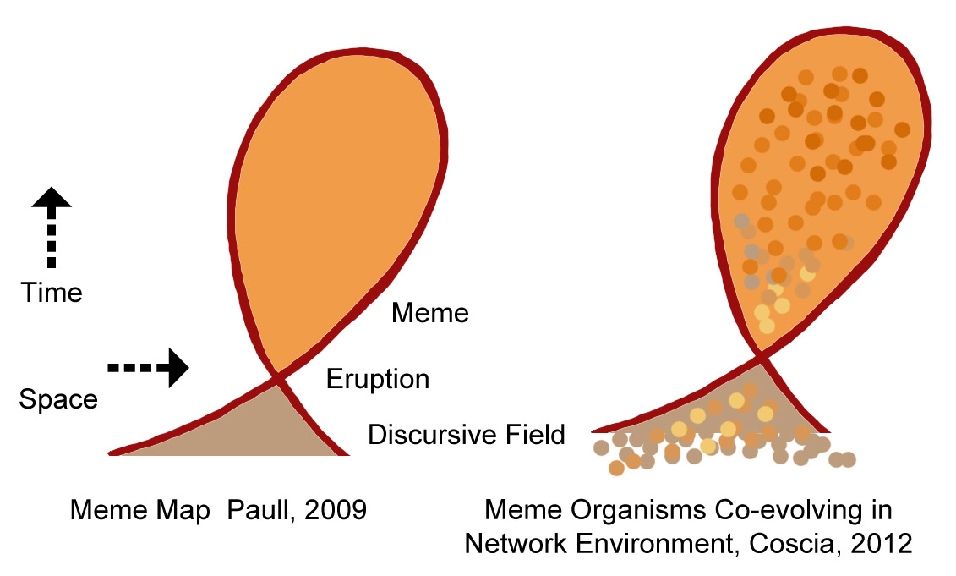
Paull’s meme map depicts a field from which a meme emerges, mapped in time and space. This diagram shows how Coscia’s adaptations demonstrate meme organisms co-evolving with a new network environment may be similarly depicted.
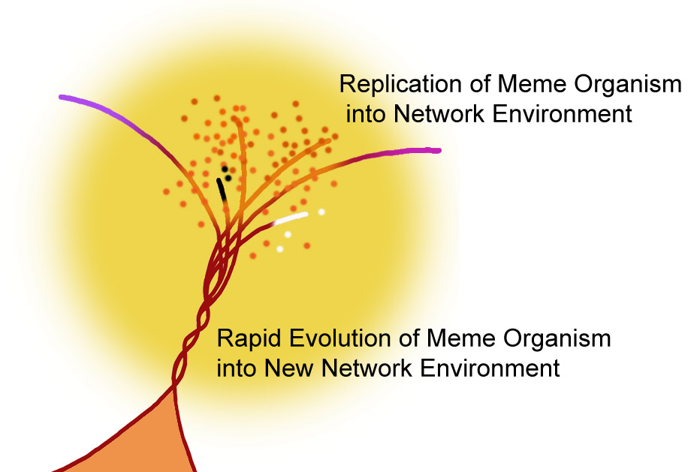
This diagram is an adaptation of Paull’s meme map demonstrating Coscia’s meme organism emerging and replicating into a new network environment.
Paull theorized a meme as having a moment of eruption at a single point in time and geographic space, and expanding from that point. Coscia developed this idea further through complex network theory, and demonstrated it by following online replications of meme organisms in social media. According to Coscia, after the moment a new meme enters a network environment, there may follow a period of gradual dispersion and rapid memetic evolution. In the new network environment, the meme organism will compete or cooperate with other memes to achieve the fittest form for replication into the environment. The environment, in turn, evolves with the meme. Some aspects of the meme organism may be rejected, others embraced, and others may evolve. There may be a short or long interval before the meme stabilizes, depending on competition or collaboration with other memes, after which it will replicate to the maximum of the environment’s ability to support it.

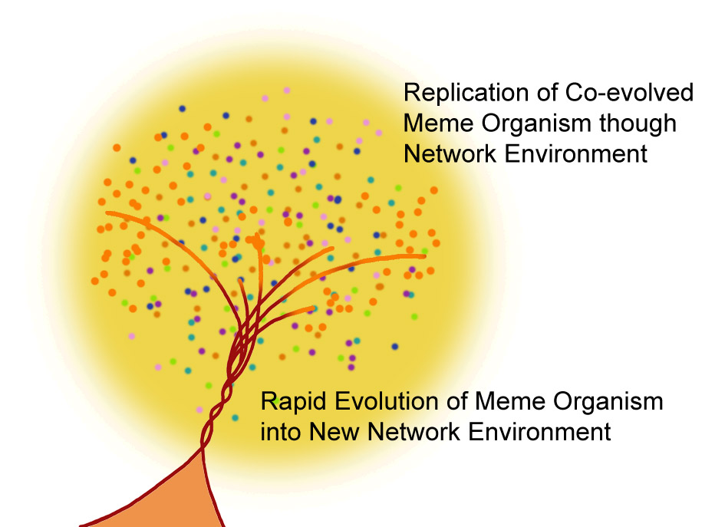
This diagram shows the meme organism co-evolving in the new network environment and replicating to the network environment boundaries.
The black henna meme organism had a period evolution in each environment where it replicated, and in each environment. The black henna meme organism evolved differently, cooperating, competing, and co-evolving with other memes in network environments, becoming divergent and often oppositional black henna meme organisms. In each case, the black henna meme organism eventually stabilized and became ‘truthy’ when the network environment simultaneously produced and consumed the meme.

The Points of Rapid Black Henna Meme Organism Co-evolution in Different Network Environments, and the Different Truths Produced
I have attempted to find the points of emergence and the network environments from which black henna meme organisms emerged, the periods of rapid co-evolution, and the newly stabilized meme organisms co-evolved within their new network environments. If these emergences had occurred in places and times where the participants were in online social networks, it would be possible to trace the flow of memes precisely, as do floatingsheep.org research projects in University of Kentucky and University of Oxford, and Truthy Information diffusion research at Indiana University. The technologies for studying the black henna meme organism’s emergence into global network environments did not exist during the initial surge of ‘black henna’ popularity, but enough trace of the mimesis remains to make some observations. The globalization of PPD skin painting occurred in semi-detatched network environments; both commonalities and differences in black henna meme organisms evolved.

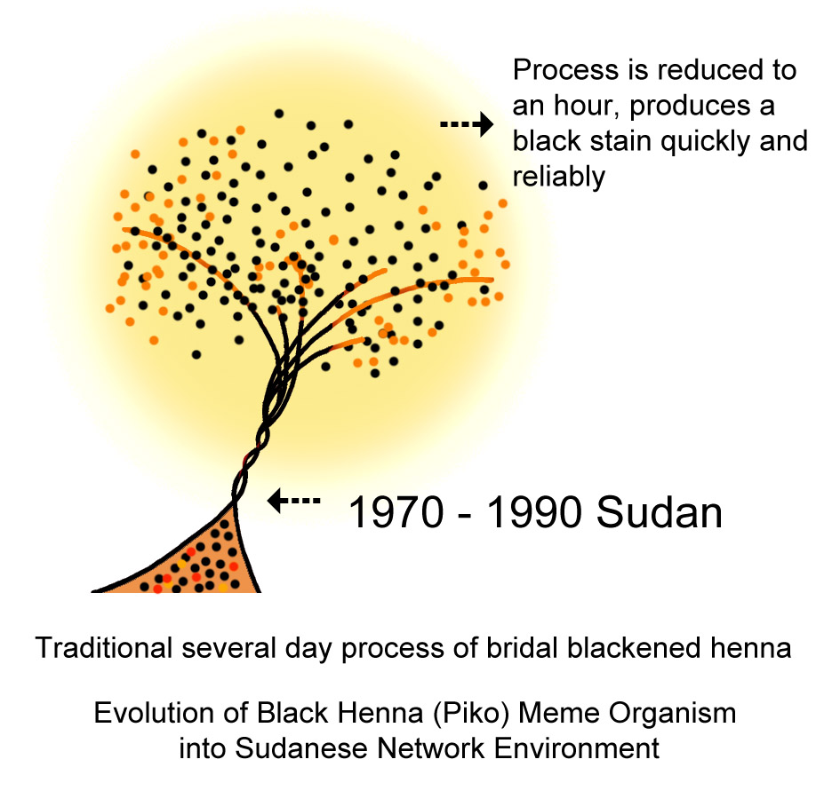
Figure Diagram of the emergence and evolution of painting skin with PPD in Sudan within the context of traditional blackened bridal henna

Sudanese bridal henna traditions favored henna patterns blackened with time, heat, alkali, and multiple applications, a process requiring several days. These traditions extended beyond Sudan to related groups in the Horn of Africa. These patterns could be created in an hour with PPD. The ease and grace PPD brought to bridal henna patterning must have been a welcome modern adaptation. This chemical technique was gradually replicated among cultural traditions in Ethiopia, Egypt, and Somalia by the 1990s. The fast, facile medium allowed artists greater expressiveness in body art, and a modern style of ‘black henna’ patterning evolved. Sudanese henna artists were sought after for their ‘black henna’ skill for the weddings of social elites. When Setona went to Egypt to pursue a pop singing career, she was valued first for her black henna work. As a popular entertainer and bridal artist, working events and weddings of the wealthy and powerful, she strongly influenced the fashion for ‘black henna’ in the region, whereas local, household henna artists functioned more as points in a random network, each having relatively limited influence on the larger social network.
The substitution of PPD for indigenous blackened henna traditions in Sudan and East Africa may have begun in the 1970’s based on the estimated dates in early injury reports beginning in 1984. This ‘black henna’ was replicated into Ethiopia, Egypt, Somalia, and the third spaces of tourism in east and northeast Africa by the 1990’s.
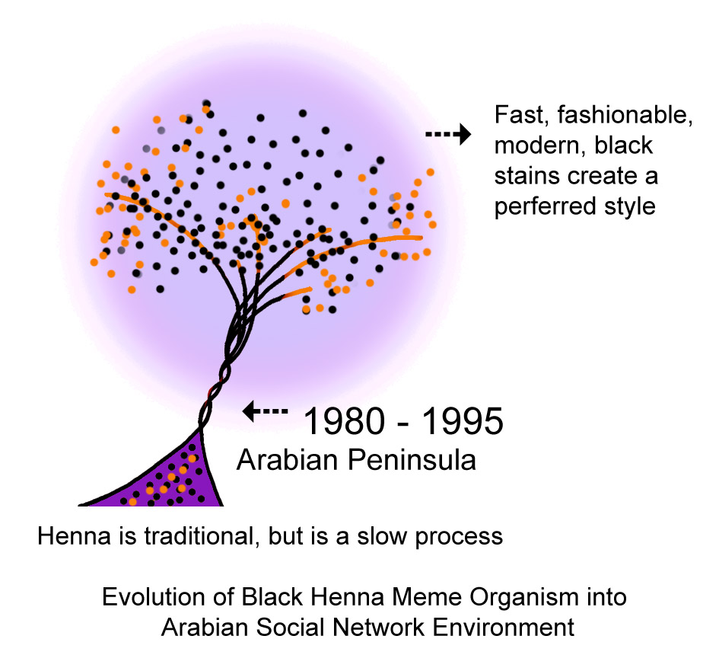
Diagram of the black henna meme organism replicating and evolving in the Arabian Peninsula within the contexts of traditional and modern henna styles.
Women in the Arabian Peninsula had continuous bridal henna tradition since the pre-Islamic period. The technique of painting skin with PPD may have migrated from Sudan with female domestic workers, or it may have been independently been discovered by a stylist working with high PPD content hair dye. The female domestic migrant labor force may also have replicated the desire for the ‘black henna’ technique across their donor countries, Pakistan, India, Malaysia and the Philippines. It is probable that there were multiple origins for ‘black henna’ body art technique as PPD is readily available.
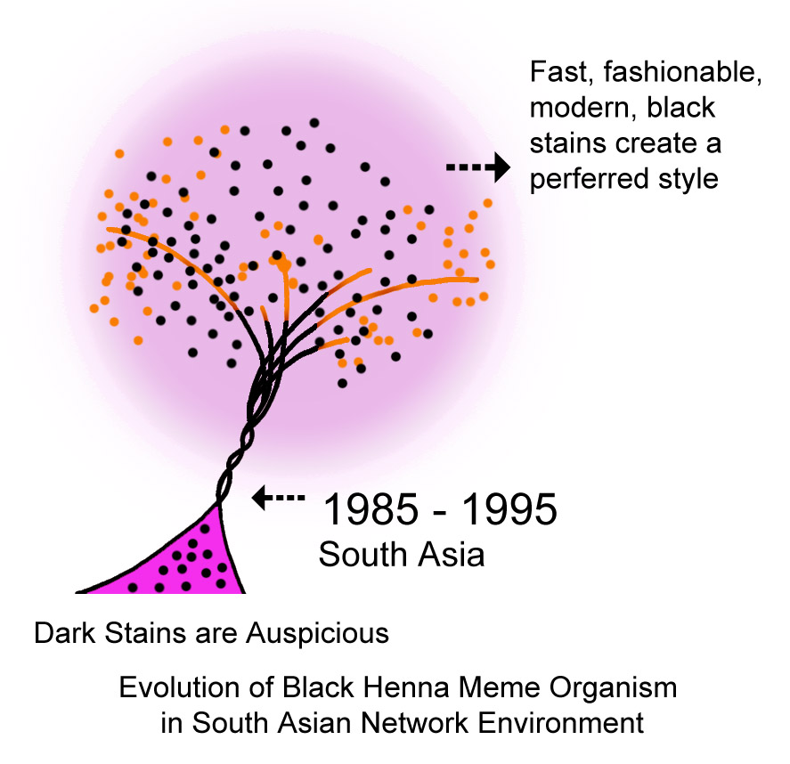
Diagram of black henna meme organism replicating and evolving in South Asia within the context of auspicious darkened henna and modern style.
Memetic replication and evolution of the fashionable black outline henna meme organism is more certain and can now be tracked by Facebook ‘likes’ when a popular artist shows a new design. These ‘likes’ follow socially connected network environments across cultural groups and may be challenged by people in black henna warming meme organism network environments. Facebook’s script facilitates the construction of network environments through ‘friending,’ ‘unfriending, and deletion of posts. This structure maintains a separation of the network environments and enhances the ‘echo chamber’ effect within them.
Fashion, and the desire for fast, stylish, black markings were a desirable alternative to henna by 1993 prior the near-fatal application of para-phenylenediamine to a woman’s feet. Black henna is presently offered through the tourist industry on the Arabian peninsula, from the desert treks to the most expensive hotels and salons, despite health ministry attempts to ban the chemical.,
Dark henna stains have been considered auspicious in many groups. In South Asia, the darker stains may be interpreted as predicting that in-laws will love the young daughter-in-law, or that the groom will love his wife. Since henna stains almost inevitably darken, this may be a bit of folklore meant to soothe anxieties rather than actually foretell an outcome. South Asian women desired darker stains as harbingers of domestic tranquility.
If Indian producers added PPD to henna hair dye by the 1970’s, that would have made an attractive modern product considerably more convenient than the two-step henna and indigo process to dye hair black. If there was no declaration of ingredients required by governmental or industrial regulation, women would have used them on skin without question. When women presented to a clinic with unexpected blistering, they simply described the injurious product as ‘henna.’ Gupta’s article showed injuries consistent with PPD skin painting, as did Ningam and Saxena’s;. The physicians may not have known that PPD was added to henna because henna and hair dye praxis was a gendered and to some extent caste-based knowledge, opaque to males and other people who had no direct experience with mixing and application.
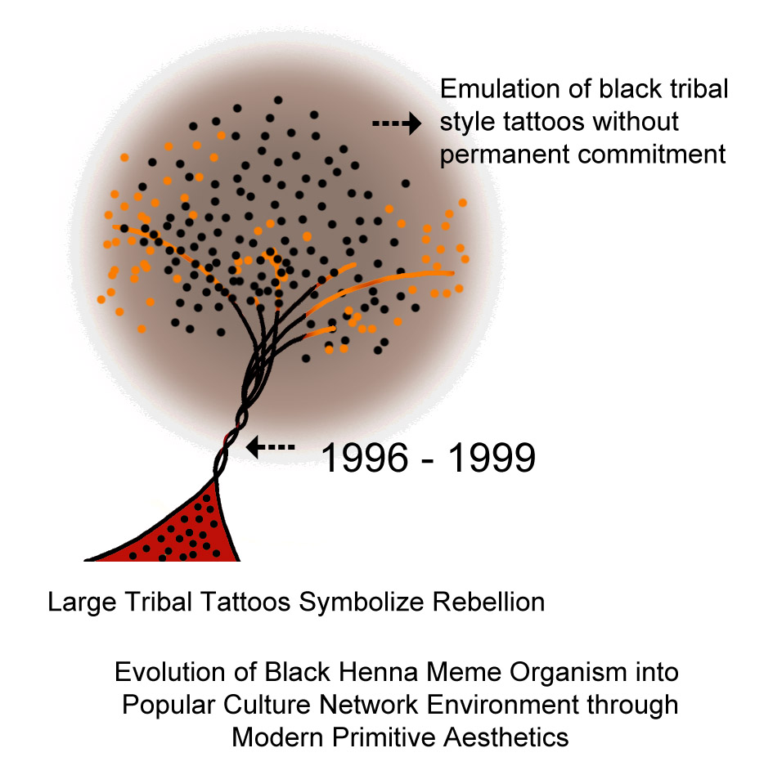
Diagram of the black henna meme organism replicating and evolving into western popular culture through the Modern Primitive movement

Upwardly mobile middle class women with jobs sought faster, more modern henna processes, more complex, stylish patterns, and the more desirable black stains. Artists’ secrecy about their mixtures was, and remains the cultural norm, as opposed to an industrialized western norm of ingredient declaration. A largely unregulated henna industry grew to provide the women the adornment they desired. When a particularly high PPD ‘black henna’ paste flooded the markets before holidays, there was a local panic of women rushing to hospitals with blistering hands. In the tourist industry ‘black henna’ replicated into the informal business sector on beaches such as the tourist haven, Goa.
The industrialized west did not have a henna tradition, but it did have tattoo traditions that emerged and mainstreamed in the 1990’s through the modern primitive movement. The modern primitives rebelled against the industrialized society and its regime of indistinguishable unmarked bodies. They rejected the normalized body by modifying their skin in emulation of ‘primitive’ ritual, but an industrial income was more difficult to eschew. If the embodiment of resistance could be temporary, the cooperative body could continue to earn income. By the time that personal computers were proliferating and The Henna Page came online, a conflated meme of’ black henna’ and tattooing was replicating rapidly.
The numerous requests for ‘black henna’ as a moneymaking project outnumbered natural henna inquiries on The Henna page Discussion Forum between 1997 and 1999 even though the injuriousness of PPD was identified by late 1997. Modern primitive tribal patterns such as Kanji, and New Age imagery outnumbered traditional henna patterns in henna kits and artists’ pattern books. The meme organism of embracing a primitive, hedonistic life with a black tribal temporary tattoo replicated easily in the third spaces of tourism where the normalized industrial bodies had accrued vacation time and money set aside for leisure.
A different black henna meme organism evolved among children in areas of tourism and ‘black henna’ had a different memetic pathway to children than other groups. Children were unlikely to have had a specific sense of rebellion against the industrialized employable body but they did enjoy rebelling against the rules of childhood, particularly the rule that tattoos are the marks of adulthood and children are not allowed to have these marks of power and dangerousness. When a child could acquire a symbol of authority and power and do so without consequence, the child was delighted. For a child, the fundamental species urge to mimesis is extremely strong; children learn through mimesis. When a child saw a line of children waiting for ‘black henna’ and saw other children proudly wearing their tattoos, that child’s will to acquire ‘black henna’ in imitation of their peers was usually indomitable.
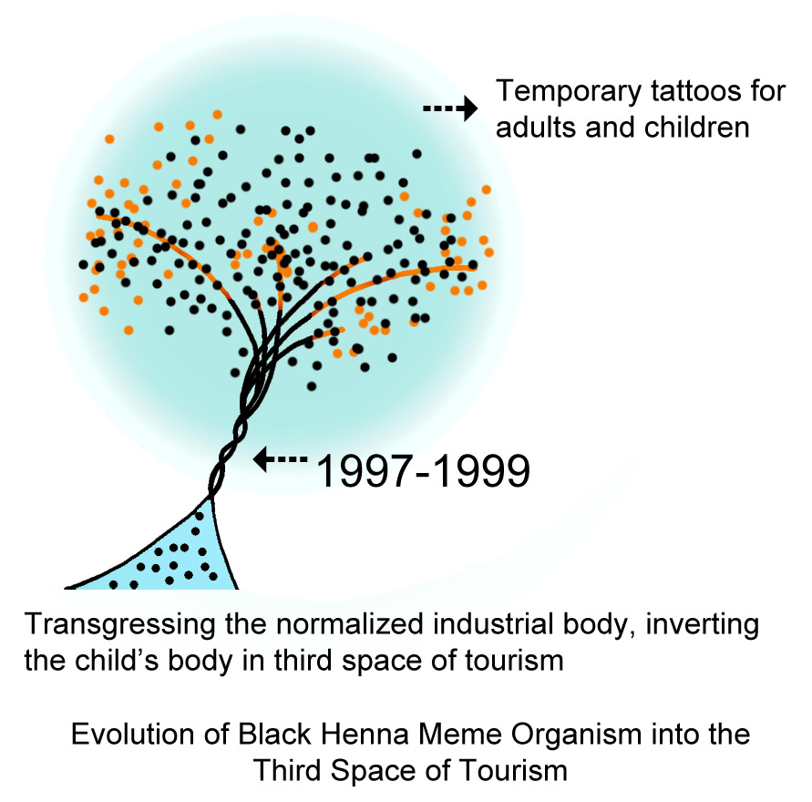
This is a diagram of the black henna meme organism replicating and evolving into the third spaces of tourism

‘Black henna’ was an ideal product in the third space of tourism. It was fast, reliable, and cheap; it exploited the western meme organisms of the exotic tribal body and the powerful rebellious adult body, and the marked sensual female body. The hypersensitivity reactions were unseen, delayed until the client had left the third space of tourism.

The Emergence of the PPD Identification and the Black Henna Warning Meme into Different Network Environments
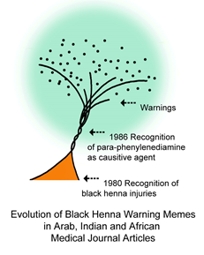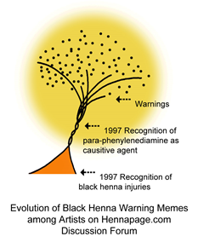
Diagrams of the evolution of black henna warning meme organisms in Arab, Indian and African medical journal articles compared to the diagram of the evolution of black henna warming meme organisms among henna artists on The Henna Page Discussion Forum

As the black henna meme organism entered different network environments at different times and under different conditions, injuries followed. The PPD injuries presented identical symptoms no matter where or when they occurred. The understandings of these injuries and whether or not they posed a significant threat was framed within the memeplexes of the differing network environments’ understandings of wellness. The understandings of the causative agent differed according to the local memeplex: the injuries were variously interpreted as being caused by the Evil Eye, skin lightness or darkness, dirtiness, poor regulation, petrol, cheapness, punishment for imperialist wickedness, or acidity. The recognition of PPD as the causative agent of ‘black henna’ injuries came at different times in different network environments.

Physicians living in areas where PPD was first substituted for slower, more complicated henna darkening techniques were the first to see injuries and the first to suggest that PPD was the cause of injuries. Their diagnosis of the causative agent was slowed by hampered by artists’ traditional secrecy about their methods, the gendering of the technology, and lack of ingredient declaration in commercially prepared henna products. When they published their notes on these cases, the information was not widely dispersed into the industrialized western countries where the medical profession did come in contact with these articles. Medical journals and articles were not as widely available online in the early 1990’s as they are now; they were physical, and access to them was generally through subscription. The evolution of electronic academic journals has accelerated the speed and distance dispersion of research meme organisms.
The opening of The Henna Page Discussion Forum coincided with the surge of interest in ‘black henna’ in the west and questions about injuries appeared soon in the discussions. The forum was a tightly bound interactive group, with participants logging on several times a day; information accumulated and evolved quickly. One artist in Los Angeles knew that PPD was being added to henna, and another had access to medical journal articles on PPD sensitization. Henna artists were familiar with the praxis of henna, so identified the irregularities of black henna more quickly than non-specialists.
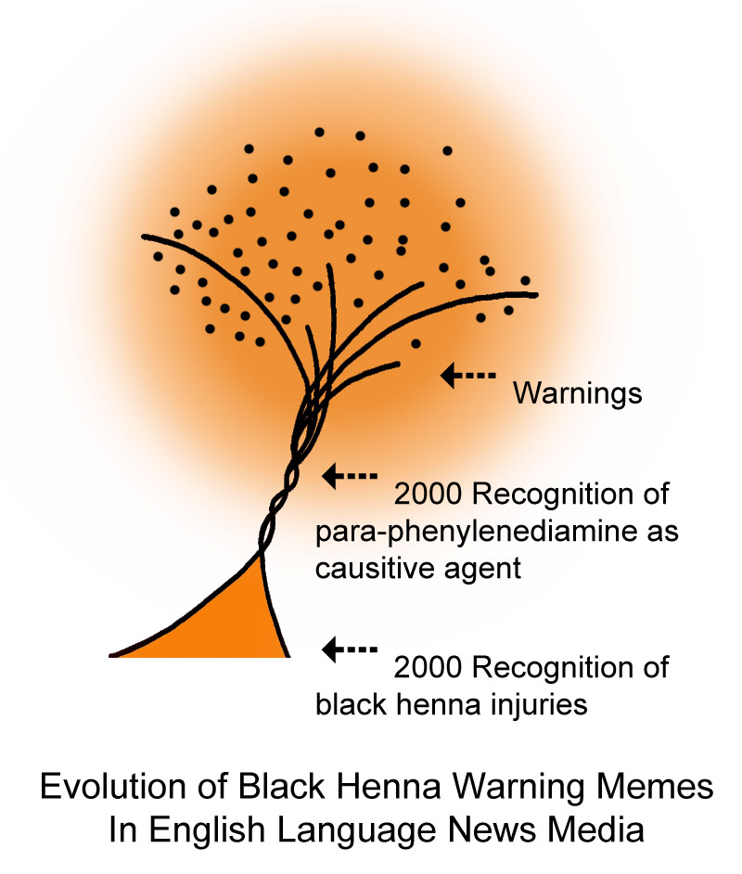
Diagram of the evolution of black henna warning meme organisms in English language news periodical publications

People in the west who were injured in areas of tourism presented to physicians at about the same time as they posted on The Henna Page Discussion Forum, but physicians were not henna specialists, did not have access to the paste that had injured their clients in distant spaces of tourism, and did not recognize that the injuries were inconsistent with henna. The black henna PPD warning meme organism took longer to evolve in medical journal articles but the process of clinical testing by physicians made the determination with greater certainty and authority than could be produced by henna artists.

The progression of the delayed hypersensitivity reaction to PPD takes place within a predictable time frame. A few rapid reactions may occur within hours but most reactions occur between four and fourteen days after skin painting and some may occur thirty days after exposure. In the third space of tourism, it is probably that the tourist will either have left the area before the hypersensitivity reaction occurs and unlikely that the tourist will be able to find and confront the artist with the reaction. Therefore, artists commonly claim that there has never been a problem with their ‘black henna.’ The injury presented in a time and place distant from the artist. The black henna injury meme organisms were therefore minimized or absent entirely in the third space tourism network environment. The black henna injury meme organisms evolved in the donor country where the person went to a physician or a journalist. Black henna injury meme organisms replicated rapidly in donor country network environment.
There is an increased risk of allergic reaction with each subsequent exposure to PPD, whether within cultural use or in an area of tourism. Based on the medical journal articles the likelihood of injury ranged between 15% and 60%, and that variation probably reflects natural sensitivity, previous exposure to the chemical, age, and dose/time absorption of the chemical into the skin. Children were probably the most susceptible to injury, and evidenced the most severe sensitizations in subsequent exposures.
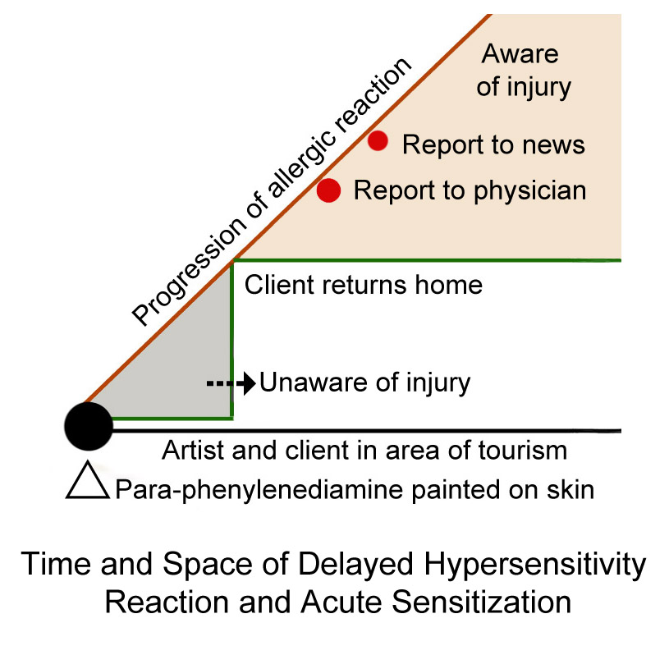
Diagram of the time and space of a delayed hypersensitivity reaction from acute sensitization from a ‘black henna’ acquired in the third spaces of tourism

A subsequent exposure to PPD from oxidative permanent hair dye years after a ‘black henna’ temporary tattoo received on a long-forgotten vacation may be a greater health threat. The extreme and increasing injuries presenting from hair dye have been the observable form of the epidemic of PPD sensitization. Physician’s estimations of extreme sensitizations through ‘black henna’ range from 50% to 100% of original applications. The severe reactions to PPD following sensitization through ‘black henna’ often require emergency admissions to hospitals; these reactions may be life-threatening or fatal.

The Seasonal Pulse of the Black Henna Meme Organism
Black henna meme organisms in spaces of tourism have a predictable annual pulse of replication, demonstrated in Google Trends analysis. As the warm season peaks, skin is bared and then ornamented. The greatest activity in ‘black henna’ searches is from North America, the UK, and India.
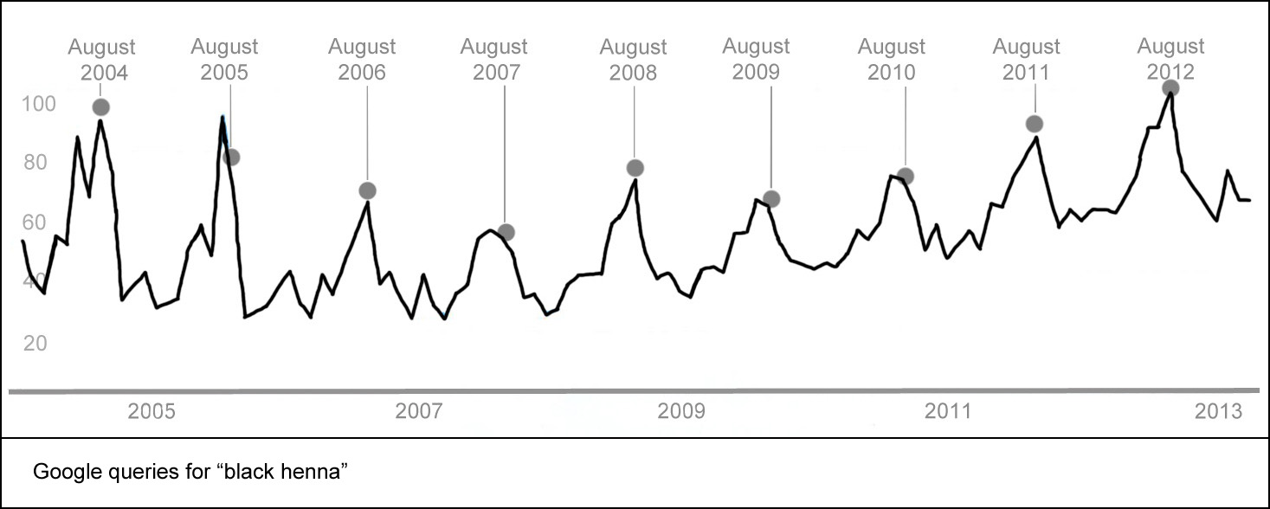
Graph of ‘black henna’ queries adapted from Google Trends. 100 on the y-axis represent the maximum number of queries, not the actual number of queries. The x axis represents January 2004 to March 2013. All subsequent graphs in this section have the same x and y axis and time frame.

The highest peak for ‘black henna’ queries each year is in July and August, about the time one would expect that people are either having a ‘black henna’ temporary tattoo on vacation, or are beginning to wonder why it has begun to itch. There is a shorter peak around spring vacation, and a lower one in January. The pulse of ‘black henna’ queries goes quiet during every November and December.
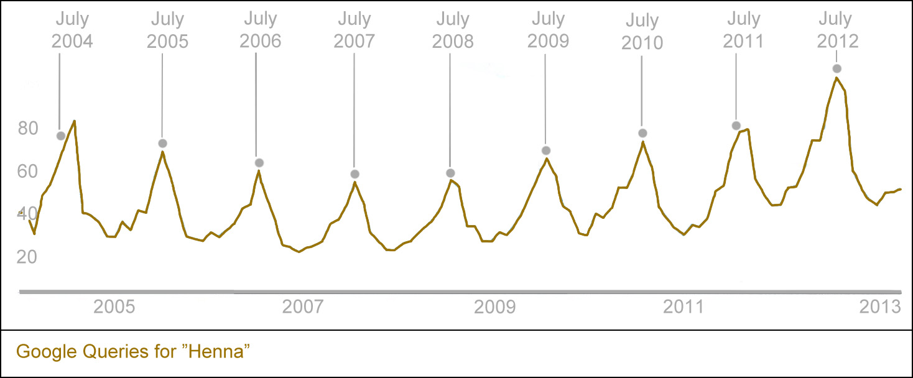
Graph of the memetic pulse of Google queries for 'henna tattoo' showing peaks each year in July or early August.

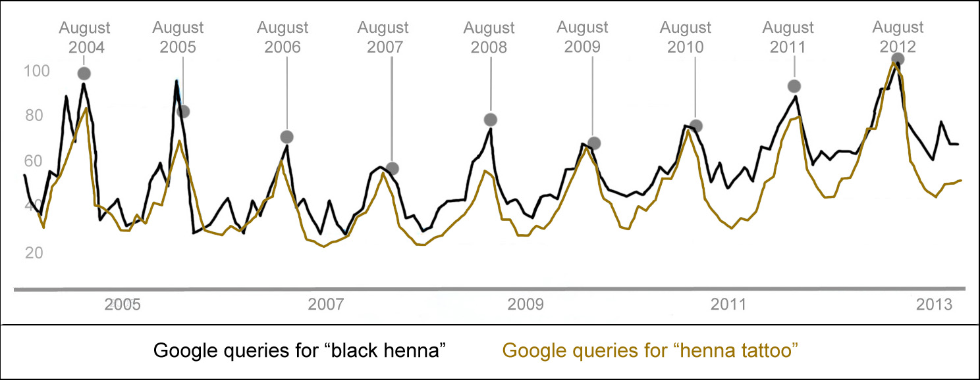
Graph comparing Google queries for ‘black henna’ and ‘henna tattoo’ adapted from Google Trends. The overlay of these two trends shows the coincidence of a summer peak for both henna and ‘black henna’ but show a sharper peak for ‘black henna’ during the spring break period each year.
The query for “henna” had the highest returns from Finland, where Henna is a common female name. “Henna tattoo” refocused the query on body art. The Philippines returned the highest number of queries for “henna tattoo” on google on March 21, 2013.
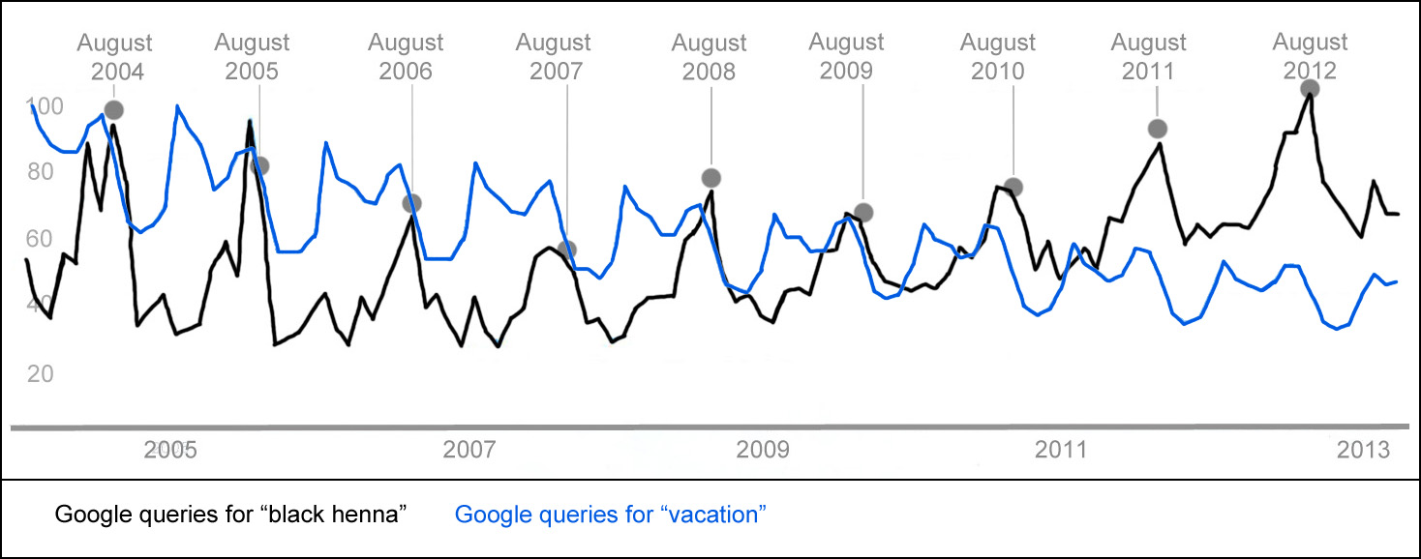
Graph comparin Google queries for ‘vacation’ and ‘black henna’ from Google Trends.

Black henna meme organism activity is more pronounced during spring break than regular henna meme organism activity. 500,000 students traveled to Panama City in Florida for Spring Break in 2012; Panama City has a large number of shops and independent ‘black henna’ vendors and spring break is their busiest season. Other beach areas have similar surges of students, and similar temporary informal economic surges of ‘black henna.’
Plotting ‘henna tattoo’ over ‘black henna’ illuminates some subtleties in the ‘black henna’ market. Black henna meme organism activity increases at more than one point each year. There is a peak roughly coinciding with spring break, a week in late March or early April when schools take a break before Easter and students from colder parts of North America go to warm areas of tourism. These students frequently participate in transgressive activities that are discouraged during the school year. Getting a ‘black henna’ temporary tattoo is so popular during spring break that the FDA and Florida produce press releases prior to the annual migration to the beaches.
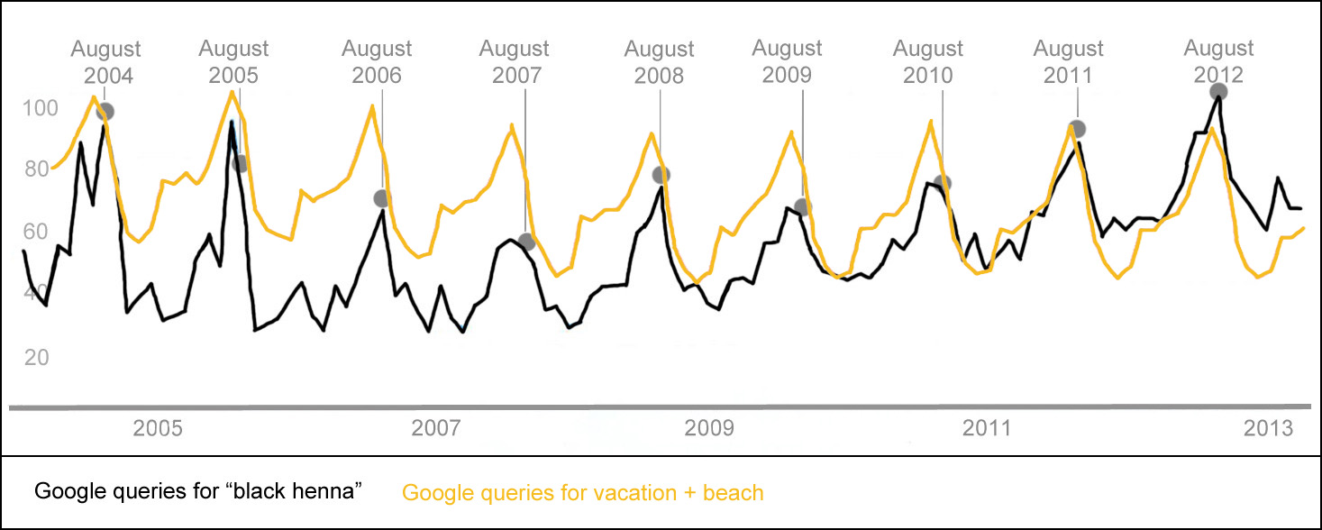
Graph showing the queries of vacation + beach and ‘black henna’ have closely matching memetic pulses.

The comparison of ‘vacation’ and ‘black henna’ queries show different pulses. The early memetic activity of ‘vacation’ queries may be for the purpose of planning vacations when workers submit their vacation requests for the year and begin to plan their time away from their job. The ‘black henna’ memes do not become active before tourists leave for vacation. ‘Black’ henna is queried after people they return home from vacation, possibly to find information on their perplexingly itchy souvenir.
A more precise fit is the pulse of vacations at beaches with ‘black henna.’ ‘Black henna’ is not limited to beach communities during vacation season but the memetic pulse indicates that is a probable area of coincidence. Vacation and ‘black henna’ have similar annual pulses, supporting the reports indicating that black henna largely exists in the informal, seasonal, economic sphere of tourism. ‘Vacation + beach’ queries arose largely from North America, as were inquiries about reservation packages and rentals.
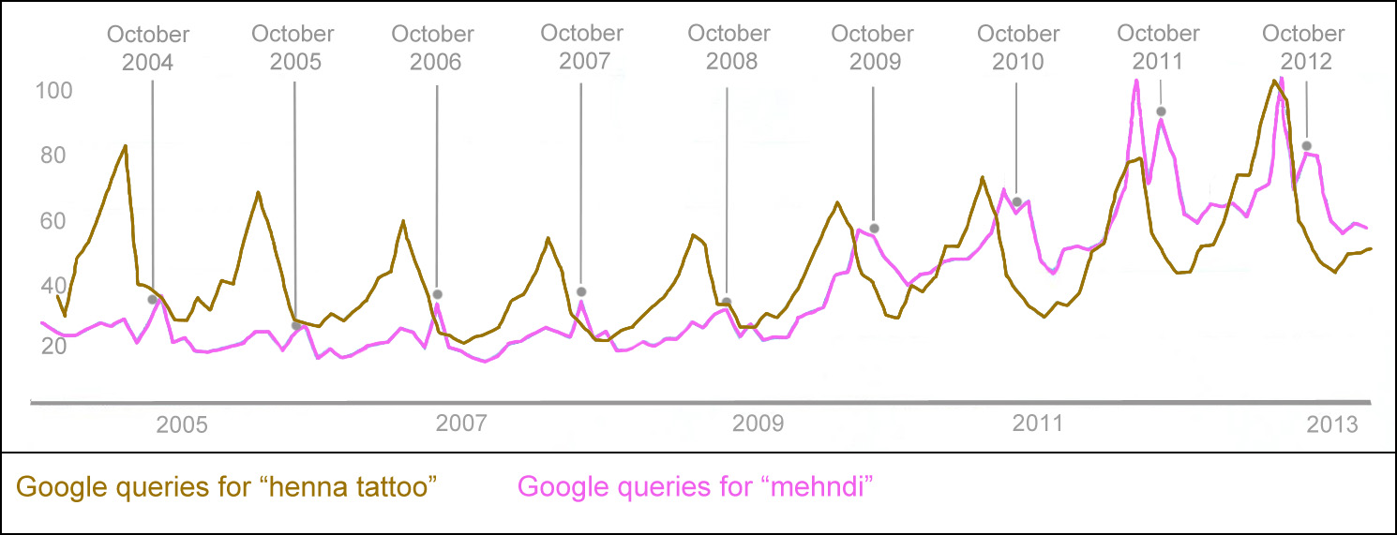
Graph showing the comparative pulses of queries for ‘henna tattoo’ and ‘mehndi’ adapted from Google Trends. This graph shows an annual ‘mehndi’ memetic surge around Diwali, a Hindu celebration that frequently includes henna parties, occurring in late October or early November, as opposed to a July and August surge for ‘henna.’

Henna and ‘mehndi’ meme organisms have annual cycles, but with differing memetic pulses. Online, henna’s memetic peak coincides with the northern hemisphere’s warm season, when skin is bared and ornamented. A ‘mehndi’ annual double peak occurs at Diwali, India’s ‘Festival of Lights’ a national holiday that people often celebrate with henna adornment, and Karwa Chauth, a late autumn women’s festival also celebrated with henna. Both are celebrated in mid-October or mid-November, with the dates being based on a lunar calendar. ‘Mehndi’ queries, originate in Pakistan and India rather than Europe and North America. The sub-queries of mehndi for Diwali and Karwa Chauth are for patterns; the seasonal mehndi meme is tightly linked with the acquisition of new patterns to ornament skin. Black henna is certainly used in the festivities of these South Asian holidays, but the pulse does not coincide with the migrations of tourism, and is in a different cultural context.
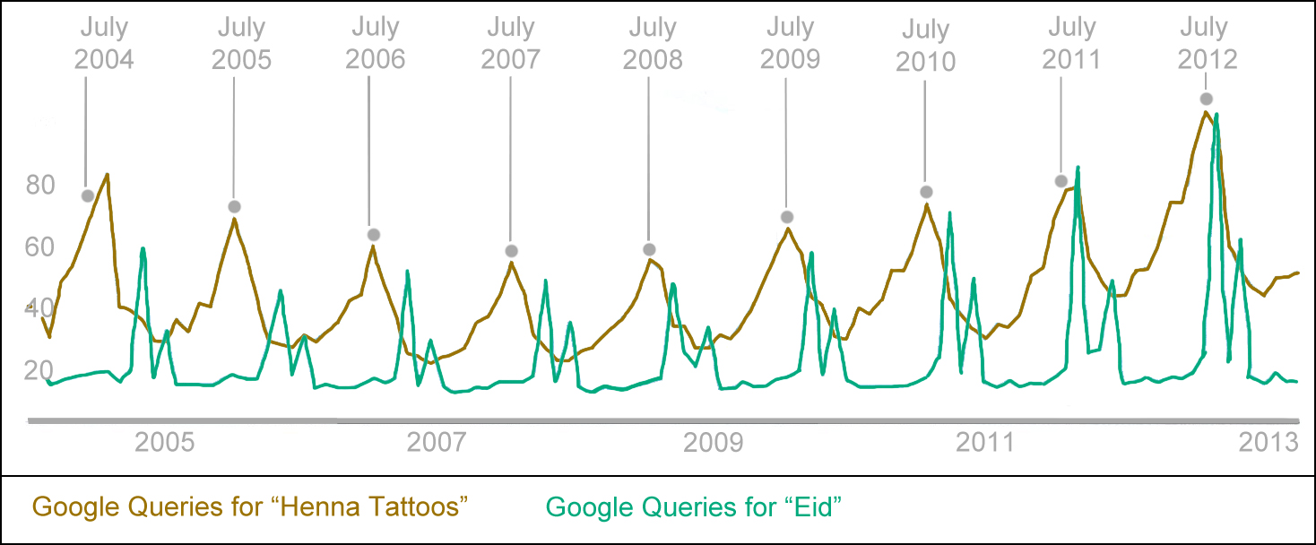
Graph showing the comparative pulses of queries for ‘henna tattoo’ and ‘Eid.’ The x-axis represents January 2004 through March 2013. 100 on the y-axis represents the maximum number or queries for both henna tattoo and Eid, not the actual number of queries. The query for ‘Eid’ shows a different cycle than ‘henna tattoo’, with peaks occurring in at the Muslim holidays in a 354-day lunar calendar. Eid celebrations frequently include henna parties.

The query for ‘Eid’ compared to the query for henna tattoo shows another memetic pulse out of annual sequence with the western beach vacation pulse of henna. The Eid meme organism pulse has two peaks occurring during the Muslim lunar 354-day year, as opposed to the warm season Northern hemisphere henna tattoo and black henna meme organism pulse of the solar year. Women celebrate Eid al-Fitr and Eid al-Adha with henna parties. The highest number of online queries for Eids orginate in Pakistan, Bangladesh, and the Arabian Peninsula; memetic activity for Eid Henna is most active in those regions. ‘Black henna’ is presently fashionable in these areas. On Google, the black henna meme organisms are most active northern hemisphere English-speaking countries drive online, during or just following their migrations to beaches on vacation.

PPD Content and Estimates of Sensitization through Black Henna Temporary Tattoos
The FDA has prohibited PPD from being used in direct contact with skin since 1938. Sensitization to para-phenylenediamine through hair dye is a well known problem, people begin showing symptoms of sensitization when they have used oxidative permanent hair dyes for about four years. The FDA has limited hair dye to no more than 6% content of para-phenylenediamine before dilution to mitigate sensitization. Hair dye not produced in the USA is not bound by US law, and may have extremely high para-phenylenediamine contents, though it is easily obtainable through online and local markets.
The PPD content of ‘black henna’ temporary tattoo paste have dye contents far above the 6% permitted for oxidative hair dye in western countries. Kligman found that 10% PPD painted as a patch test on skin causes sensitization in 100% of subjects in five applications or fewer. The blistering and scarring appears in the area of the pattern five to twenty days after application, and may sensitize as many as 50% of the subjects on the first application.The likelihood and intensity of PPD sensitization is correlated with the content, the length of time the paste is on skin, the area of the skin covered, the age of the subject, genetic predisposition, and previous contact with the chemical. Bigen Oriental black hair dye at 12.3% PPD is at the low end of the comparison chart, and is known to cause allergic reactions
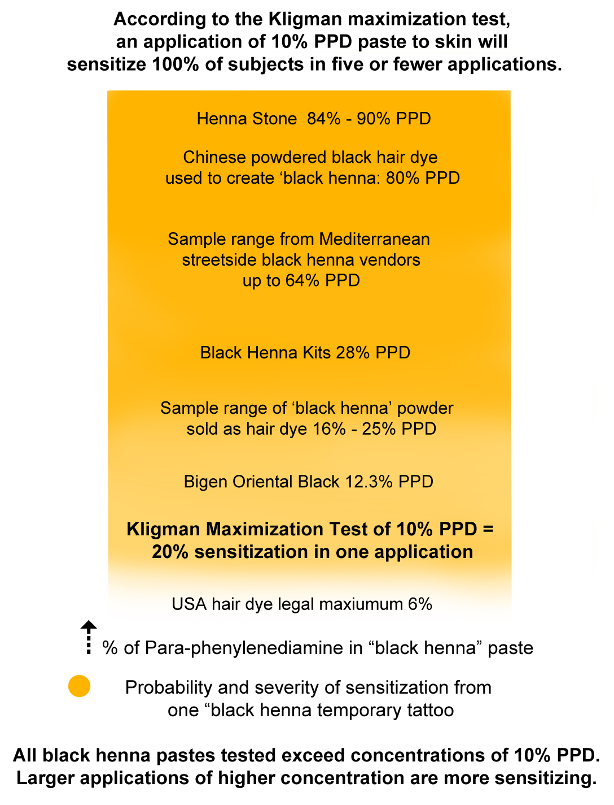
Diagram of the proportional levels of PPD in ‘black henna’ pastes and estimates of sensitization in a single application of ‘black henna’ based on Kligman’s Maximization test.
The 15.7% PPD ‘black henna’ paste tested by Dr. Brancaccio caused a severe allergic reaction. The black hair dye powders containing PPD sold through Middle Eastern, South Asian and Arab markets range from 16% to 29% dye content. Blackhennakits.com ‘black henna’ was tested by the FDA and found to contain 28% PPD.
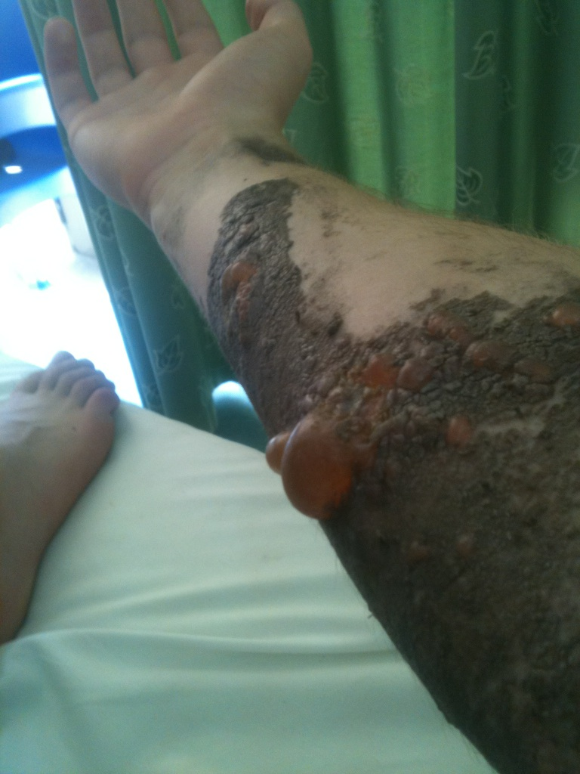
Though it would be unethical to test and is impossible to assemble quantitative information from the informal economic sector on injuries from black henna temporary tattoos, it appears that larger applications of higher PPD content black henna temporary tattoo paste cause more severe allergic reactions.

Higher PPD contents come from mixtures of Piko and henna stone, used through Africa and around the Mediterranean areas or tourism. Beachfront black henna artists’ pastes tested up to 64% PPD. ‘Spiking powder’ or Chinese black hair dye used to blacken black henna temporary tattoo paste in Bali was found to be 80% PPD. Henna stone, believed to be a harmless natural product, is the most dangerous component of ‘black henna’ and was found to be 83% to 90% para-phenylenediamine 90%

Cultural Memes Collaborating and Competing with Black Henna Meme Organisms
Commonly held cultural memes collaborated or competed with black henna meme organisms, and drove some of the understandings of ‘black henna’ in local network environments and the larger ideosphere. The following meme organisms are summaries of understandings that appeared in news articles and online, detailed in the previous chapters of this work.
One black henna harmlessness meme organism evolved from, “’black henna’ is created with hair dye, and hair dye is not harmful.” Hair dye has been used by most women and many men at some time in their lives, and in their experience, hair dye has appeared to be harmless. Home dye kits are available in grocery stores and there is no regulation on sales. In USA, Canada, and Europe, chemical hair dye powder is required to have a PPD concentration of no more than 6%, so that PPD is at a level of 1% or lower in dilution when applied to hair. Chemical hair dye is to be kept out of contact with skin to the greatest extent possible. The levels of PPD required to stain skin black are over 10%, far higher than what is considered safe use in hair dye. All permanent oxidative hair dye contains PPD and is a strong sensitizer, and PPD was voted allergen of the year in 2006.
A black henna artists’ meme organism is, “I may keep my ingredients secret,” or, “I trust my supplier.” Secrecy of methods and process was a way of preserving a competitive edge before patents were available, and remains a meme organism replicating in many network environments. The declaration of ingredients in products is a relatively modern concept evolved from injuries and subsequent government safety regulations.
Partially fermented powdered indigo was, and still is marketed as ‘black henna’ to be used in combination with henna to dye hair black gave support to the black henna harmlessness meme organism and obscured the dangerousness of black henna hair dye products containing PPD. Indigo does not dye skin black. Chemical hair dye mixes containing PPD are marketed as black henna and frequently do not have an ingredient declaration. Fermented indigo and chemical black henna hair dye are two different products but are similarly marketed.
The meme organisms of “people should be free to do anything they like with their own bodies,” versus “the government should protect people against things that will harm them,” were polar aspects of arguments for and against the regulation of ‘black henna’ in the areas of informal economies. The argument of agency in regards to one’s own body has also been tied to concepts of free speech, creativity and expression. The demand that government should mitigate risk for people has not translated easily and effectively into enforceable, protective laws regulating an informal economy. In most areas where laws against PPD skin painting were passed artists continued to serve customers the black henna they wanted. Artists became secretive in response to the prohibition of a desired commodity.
People are inclined to trust their personal experience above all other information, giving rise to, “if you had a ‘black henna’ temporary tattoo once and did not have a problem, you may have another without a problem.” Many people do not react to the first contact with a sensitizer. When a person does come in contact with a sensitizer, the body's immune system produces antibodies against the sensitizing agent, the antigen. The antigen-antibody reaction will become greater at each exposure to the sensitizing agent. Many people did not react to ‘black henna’ at the first application on vacation. The second application of ‘black henna’ to freshen the stain or a new application to have a temporary tattoo to show off at home often caused a severe allergic reaction. The ‘have a spot test today and come back tomorrow’ proffered by ‘black henna’ vendors to customers to provide a sense of safety and prudence was particularly misleading; dermatologists advise against patch testing with PPD because of the risk of sensitization. The delayed ‘black henna’ hypersensitivity reaction might occur up to thirty days after the test and the spot test might, itself, sensitize the person.
The following are paired cultural constructions of space that influenced henna and black henna meme organisms. “Well-regulated spaces are safe, therefore ‘black henna’ applied in licensed salons is safe,” versus “unregulated spaces are dangerous, therefore black henna applied by artists working as streetside vendors is unsafe.” These memes were replicated in people’s conversations, newspaper articles, and medical journal articles. The regulation of space does not affect PPD allergenicity. Many ‘black henna’ temporary tattoos are applied in salons and licensed spaces when ingredient declaration is absent and the risks are unknown or not considered serious.
Similarly, “expensive spaces that reproduce the comforts of the industrialized world are safe, so ‘black henna’ in four-star hotels must safe.” Tourists whose children were injured by poolside black henna artists often expressed a sense of betrayal in that they expected the expense and familiarity of their surroundings to insure harmlessness. Tourists also expected that ‘black henna’ vendors working on the premises of a package vacation venue would provide a safe product borne of the assumption that careful planning and controlled environment would eliminate risk.
Injuries are constructed differently in different network environments based on assumptions about freedom, personal responsibility, legal protection, and the invisibility of an injury that was delayed by days or weeks. The injuries happen; be careful, meme organism was frequently incorporated into black henna warning meme organisms in the third space of tourism. ‘Being careful’ would imply that the artist and consumer both had an understanding of the injuriousness of PPD, and could make an informed judgment about the dose/time likelihood of the artist’s paste on their skin, which was unlikely to be the case.
The meme organism of, ‘If someone harms you, you can sue for damages,’ replicated into Western constructions of black henna warning meme organisms. This meme replicates but rarely proceeds to legal action in seasonal informal economies where the artist cannot be found. If there an identifiable responsible party where the injury occurred, such as as the owner of a mall, hotel, or theme park, and the injury occurs in a country where negligence that results in harm may be legally addressed, a lawsuit may be filed. Filing suits across international boundaries between donor and host areas of tourism, may be difficult or impossible.
The injury memes of ‘black henna injuries are never more than a little rash,’ versus ‘visible blisters and scars are serious injuries,’ produce a cultural binary conflict about the consequences of painting PPD on skin. In newspaper reports on black henna injuries from the UK, the ruptured smoothness of a child’s skin is framed as a rupture of innocence, casting permanent shame on both child and parent. It is unusual for PPD to reach full blistering within the time frame that a person can confront the artist in the third space of tourism, so artists rarely see a fully developed reaction. Visible, unexpected injuries on children are also triggers for memes of empathy and grief based on appearance. Visible injuries are often more distressing to care givers than invisible injuries such as children’s’ fevers and digestive upsets which rarely attract media attention.
The meme, ‘If I do not see harm, no harm exists,’ closely follows the assumption that there is little harm in painting skin with PPD other than a mild rash. ‘If I do not intend harm, no harm exists,’ seems to be part of black henna artists’ answers when confronted with angry patrons. The intentionality of harm is part of legal judgments in assault cases: harm may be accidental, unintentional, negligent, or malicious, and these have different penalties under law. Customer’s anger towards and demands of compensation from artists was often deflected with a claim to innocence, “I had no idea; I never meant to harm anyone.”
“If I warn a person of possible allergic reactions, I am not responsible for their injury.” In several injury cases black henna artists insisted that they warned every consumer about potential allergic reactions and offered a patch test. Customers generally responded that there was no such warning or offer. Perhaps the artist exaggerated their attention to warnings. Perhaps the consumer paid little attention to warnings. If DuPont, the patent holders of PPD state that it PPD never be painted on skin and government agencies such as the FDA forbid the use on skin, whether or not there was a warning may beg the question of injury liability. The PPD warning meme organism was never replicated from patent holder to manufacturer to end consumer and at each step, liability was disclaimed.
Mimesis is a powerful force in human behavior and generally has served social species very well. “If lots of people are doing it, I should do it too,” is an evolutionarily beneficial response to seeing their pack running towards, or away from something. A member of a pack may live longer if they run with the other members rather than carefully evaluating the presence of a predator, or sudden windfall of food. Parents often commented that the child saw many other children with ‘black henna’ temporary tattoos, and became infatuated with the idea of acquiring one. “If everyone is doing it, it must be OK,” follows the same principle of pack memetic behavior. “If celebrities are doing it, I should do it too.” Emulating powerful and influential members of a pack is not only apt to preserve life, it tends to elevate a member’s status in a group by associate with elites, and functions as an evolutionarily useful process.
There are social contexts of the black henna warning meme when people are injured by ‘black henna.’ Parental warnings about injured children are quickest to surface; people seem to have a sense of rhetorical urgency and drama when they warn about ‘black henna’ following an injury to their child. These warnings are socially useful, and genuinely heartfelt and perhaps allow some catharsis of the dismay a parent has for their child’s injury. If a child is harmed, a social group often accuses the parent of being negligent. Warning may absolve some of the guilt. People often describe their own or their children’s injuries in great detail and narrate how suffering will continue into the future. Recitation of injuries endured is often a way of elevating status, particularly among women; Pashtun women excel in narrating stories of sorrows suffered, and eliciting empathy enhances their social position. Warning of injuries suffered in areas of tourism also allows the reproduction of narratives of western hegemony and superiority in a politically acceptable framework.
The construction of blame for ‘black henna’ injuries frequently comes wrapped in social narratives of western superiority, colonial hegemony, and distrust of lower classes of workers. Artists working in ‘black henna’ may be termed dirty, unscrupulous, and greedy when they have caused injuries. People are often chided for trusting a foreign person to mark their skin and reminded that they should expect to be damaged from such foolishness. Sunburns, hangovers, disruptive bacteria and viruses in the traveler’s body are expected to be resolved quickly upon the return home. If the body returns marked and unwell from the third space of tourism, people often import memes of xenophobia, class, and colonialism in their quest to place blame. The memes of transgression in the third space of tourism are brought to bear in ‘black henna’ narratives. It is acceptable for a traveler to transgress donor norms in the host’s space, but the traveler’s body is expected to normalize upon return to the donor country.

Beyond the Boundaries of the Online English Language Network Environment
Google’s first hundred returns for a ‘black henna’ query contain seventy-seven pages with warning memes of the dangerousness of PPD. One of the returns is an entry page to a ‘Tumblr’ social network of artists for whom ‘black henna’ is a beautiful and desirable cultural body art. Many artists’ pages on Facebook feature and admire ‘black henna.’ One may assume that the boundaries of divergent groups separate some mutually exclusive network environments within online English language network environments. This research work focuses on the online English language memes of ‘black henna’ in areas or tourism, but the competing black henna memeplexes of other network environments offer definition through contrast to the English language black henna warning meme organisms.
Cindy Trusty, an American henna artist posting to Facebook described a black henna meme organism network environment boundary encounter between with a Somali family in the Twin Cities Minnesota.
Every time you hear about PPD in Minnesota, it is associated with the Somali Mall. I did an event a couple years ago...a grand opening for a business. I was doing face painting and henna. Two beautiful young Somali girls came up to me, and asked me about my henna -- they wanted to know if it "hurt." I showed them photos of what black henna can do, and told them of the dangers. They pulled up the sleeves of their traditional clothing...and their arms were COVERED with scars. They said they didn't KNOW it was from the "black henna"!!! So they went over and got their mom. She couldn't speak English, so they translated for me. She started yelling in Somali and stormed off, dragging the younger girl with her. The older one looked at me, so very sad, and said, "I'm sorry, but my mom says your henna is garbage. She says it doesn't matter what the black henna does...it is beautiful, and it is what is expected, and it is what we have to get." She then followed her mom. I wanted to freakin' CRY.

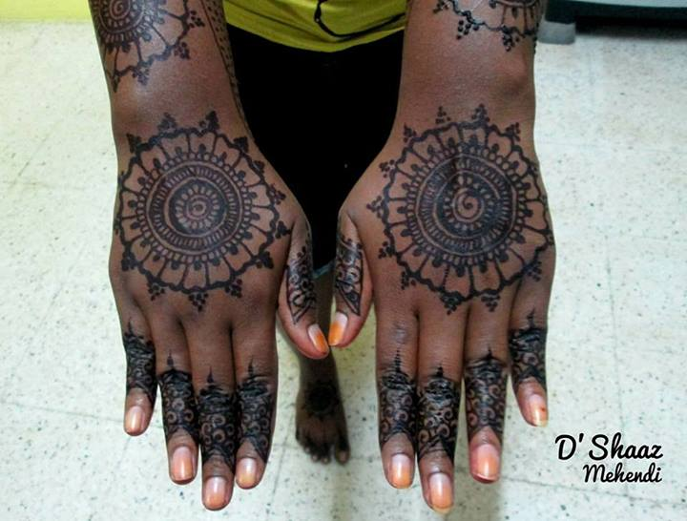
Black henna from a black henna artist’s Facebook page

Black henna warning meme organisms in the memeplex of multiculturalism and mutual respect become areas of conflict. The globalizing memes of embracing other people’s cultures do not include guidelines on negotiating concepts of injury. To imply that ‘black henna’ may be harmful summons of meme organisms of imperialist hegemony, stereotyping, and racism. Potentially productive discussions of ‘black henna’ among different network environments fail against these highly emotional tropes.
The communities of ‘black henna’ on Facebook show the flows and boundaries of black henna meme organisms through the ‘likes’ to pages and images; the flows move through ethnic communities, diaspora, and people who have similar aesthetic preferences. These ‘black henna’ artists have no shortage of clients and admirers. ‘Black henna’ work is a route to economic independence and a better life for the women who practice it in the social groups where it is fashionable. Understandings of ‘black henna’ injuries in cultural and social networks of diaspora will surface over time and the people in these networks will balance risk and benefit for themselves. The spaces in the margins between black henna warning meme organisms and ‘black henna’ acceptance will be the areas of misunderstanding, harm, and dismay. Black henna meme organism of warning or avoidance will emerge and evolve in the within localized network environments.

Foucault,M. 1969. Archaeology of Knowledge, 1969, trans.A. M. Sheridan Smith (London: Routledge, 2002)
Blackmore, S. 2000. The Meme Machine. Oxford: Oxford University Press, USA
Schifman, L., Thelwal, M. 2009. “Assessing global diffusion with Web memetics: The spread and evolution of a popular joke.” Journal of the American Society for Information Science and Technology Volume 60, Issue 12, pages 2567–2576
Paull, John. 2009. "Meme Maps: A Tool for Configuring Memes in Time and Space." European Journal Of Scientific Research 31, no. 1: 11-18. Academic Search Complete, EBSCOhost (accessed December 27, 2012).
Coscia, M., 2013. “Competition and Success in the Meme Pool: a Case Study on Quickmeme.com” Association for the Advancement of Artificial Intelligence
Blackmore, S. 2000. The Meme Machine. Oxford: Oxford University Press, USA
Blackmore, S. 1999. The Meme Machine. Oxford University Press. Oxford UK
Schmidt, Wolf-Peter, Robert Aunger, Yolande Coombes, Peninnah Mukiri Maina, Carol Nkatha Matiko, Adam Biran, and Val Curtis. 2009. "Determinants of handwashing practices in Kenya: the role of media exposure, poverty and infrastructure." Tropical Medicine & International Health 14, no. 12: 1534-1541. Academic Search Complete, EBSCOhost (accessed December 27, 2012).
Meyer, Dick (December 12, 2006). "The Truth of Truthiness". CBS News. Retrieved December 14, 2006. Truthiness is a quality characterizing a "truth" that a person making an argument or assertion claims to know intuitively "from the gut" or because it "feels right" without regard to evidence, logic, intellectual examination, or facts.
Jeanblack. Comment “screamed at for confronting black henna booth” posted to Open Henna Circle. August 2, 2011 http://hennatribe.org/viewtopic.php?p=112115&sid=c1d1a271f30d5c89bd0680dc638cf326 (accessed November 14, 2013) Black henna in Canada? I think not! Now I was already in a super pissed mood because i was actually a vendor at this 3 day festival (i left after the first day because i have strep throat, the organizers put me in the most horrible location & didn't follow through with agreements). Already being in a bad mood, i wasn't able to pull of my usual play sweet & dumb to get info out of them - i just asked straight up if they are using PPD or jagua. He said jagua & asked why i was asking, i let him know & them he blew his top! He & his wife (both Indian) started screaming at me, pulling the typical "i'm Indian & your white, what do you know about henna B.S.) and when i try to explain that i am the local professional certified natural henna artist and just making sure that no one is having PPD applied , he just screamed more & they both started yelling for me to go away. It was terrible because there were quite a few people in the booth (and you could hear them 5 booths away) & i don't want to hurt my local reputation.
“Black Henna Tattoo” posted to Best Beauty Advice. http://bestbeautyadvice.com/?p=683 (accessed July 17, 2013) I learned how to do them while visiting a beach town in Mexico. A local shop offered henna tattoos that were black instead of the traditional brown/red. Everyone in my party of 15+ got one. We loved it!
"Salon staff to take test under new rules." The National. June 18, 2012 Monday . Date Accessed: 2013/06/06. www.lexisnexis.com/hottopics/lnacademic. Mr Al Rumaithi also said the municipality received a complaint in December that a salon client received third-degree burns from black henna, which contains petrochemicals. "When we inspected the salon we did not find any black henna because they hid it," he said. "Then we sent a customer asking for black henna, the shop asked her to come at 10pm. "When she entered at 10pm and they started using black henna on her, we captured them red-handed. The black henna was mixed with petrol and Adnoc lube. We referred the matter to the court and [the salon] was fined Dh8,000."
Kellerman, A. 2002. The Internet on Earth: A Geography of Information. Chichester, England: John Wiley & sons Ltd. pp 3 - 5
Ed. Kraak, M. 2001. Users of Maps on the Web. Web Cartography. Van Elzakker, C. P. J. M. Taylor and Francis, London. p 41
Landweber, L.1995. from Castells, M. 1998, End of Millenium Vol III, The Information Age: Economy, Society and Culture. Blackwell, Oxford. p.94
p-Phenylenediamine (PPD) 1,4-Benzenediamine. Dupont. The Miracles of Science. http://www2.dupont.com/Specialty_Chem_Intermediates/en_US/products/ppd.html
United States Department of Labor. “m-, o- and p-Phenylenediamine” Occupational Safety and Health Administration. https://www.osha.gov/dts/sltc/methods/organic/org087/org087.html (accessed November 14, 2013) 1.1.2. Toxic effects (This section is for information only and should not be taken as the basis of OSHA policy.) Exposure to phenylenediamines has been reported to affect the kidney, liver, and blood. Inhalation causes respiratory problems and asthma, but the most common toxic effect is dermatitis. (Ref. 5.12.) The current OSHA PEL and ACGIH TLV are 0.1 mg/m3 for p-phenylenediamine with skin notations. ACGIH is now considering the same TLV for m- and o-phenylenediamine and is also considering adding o-phenylenediamine to its suspected human carcinogen list. Currently there are no OSHA exposure limits for m- or o-phenylenediamine. 1.1.3. Workplace exposure The major uses for phenylenediamines are in the manufacture of dyes. They are also used to dye hair and fur, as photographic development agents, curing agents for epoxy resins, vulcanization accelerators, and as components of gasoline antioxidants. (Ref. 5.13.)
Rollison, DE; Helzlsouer, KJ; Pinney, SM (2006). "Personal hair dye use and cancer: a systematic literature review and evaluation of exposure assessment in studies published since 1992.". Journal of toxicology and environmental health. Part B, Critical reviews 9 (5): 413–39. doi:10.1080/10937400600681455. PMID 17492526.
Chaudhary, SC.; Sawlani, KK.; Singh, K. “Paraphenylenediamine poisoning.” Nigerian Journal of Clinical Practice, v. 16 issue 2, 2013, p. 258-9.
Nirmal. “Two Mehndi Whores” posted to Away from Our Heritage. http://awayfromourheritage.blogspot.com/2010/01/two-mehendi-whores.html?spref=fb , later moved to http://awayfromourheritage.blogspot.com/2012/05/archive-non-celebrity-goris-action.html?q=Two+Mehndi+Whores (accessed April 13, 2011)
holikarang. Comment “This blog needs to be reported” posted to Open Henna Circle, April 13, 2011http://hennatribe.org/viewtopic.php?t=11771 (accessed November 14, 2013)
umm fauziyah. Comment, “Re: How to get black henna...” posted to The Henna Page Discussion Forum July 07, 1997. http://web.archive.org/web/20010520022733/http://www.hennapage.com/henna/discuss/messages/853.html (accessed November 14, 2013)
Gatherer D (2002b) “Identifying cases of social contagion using memetic isolation: comparison of the dynamics of a multisociety simulation with an ethnographic data set.” Journal of Artificial Societies and Social Simulation 5, no. 4 http://jasss.soc.surrey.ac.uk/5/4/5.html
Alison. Comment, “Re: I'm starting experiencing Henna... I can't make it black! Any Suggestion?” posted to The Henna Page Discussion Forum, July 14, 1998. http://web.archive.org/web/20010222034954/http://www.hennapage.com/henna/discuss/messages/3260.html (accessed November 14, 2013) I have found a product that is BLack. It is not henna but Egyptian Amunez. Lasts as long as henna and is easier and quicker to mix. I got sick of losing business because everybody wanted black and here it is. I haven't looked back. I'll be in Rome next week. Email me back ASAP
Jessdel27 “Temporary Tattoo Dangers to Children” posted to Babies Online, The Blog, August 11, 2008. http://blogs.babiesonline.com/health/temporary-tattoo-dangers-to-children/ (accessed November 14, 2013)
Kellerman, A. 2002. The Internet on Earth: A Geography of Information. Chichester, England: John Wiley & sons Ltd. pp 3 - 5
Jamie. “Black Henna Nightmare” posted to Frito Lay Sweepstakes December 28,2005 http://www.fhlostoncreative.com/elblog/archives/2005/12/black_henna_nig.html (accessed November 14, 2013)
Bubu bunny. Comment “I just got a black henna tattoo!!!! help?” posted to Yahoo answers, 2009. http://ph.answers.yahoo.com/question/index?qid=20100503045558AAimoAv (accessed November 14, 2013) I just got a black henna tattoo!!!! help? and i didnt know that black henna can cause skin bruising!!!! what should i do now? how can i remove it?? help me pls b4 its too late!!!! should i go to the doctor or not?? pls help cuz im freakin out right now!!! do you guys think it would help if i would pour warm water over it and scrub it every hour??? will i have a scar now??? i have that black henna tattoo all over my back!!!!! its so big i dont want my whole back to be scared =((((( heeellpp pls!!! A Top Contributor is someone who is knowledgeable in a particular category. Best Answer - Chosen by Voters Stop freaking out, wash it, and go to the doctor. Some people do not react, and your first exposure is slightly less likely to cause severe reactions as further ones are. Get an allergist or something that's familiar with the effects and risks of PPD exposure. Then when you're treated, find out if giving black henna art is illegal in your area, and contact the authorities. Even if it's not, contact them, especially if you have a reaction which required more medical attention. From now on, no matter how you react, you need to avoid PPD. Research it, avoid hair dyes, look into the risks of PPD exposure, and see what you can do to put the person responsible out of business, and try to help educate others so they can avoid getting a harmful design. http://www.hennapage.com/henna/ppd/gotodoctor.html
Michele. “So You Want A BLACK Henna Tattoo?? Let me tell you why you don’t!” Mehndi by Michele. http://www.angelfire.com/mn3/mehndibymichele/ppd.htm (accessed November 14, 2013)
Rachel Benbow. Comment, “The Evils of Black Henna or "Bali Tattoo" posted to Baraka, Tribal Fusion and Goth Bellydance. http://www.barakadance.net/henna/black.html (accessed November 14, 2013)
Agarwal, R. and Pujara R. “Watch Out for Black Henna!” posted to ABCD Lady, a magazine for the American Born Confident Desi. http://www.abcdlady.com/2005-12/art1.php (accessed November 14, 2013)
Michele Coscia, 2013, “Competition and Success in the Meme Pool: a Case Study on Quickmeme.com,” International Conference of Weblogs and Social Media, Association for the Advancement of Artificial Intelligence (www.aaai.org)
“Analytics for any Website” Alexa, the web information company. http://www.alexa.com/ (accessed November 14, 2013) The Global Leader in Analytics Alexa is the leading provider of free, global web metrics. Search Alexa to discover the most successful sites on the web by keyword, category, or country. Use our analytics for competitive analysis, benchmarking, market research, or business development. Use Alexa's Pro tools to optimize your company's presence on the web.
Paull, J. 2009. Meme Maps: A Tool for Configuring Memes in Time and Space. European Journal of Scientific Research 31, 1:11-18.
Foucault, M. reprint edition 1982. “The Archaeology of Knowledge & The Discourse on Language” Vintage.
Michele Coscia, 2013, “Competition and Success in the Meme Pool: a Case Study on Quickmeme.com,” International Conference of Weblogs and Social Media, Association for the Advancement of Artificial Intelligence (www.aaai.org)
Truthy. Information diffusion research at Indiana University...http://www.truthy.indiana.edu/ (accessed November 14, 2013) Truthy is a research project that helps you understand how communication spreads on Twitter. We currently focus on tweets about politics, social movements and news.
Ellis, Aurora. “A Nubian Wedding” Daily News Egypt. August 29, 2013 http://www.dailynewsegypt.com/2013/08/29/a-nubian-wedding/#dnePhoto/0/ (accessed November 20, 2013) The dukhan Before the official henna the groom’s sisters and friends go to a henna designer to have their hands decorated; we spend over eight hours crammed together in a small room, watching the lines of liquid henna stream out the small tube and admiring the artist as she drew intricate designs on our hands and feet. After the henna dried, we washed it off to reveal beautiful and delicate designs. We then placed our hands and feet over a hole in the corner of a dark and smoky room the women call the dukhan. The dukhan, the literal translation from the Arabic means ‘smoke’, is a smoking fire that has been built in a hole in the ground. It is used in both Nubia and parts of Sudan to aromatise the body and to blacken the henna patterns on the skin. Seyam emphasised that it is rituals like this that highlight the importance of henna and the henna day in Nubian weddings.
umm fauziah. Comment, “Re: How to get black henna...” posted to The Henna Page Discussion Forum, December 5, 1997. http://web.archive.org/web/20010520022733/http://www.hennapage.com/henna/discuss/messages/853.html (accessed November 14, 2013)
Editorial Review for “Setona, Queen of Henna.” Reidel Music http://www.amazon.com/Setona-Queen-Henna/dp/B000055WVS (accessed August 24, 2013)
Sir Hashim, M., et al. “Poisoning from henna dye and para-phenylenediamine mixtures in children in Khartoum.” Annals of Tropical Paediatrics: International Child Health, v. 12 issue 1, 1992, p. 3-6
“Sudan; Office To Monitor and Combat Trafficking in Persons, 2013 Trafficking in Persons Report, Tier 3” U.S. State Department. 2013. http://www.state.gov/j/tip/rls/tiprpt/countries/2013/215621.htm (accessed November 14, 2013)
Abdulla, Kamil A and Neil McD Davidson. 1996. A woman who collapsed after painting her soles. The Lancet 348, no. 9028:658.
Marie-Louise Olson “Doctors warn of black henna risk” TheNational. May 13, 2012 http://www.thenational.ae/news/uae-news/health/doctors-warn-of-black-henna-risk (accessed November 14, 2013)
Naila. Comment, “Black Henna” posted to Open Henna Circle. http://hennatribe.org/viewtopic.php?t=11832&sid=1ce32d8ec620756b2eca5849bdadb8a7 (accessed November 14, 2013) Hello I recently went to Dubai and at the hotel I was staying we got some tatoos with an excellent black henna product. I asked the artist why they were using the product because it is well known to be dangerous. She said this was similar to henna but not henna and that it was completely safe. The high class hotel would not allow this product to be licensed in the hotel otherwise. My daughter and I tried a bit and it was great. It peeled off like a stencil once dry. Now recently in the Uk we came across a product boasting the same claims, but oh no! it was dangerous. my daughter has scares on her hand. The product is made in Pakistan and claims to have no side affects. Has anyone else come across this product? it's in glamourous black box
Afkar Abdullah. “Ajman cracks down on salons using harmful products” Khaleej Times. June 22, 2012 http://www.khaleejtimes.com/kt-article-display-1.asp?xfile=data/nationhealth/2012/June/nationhealth_June36.xml&section=nationhealth (accessed November 14, 2013)
“Salons ignore govt directive on hair dye.” Gulf Times. August 15, 2013. http://www.gulf-times.com/qatar/178/details/362845/salons-ignore-govt-directive-on-hair-dye (accessed November 20, 2013)
Gupta, B N, A K Mathur, C Agarwal, and A Singh. 1986. "Contact sensitivity to henna." Contact Dermatitis 15, no. 5: 303-304. MEDLINE with Full Text, EBSCOhost (accessed April 7, 2013)
Nigam, P K, and A K Saxena. 1988. "Allergic contact dermatitis from henna." Contact Dermatitis 18, no. 1: 55-56. MEDLINE with Full Text, EBSCOhost (accessed April 7, 2013).
Pasricha, J S, R Gupta, and S Panjwani. 1980. "Contact dermatitis to henna (Lawsonia)." Contact Dermatitis 6, no. 4: 288-289. MEDLINE Complete, EBSCOhost (accessed October 26, 2013).
Oindrilla. “Best Black Mehndi Designs – Our Top 10” StyleCraze, India’s Top Beauty Network. Jun 11, 2013 http://www.stylecraze.com/articles/best-black-mehndi-designs-our-top-10/?ref=topbarpos1 (accessed November 18, 2013) Black Mehndi, also known as Chemical Mehndi, is the resultant of mixing chemicals and dye with henna. Black Mehndi designs done with the help of the black chemical cone, creating the borders and filled in with henna/mehndi give an amazing dual colour effect and look really beautiful when applied on hands or feet. A lot of Arabic mehndi designs feature black mehndi as well. Black Mehendi is the preferred choice of many for festivals, occasions and weddings or even for casual wear since it imparts a look different from the usual mehndi we do and provides sharper, stronger colour and more prominent designs which lend a great attractive effect. Whether used for outlining or by itself, black mehendi designs beautifully imbibe the traditional with the modern, thus being trendy and classy all at the same time.
Shehbaz & Jilani Mehandi Designer. Comment posted to Facebook Gallery, May 31, 2013. https://www.facebook.com/photo.php?fbid=251500338322061&set=a.213088258829936.48928.212745575530871&type=1&theater (accessed November 14, 2013) Mary DeHart Bennett This is very pretty...what brand of henna is it? Does it have some dye plus the henna powder or what ingredients? Shehbaz & Jilani Mehandi Designer its a mixture of some special ingredients which is made by myself....... and its a latest brand of henna and its colour is so good.. and where r u live my dear...
“Women throng hospitals with mehndi itch in Tamil Nadu” Deccan Chronicle, August 21, 2012. deccanchronicle.com http://www.deccanchronicle.com/channels/nation/south/women-throng-hospitals-mehndi-itch-tamil-nadu-991 (accessed August 12, 2012) Over 100 young Muslim women thronged the casualty ward of Rajiv Gandhi Government Hospital late on Sunday evening with red, itchy palms after they suffered an allergic reaction to mehndi. Doctors received dozens of patients complaining of a burning sensation in their hands and feet after they applied mehndi, ahead of celebrating Eid on Monday. “Last evening, we treated 109 women as out-patients. We gave them anti-histamine tablets and sent them away as they did not have serious symptoms. However, four women had to be admitted for treatment. They are fine now. They will be discharged on Tuesday morning,” said Dr V. Kanagasabai, dean, Rajiv Gandhi Government Hospital. Rumours create panic in Karnataka Ramzan celebrations turned out to be a dampener in Salem, Krishnagiri and other parts of western TN after rumours made the rounds that 10 children had died in Bengaluru suburbs after applying mehndi for Eid celebrations.
sarzit11. Comment, “Beware Black Henna Tattoos” posted to Trip Advisor, Apr 21, 2010. http://www.tripadvisor.com/ShowTopic-g311425-i9663-k3571861-Beware_Black_Henna_Tattoos-Marsa_Alam_Red_Sea_and_Sinai.html (accessed November 14, 2013) Gigo the chap on the beach who did the henna tattoos was lovely and my sons both had a design on their arm plus their name in arabic on our 2nd day. ( I had my name in arabic done for free on my wrist - it was great as all the waiters knew my name). Gigo said that the tattoo would last 2 weeks, so to go back on our last day and he would re-apply it for free. We did this the day before we came home and all was great. After about 2 days at home the tatoos both started to itch, become red and inflaimed. The boys were in great discomfort and we had to get an emergency appt with our GP. 2 weeks on and they are still red, inflaimed and itchy after antihistamines daily. I have since read on the internet that black henna is banned in many countries and that it has harmful chemicals that potentially will cause allergic reactions to certain dyes, medicines etc for life. DONT have it done, however tempting OR look up the facts about the harm from black henna tattoos BEFORE you go. The scar can take up to a year to go and some people have been scarred for life. The Thompson rep told us about the dangers of the water, not to book trips with the people along the beach as their mini-buses wouldn't be insured etc, to wash hands after handling money. I think they should also warn about the tattoos.
V. Vale and Andrea Juno, eds. 1989. Modern Primitives: an Investigation of Contemporary Adornment & Ritual Re/search San Francisco, CA.
Doyle, Laura, ed., Bodies of Resistance: New Phenomenologies of Politics, Agency, and Culture, Northwestern University Press, 2001
Fabius, C. 1998. Mehndi: The Art of Henna Body Painting. Three Rivers Press. New York, NY
Daily Mail Reporter. July 10, 2008. “Holiday henna warning as boy, 10, is scarred for life after tattoo goes horrifically wrong” Mail Online, part of the Daily Mail, The Mail on Sunday and Metro Media Group. Glam Entertainment. Associated Newspapers Ltd. http://www.dailymail.co.uk/news/article-1033698/Holiday-henna-warning-boy-10-scarred-life-tattoo-goes-horrifically-wrong.html (Accessed January 28, 2012)
Eman Tuhama. “Mixing henna with PPD causes skin complications” Yemen Times. July 23, 2012. http://www.yementimes.com/en/1592/health/1183/Mixing-henna-with-PPD-causes-skin-complications.htm (accessed November 14, 2013) On the day of her wedding one year ago, Liqa’a Mohammed put henna on her skin. Today, the burns caused by the henna are still visible on her skin. “I didn’t realize that the henna I used wasn’t natural,” she said. “At first, I thought the burns were because of an evil eye. I went to a sheikh to heal me with the Qur’an, but I didn’t recover. The skin irritation increased, so I had to visit a doctor. He gave me ointments and told me that it was caused by the chemicals added to henna.
Google Trends. Black Henna. http://www.google.com/trends/explore#q=black%20henna&cmpt=q accessed March 7, 2013 and attached spreadsheet black_henna_032113.csv
Google Trends. Henna Tattoo http://www.google.com/trends/explore#q=henna%20tattoo&cmpt=q accessed March 21, 2013
Google Trends. Henna. http://www.google.com/trends/explore#q=henna&cmpt=q and attached spreadsheet henna.csv
Google Trends. Henna Tattoos. http://www.google.com/trends/explore#q=Henna%20tattoo (accessed March 21, 2013) and attached spreadsheet henna_tattoo.csv
Google Trends. Mehndi. http://www.google.com/trends/explore#q=mehndi&cmpt=q (accessed November 18, 2013)
Google Trends. Diwali. http://www.google.com/trends/explore#q=Mehndi&cmpt=q (accessed March 21, 2013) and attached spreadsheet mehndi.csv
Google Trends. Eid. http://www.google.com/trends/explore#q=eid&cmpt=q (accessed November 18, 2013)
Jacob, SE.; Brod, BA. “Paraphenylenediamine in black henna tattoos: sensitization of toddlers indicates a clear need for legislative action.” The Journal of clinical and aesthetic dermatology, v. 4 issue 12, 2011, p. 46-7.
LaBerge, L.; Pratt, M.; Fong, B.; Gavigan, G. “A 10-year review of p-phenylenediamine allergy and related para-amino compounds at the Ottawa Patch Test Clinic.” Dermatitis : contact, atopic, occupational, drug : official journal of the American Contact Dermatitis Society, North American Contact Dermatitis Group, v. 22 issue 6, 2011, p. 332-4.
Kligman, A. M. 1966. “The identification of contact allergens by human assay; III, The maximisation test: a procedure for screening and rating contact sensitisers.” Journal of Investigative Dermatology; 47:393–409.
Star Tribune. July 2, 2011. “Temporary tattoos put blisters on metro kids” Star Tribune, Minneapolis, MN. http://www.startribune.com/local/124797314.html (accessed December 12, 2014) About half of the children who got the tattoos on June 7 had skin reactions, including blistering and weeping lesions, according to the state Health Department. In most cases, the lesions appeared within 20 days and half appeared within seven days.
Ho, S.G. Y., White, I. R., Ryecroft, R. J. G., MacFadden, J. P. 2004. “Allergic contact dermatitis from para-phenylenediamine in Bigen1 powder hair dye.” Contact Points. Contact Dermatitis.51 Page 93 Blackwell Munksgaard.
Kligman, A.M. 1966. “The identification of contact allergens by human assay; III. The maximisation test: a procedure for screening and rating contact sensitisers. Journal of Investigative Dermatology; 47:393–409.
Brancaccio, RR., et al. “Identification and quantification of para-phenylenediamine in a temporary black henna tattoo.” American Journal of Contact Dermatitis, v. 13 issue 1, 2002, p. 15-8.
Bajaj, A. K., Dubey, K. S., Misra, K. A simple spectroscopic technique proposed for scanning the depigmenting potential of azo dyes. Contact Points. Contact Dermatitis 2004:5188 page 97 Blackwell Munksgaard.
Al-Suwaidi, A. Ahmed, H 2010 “Determination of para-Phenylenediamine (PPD) in Henna in the United Arab Emirates” International Journal of Environmental Research and Public Health, 7, 1681-1693; doi:10.3390/ijerph7041681
FDA. Inspections, Compliance, Enforcement, and Criminal Investigations. Black Henna Ink, Inc. 14-Aug-06. FDA U.S. Food and Drug Administration. http://www.fda.gov/ICECI/EnforcementActions/WarningLetters/2006/ucm076032.htm (accessed November 3, 2013)
1598benny. Comment “So it turns out my friend has a reaction to Henna tattoo's...” posted to Reddit February 3, 2013 http://www.reddit.com/r/WTF/comments/17tand/so_it_turns_out_my_friend_has_a_reaction_to_henna/c88mlyy
Almeida, PJ., et al. “Quantification of p-phenylenediamine and 2-hydroxy-1,4-naphthoquinone in henna tattoos.” Contact Dermatitis (01051873), v. 66 issue 1, 2012, p. 33-7.
Avnstorp C, Rastogi SC, Menné T. 2002. Acute fingertip dermatitis from temporary tattoo and quantitative chemical analysis of the product. Contact Dermatitis. August 47(2):119-20.
Özkaya E, Yazganoglu KD, Arda A, Topkarci Z, Erçag E. 2013. The "henna stone" myth. Indian Journal of Dermatology and Venereal Leprology 79:254-6
"ADM cautions salons on health standards." Khaleej Times (United Arab Emirates). August 14, 2012 Tuesday . Date Accessed: 2013/06/06. ABU DHABI - In the build-up to the Eid Al Fitr holidays, the Municipality of Abu Dhabi City (ADM) is ramping up inspections of women's beauty salons to ensure their compliance with ADM's public health and safety standards. In a statement issued on Tuesday, the ADM urged beauty centres and their patrons to exercise caution during the busy period leading up to Eid celebrations. "Intensifying the inspection during these days from the evening up to midnight is intended to educate those in charge of beauty salons and centres as well as their staff about the health standards that ought to be observed in these outlets," stated Khalifa Al Rumaithi, ADM's Director of Public Health. The municipality made a special note of the increased use of henna, reminding salons to be on the lookout for unsafe henna blends. The natural henna product is often mixed with petroleum or other harmful additives to enhance its dying effect, causing damaging health effects to some users. Ruby from the Beautiful Henna Centre in Abu Dhabi said she offered only natural henna blends, although her salon received an average of 10 to 12 calls everyday requesting "black henna", which is commonly made up of unsafe chemicals to obtain its dark hue. "Black henna is not henna actually," she said, explaining that the henna plant can only naturally produce orange, red and brown colours. "Since it is not meant to be used on the skin, you can imagine how strong the side effects can be, like causing long-lasting skin allergies," she added. Even though clients are informed of the ban and the health risks associated with black henna, Ruby said demand is still strong. Inspectors are confiscating any harmful beauty products found in salons and the municipality may fine, prosecute and even shut down salons if found violating its health and safety standards.
Devos, S. and Van Der Valk, P. “The risk of active sensitization to PPD” Contact Dermatitis, 2001, 44, 273–275
Grima, B. 1991. “The Role of Suffering in Women’s Performance of Paxto” Gender, Genre, and Power in South Asian Expressive Traditions. Chapter 3. edited by Arjun Appadurai, Frank J. Korom, Margaret Ann Mills, University of Pennsylvania Press
D'Shaaz Mehendi’s Photos posted to Timeline Photos, Facebook, November 8, 2013. https://www.facebook.com/photo.php?fbid=177811115752518&set=pb.134947743372189.-2207520000.1384781349.&type=3&theater (accessed November 20, 2013)
Cindy Trusty, posted to Facebook messages, October 6, 2013 https://www.facebook.com/messages/cindy.trusty (accessed October 6, 2013)
D'Shaaz Mehendi’s Photos posted to Timeline Photos, Facebook, November 8, 2013. https://www.facebook.com/photo.php?fbid=177811115752518&set=pb.134947743372189.-2207520000.1384781349.&type=3&theater (accessed November 20, 2013)
Henna Al Sudani Somali Facebook Page. Facebook. https://www.facebook.com/hlema.arok?fref=ts (accessed November 20, 2013)
Kauthar Moh'd. “Urembo mzuri lakini Mmmh” Posted to Facebook October 29, 2013 https://www.facebook.com/photo.php?fbid=439488022822107&set=a.355283044575939.1073741825.100002827397185&type=1&theater (accessed November 21, 2013)

