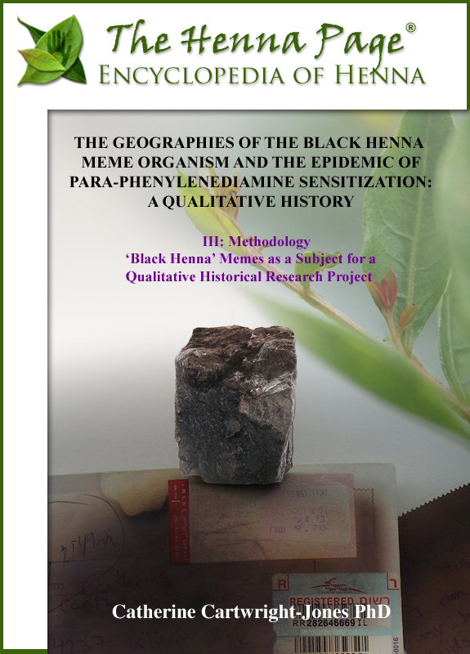

CHAPTER III: METHODOLOGY
Methodology Part 1: ‘Black Henna’ Memes as a Subject for a Qualitative Historical Research Project
The methodologies of this paper are enlisted to construct the physical and discursive epidemiology of the ‘black henna’ temporary tattoo memes into a qualitative history. I will use the term ‘meme’ when I refer to a generalized cultural concept of henna and ‘black henna.’ I will use the term ‘meme organism’ when I refer to a specific form of a meme with its associated concepts, to focus on its evolution in a network environment, as does Coscia in his study on competition and success of a meme in a meme pool. I will look for the evolution and variants of meme organisms, the human actions, and the consequences produced by the meme organism and their variants, especially as they replicate and evolve in the third spaces of tourism.
Coscia’s approach to meme organisms, and the attributes that allow memes to compete or conflict with other memes in a network environment, is useful in this study because, in different environments, people have very different concepts of what henna is and is not. Henna and ‘black henna’ memes have evolving attributes that facilitate or inhibit their success as replicators as they evolve in their network environments. Their network environments co-evolve, adjusting to these evolving meme organisms. In chapters four and five, I will track the differential evolution of henna meme organisms through their different network environments and demonstrate the conflict this evolution has created.
The black henna meme organism replicated online through the network environments of virtual and physical spaces from the 1970s to the present. These meme organisms reproduced and evolved through observation, description, images, products, and sometimes through misinformation and misunderstanding in their environments. Because these memes inhabit human minds and the artifacts of human minds, and because minds and their artifacts have geographic locations, the human minds and artifacts hosting memes can be located and memetic geographies can be described. Through mappings and discourse analyses of online references to ‘black henna’ temporary tattoos, it should be possible to trace the epidemiology of the ‘black henna’ material practice and consequences to the extent that online activities simultaneously represent and reproduce the material world.
The henna meme organism and its variants have different expressions within different environments, so the lack of a definable unit may be unsettling in the normal framework of analysis. The use of the word ‘organism’ may seem to some to be objectionably anthropomorphic, but, as Coscia shows, memes behave as organisms in that they are replicators that compete, cooperate, evolve, or become stable in environments of understandings. The attributes of a meme organism vary and add to the success or failure of memetic replication within an environment. When a meme organism co-evolves in its network environment and becomes stable, with stable attributes, that meme becomes an element of knowledge within that environment and is regarded as a fact or truth.
Dawkins’s original definition of a meme is ‘that which is imitated,’ or that information which is copied from one person to another, and that which is imitated may be simple and finite or complex and disperse. Memetics is frequently used to model mathematical algorithms in network theory, and researchers have successfully extended memetics as a research method in a wide range of social and cultural research topics such as cults, popular culture, folklore, economic activity, public policy, suicide, urban legends, and public health. This project will not use mathematical algorithms because the World Wide Web archive is inherently ephemeral, and, in the fifteen years of tracking the black henna meme online, much of the data that would be necessary to trace the algorithmic progression of the black henna meme, as done by Coscia’s memetic research, has been lost to link rot, overwriting, and site abandonment.
Floatingsheep.org’s methods of mapping and charting user-generated geocoded data would be ideal for mapping the black henna meme tweeted in real time from summer beaches, but that would limit mapping to a single summer and to an area where prolific tweets could be monitored. Much of the older online material on ‘black henna’ is no longer supported, was not cached, and has been deleted from servers. The early webpages of ‘black henna’ were not geocoded; location often must be inferred. This work, spanning online material on ‘black henna’ from 1997 to 2013 is constructed within the limitations of the material available, approaching the chronological and geographic replication and evolution of the memes through discourse analysis.

Web Memetics
More than any previous medium, the Internet has the capabilities to disperse memes globally, spreading them virally them through networks where they can be accessed and replicate into new minds. Schifman and Thelwall’s “Assessing Global Diffusion with Web Memetics: The Spread and Evolution of a Popular Joke” introduced their Internet-based general method, Web Memetics, of analyzing the distribution and evolution of memes in time and space. I will use their approach to form part of the methodology, as this technique allows the memes to be mapped and charted to show the replication, dispersion, evolution, variation, and effects of the black henna meme organism through different flows using methods adapted from Zook, Paull, Schifman and Thelwall. I will use Coscia’s theories of co-evolution of memes in the environments of networks to show how henna memes diverged, evolved, and were contested at boundaries of understandings. I will combine these methods of meme mapping with qualitative discourse analysis, using the web pages retrieved through Web Memetics as the historical archive.

Memes and Cultural Geography
Cultural Geography often concerns itself with the effects of the movement of beliefs, goods, and social practices through time and place, and the adjustments that occur in globalization or migration, of culture. Studies in cultural geographies have often been constructed through interviews, diaries, observation, sampling, surveying, and group discussions. Virtual observations of such processes can presently be done online. Viewing subjects online permits the observer to not intrude into the dynamic of the interactions and to view months and years of interactions, but it prevents the observer from asking questions. Cultural geography may be studied virtually as it can be in person, and, though there are differences in virtual cultural geography from traditional methods, the differences are manageable.
Memes are units of culture, so a cultural geographer may define the units of study as memes. If a meme is a unit of culture that can be located, replicated, and dispersed through repetition, then cultural geography, as a study of location and dispersion of culture, has a potential engagement with memetics. Zook maps such units of culture through scripts developed to locate and map through Google maps, Twitter hashtags, and tweets in short, well-defined time frames, demonstrating “that mappings of virtual representations of material practices are important tools for understanding how online activities simultaneously represent and reproduce the material world.”

Memes and Henna
Henna may be considered a meme as well as an artifact because a meme is a replicating communicative convention, practice, and cultural work transmitted from one individual to another by imitation. In this, it is similar to replication of memes through folklore and art.
Henna is a form of ceremonial body art, a cultural meme that has replicated vertically since the Bronze Age in North Africa, the Arabian Peninsula, the Middle East and South Asia. Henna body art was replicated through direct observation and imitation in family settings during significant social events such as Eids, weddings, circumcisions, and festivals. These were largely situated societies, and henna memes replicated vertically, in place, through children’s and adolescents’ prolonged cultural apprenticeship to their parents and others in their communities. These situated henna memes did not replicate far beyond the geographies of the people’s place, their migrations, and the growing zone of the henna plant. During periods of economic interaction between cultures with henna practices and those to the north, some information about henna passed in commercial goods, travelers’ reports, paintings and books. In the late 1990’s the henna meme began to globalize horizontally, first through periodical news and educational publications, then through motion pictures, the Internet, and other rapidly dispersing media.

Globalization of the Henna Memes
Online, henna memes replicated rapidly, but without the ‘placed’ cultural context and direct observation characteristic of vertical transmission. The black henna meme also replicated online, spawned from the misconception that there was such a thing as ‘black henna’ and the conflation of tattoo and henna body art. The first task of this project is identifying the origins of the black henna meme prior to 1980 and tracking its media presence chronologically and spatially from the first indications PPD was being used to create body art to its recognition as a global public health problem 2010. Memes may be either detrimental or beneficial to the people whom they inhabit; both dangerous and useful ideas can, and do, proliferate. The harmfulness or harmlessness of a meme does not necessarily affect its ability to replicate from one person to the next. In the case of ‘black henna,’ the global reproduction of the meme can be tracked also by the injuries it causes.

Approaching the World Wide Web As an Archive
Though one branch of academic memetics study is based in mathematical analysis of networks, I will approach the memetics of ‘black henna’ through methods more commonly used in cultural geography: qualitative and quantitative analysis of an archive, following the recommendations for assessing evidence in historical geography in Michael Roche’s article, “Historical Research and Archival Sources.” The web can be used as an archive for qualitative research in cultural geography, as easily diaries, rutters, newspapers, broadcasts, and magazines. The searching is somewhat simpler, through online search engines, which allow vast numbers of webpages to be searched and displayed. The web archive is ephemeral, and webpages may be overwritten or be abandoned, but rutters, newspapers, broadcasts and diaries are ephemeral as well. Roche’s list of challenges is not dissimilar in physical and virtual materials: some documents online and in archives are legible and some are not. Some are retrievable and some are not. Some have a high level of veracity and authority and some are spurious and trivial. I used “The Historian’s Standard Questions of Documents” presented by Roche as part of qualitative webpage analysis:
- “What was the writer’s bias?
- What was the writer’s situation and intention at the time of writing?
- What were the writer’s opportunities for knowledge?
- What were the writer’s general standards of truthfulness?
- What powers of critical observation did the writer usually bring to bear (was the writer credulous?)
- What was the writer’s framework of ideas and what did certain words mean when used by the writer.”
The web has similar structural and preservation problems as other archives. Some information is facilitated and some is hindered by bandwidth, alphabet, and script. Some webpages are preserved and some are lost through accidental server crashes or abandonment. There are formal and informal fields of discourse and positionality to be taken into consideration. I will use qualitative analysis to approach these problems in many aspects of this paper; qualitative analysis is an applicable approach when the researcher cannot present the archive as necessarily complete or representative.
I believe the World Wide Web is a suitable place to trace the memetic spread of ‘black henna’ for several reasons. The global proliferation of the black henna meme in 1997 coincided with a period of rapid proliferation of personal computers connecting to the World Wide Web, so the replication of the meme is preserved in online archives. Because henna body art largely is practiced in the seasonal informal economic sector, very few records of this period remain other than web pages archived on the Internet. Little formal attention was paid to henna: a few popular ‘how to’ books were published following the popularization of henna in 1998, and a single academic paper, “Henna and Hip Hop: The Politics of Cultural Production and the Work of Cultural Studies” was written. Henna body art was widely dispersed, though the performance was dilute: English-speaking artists often commented that they are the only person in their area doing henna. The World Wide Web is a very deep archive, but it can be easily searched through search engines for relevant material, so sparse, disperse evidence is not an impediment to study. Henna body art is also ephemeral: the stain is exfoliated from the skin in less than one month. Unlike physical objects, infrastructures, or other more permanent media, there is no physical evidence left to study years after the moment henna body art is created. Ephemeral cultural arts such as historical dance and ancient music are notoriously difficult to research, but such can be reconstructed through secondary evidence. Web pages of online conversations, pronouncements, and images of henna body art remain live for years and can be retrieved for study. In this regard, henna information is more accessible than one might expect.

The Challenges of Archival Research on the World Wide Web
There are benefits and challenges to using the World Wide Web to research the black henna meme. One benefit is that the online utterances on henna are retrievable and the collection does not require notepads, recorders, or travel. Viewing a document does not alter the content. Interviewers may alter the interview by their presence. However, unlike personal interviews, it is not possible to set up a systematic body of questions, or even ask questions of the author of the web page. Most pages are static, and interactive pages are often quickly out of date, out of sight, or abandoned completely.
One of the challenges of collecting research material from the World Wide Web for any researcher is the overwhelming and rapidly growing number of web pages. On December 7, 2010, a Google search for www returned 19,490,000,000 responses, a rough number of pages live online. Fortunately, much of this volume can be managed by the techniques of Web Memetics though not all areas of the web of the can be searched. The Internet Wayback Machine, a collection of archived pages from as early as 1996, is not presently searchable. Facebook is only partially searchable in 2014 because many participants limit public access to their posts. The Deep Web and the Dark Web, areas of the web that are passworded, private, or unlinked and not part of the Surface Web, are not reachable by standard search engines, and were not part of this research project.

Identifying Returns with Reasonable Certainty
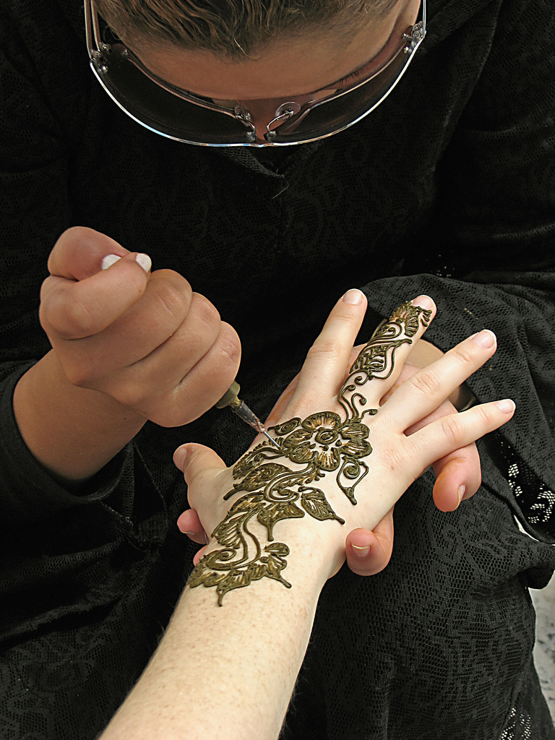
Henna paste is always some shade of green.

One problem for this research to overcome is to be able to recognize ‘black henna’ with a reasonable level of certainty from a description or photograph. I use my twenty years of experience as a henna artist to assist these determinations. ‘Black henna’ appears different from henna in appearance, application, method and results. When people describe their experience with temporary body art, they often mention something in terms of time, materials used, length of time that the paste is on the skin, the duration of stain, color of stain, the sensation of the paste on the skin, or the smell of the material, that indicates whether they are referring to henna or ‘black henna.’ When there is insufficient information to make a judgment of whether or not a particular incident involves henna or ‘black henna,’ I will exclude it from this study.
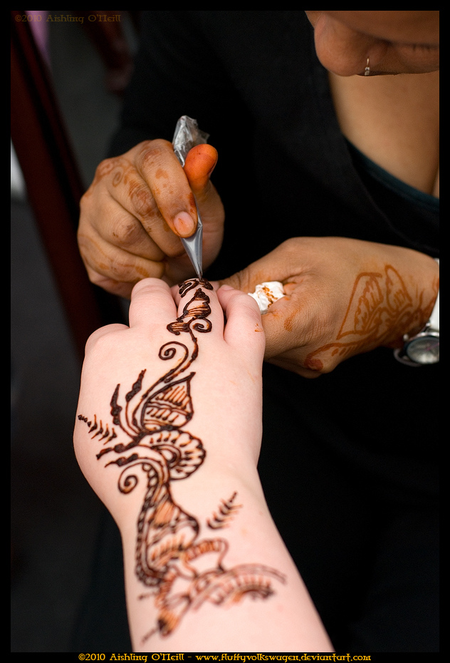
Henna often leaves orange stains on the artist’s hands.

Henna paste is always some shade of green, though the color in the photograph may be very dark green as it dries. Artists often have orange stains on their hands from working with henna. Henna paste frequently cracks when drying. When henna paste flakes off, the skin is stained orange. Henna stains are darker on palms and soles and lighter on arms, legs, and torsos. In text descriptions, the person may mention that the henna darkened over several days. When people describe the scent of henna, they may mention that it smells like herbs, or, if the artist has mixed petrol or paint thinner in the paste, they may mention that smell. People may mention that they were told to keep the henna paste on the skin for several hours. Many henna artists do something to seal the henna onto the skin, such as dabbing it with lemon-sugar.
A few people are allergic to lemon juice, lavender, tea tree oil, or other common components of henna paste, but the description of the itching is different. These additives usually cause sudden generalized itching and do not cause a hypersensitivity reaction with blistering in the precise area of the pattern.
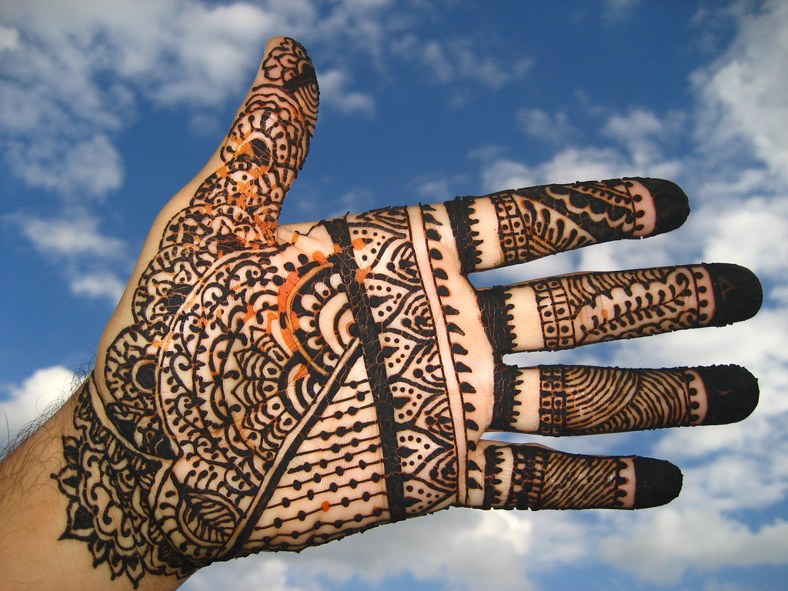
When natural henna paste flakes off, the skin is stained orange.
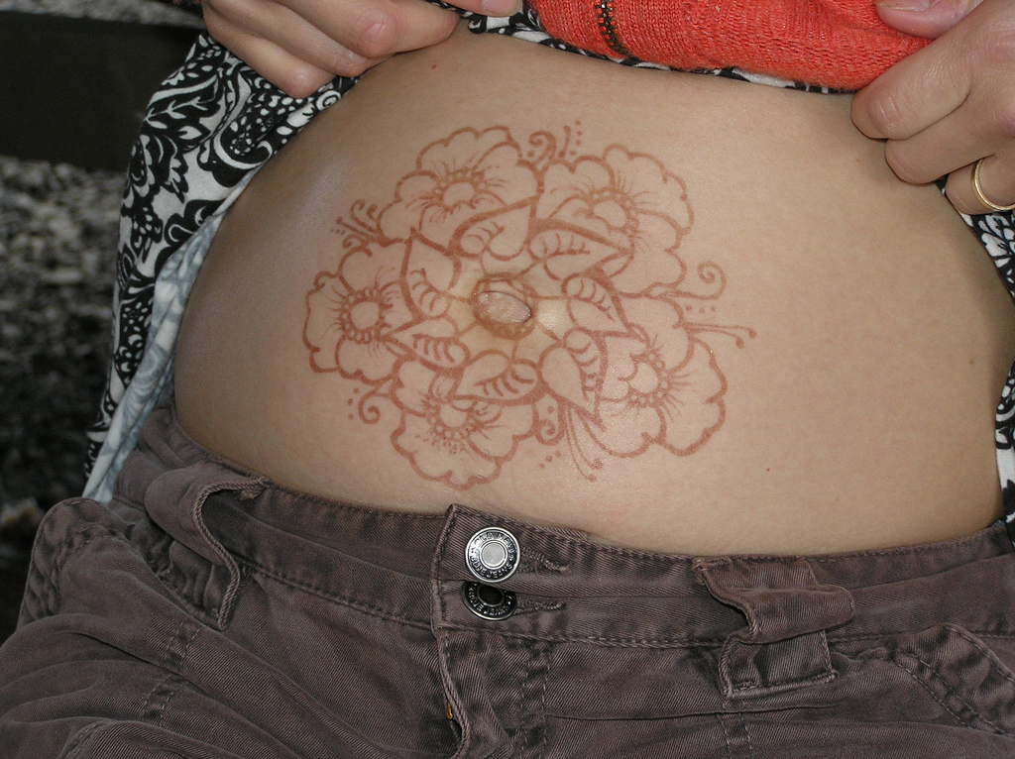
Natural henna will always stain the arms, legs, and torso some shade of orange to brown.

There are a number of characteristics in images and texts that indicate a temporary tattoo was made with PPD, not natural henna. ‘Black henna’ paste is always black. Artists often have black stains on their fingertips when they work with ‘black henna.’ When ‘black henna’ paste flakes off, the stains are black no matter where they are on the body. ‘Black henna’ paste usually does not have a scent. Artists do not seal ‘black henna’ to the skin with lemon sugar, nor do they advise people to keep the paste on ‘for as long as possible.’ The person may describe subsequent itching from ‘black henna,’ or the artist may mention that some clients experience allergic reactions.
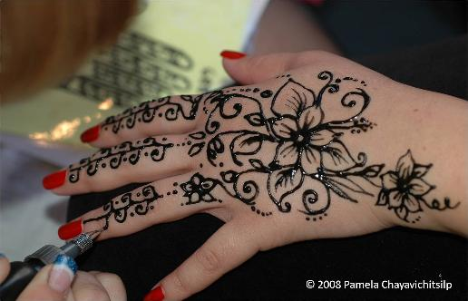
Black henna paste on skin is always black.

If the artist mixes the paste with peroxide, or wipes peroxide onto the skin after painting it, part of the activation of oxidative permanent hair dyes and the mixture may be assumed to contain PPD or a closely related chemical. Mixtures containing henna stone, Turkish stone, German stone, or Bigen or Piko contain PPD, so, if there is a mention of these being used in henna, one may conclude that the mixture contains PPD. If there is information accompanying the image that mentions that the stain is black, or that there is itching, blisters, and discomfort, the paste is almost certain to contain PPD.
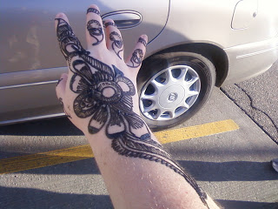
Black henna paste on skin.
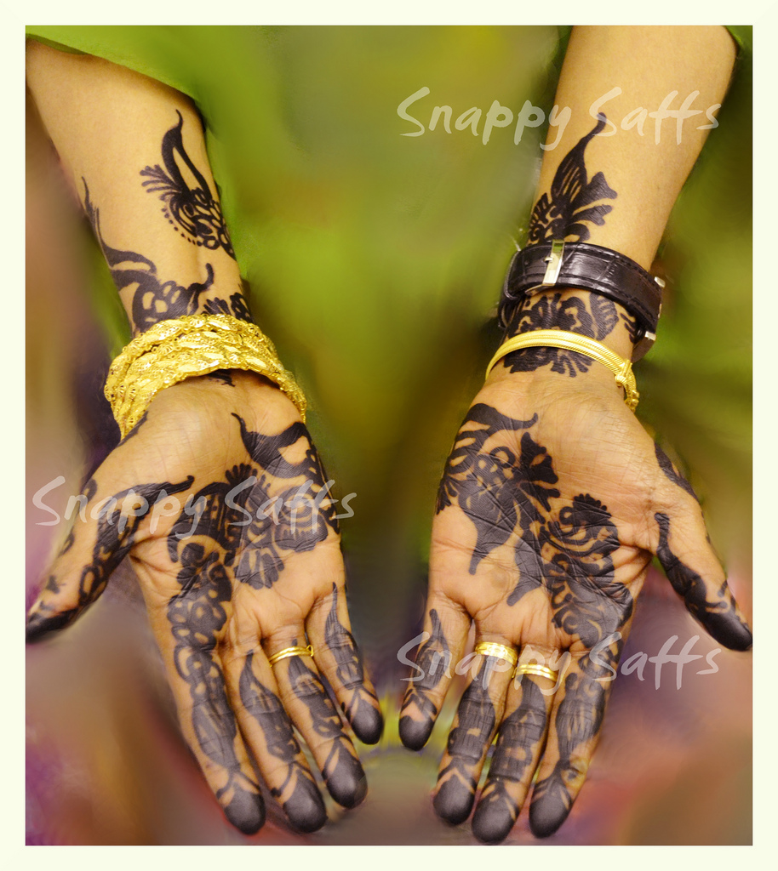
Snappy Saffs: Wedding Henna, black henna, showing the same black color on palms and wrists.
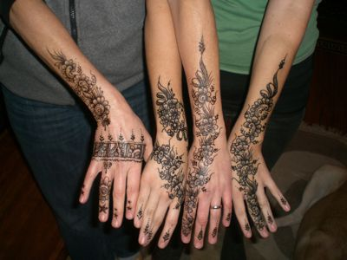
Black henna paste on skin, with a description of subsequent itching.
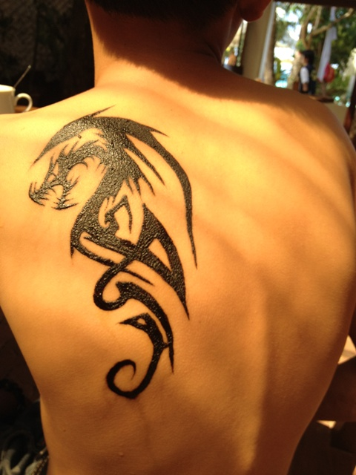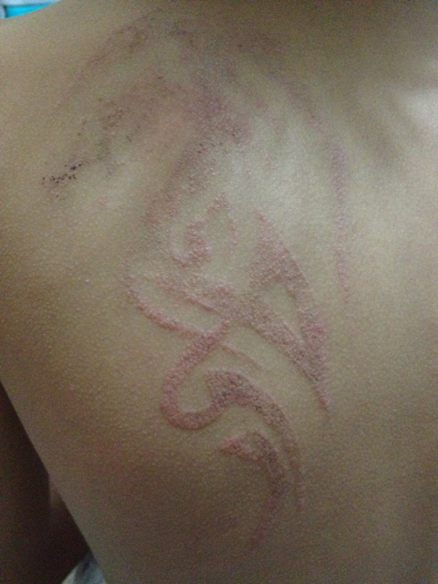
Before and after images of ‘black henna’ showing delayed hypersensitivity reaction of PPD painted on skin.
To demonstrate determination of ‘black henna’ in an area of tourism, the Figure X is a useful study, one of the images from one hundred eighty-eight returns on search of ‘Borocay henna’ on flickr.com. This image, by Doryll Medroso, posted on flickr.com was available in a larger size (1024 x 687 px), with enough detail to identify indicators of a PPD mix. The paste being applied to the client’s back is black. There are black stains on the artist’s finger.
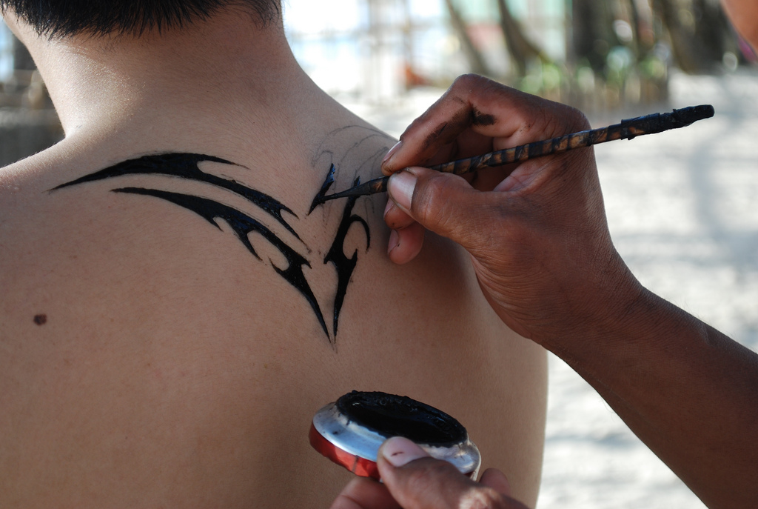
Doryll Medroso’s Henna in Borocay

If the artist is working with natural henna, the stains wil be orange. The pointed stick applicator is unusual for a henna artist, but not impossible. Because the stick is stained black, not orange or brown as would be the case if the artists were using natural henna, one may interpret the artist is using the stick to apply para-phenylenediamine instead of henna. The mixing cup often used for a PPD mixture; an artist mixes up a small amount of PPD with hydrogen peroxide to activate the oxidative dye. Natural henna would not be mixed in a small cup just before application; there would be insufficient time for dye release necessary to produce a dark stain. There is a smudged area on the client’s back that is black, not orange. I believe that these details indicate this body art is ‘black henna’ containing PPD, though the person has tagged the photo, “henna,” without further description.
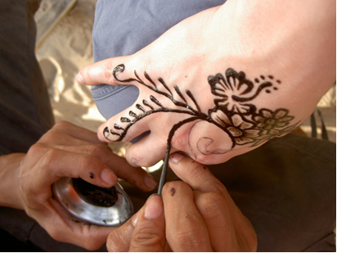
Figure 1: SuzyQuzy gets henna in Borocay

SuzyQuozy posted images of her Borocay ‘black henna’ on Flickr.com. The artist’s application method and stains on his hands were again consistent with the mixing and application of PPD and are not consistent with the mixing and application of henna. SuzyQuozy’s subsequent picture of a black stain on her hands when she removed the paste confirms that PPD was applied to her skin.

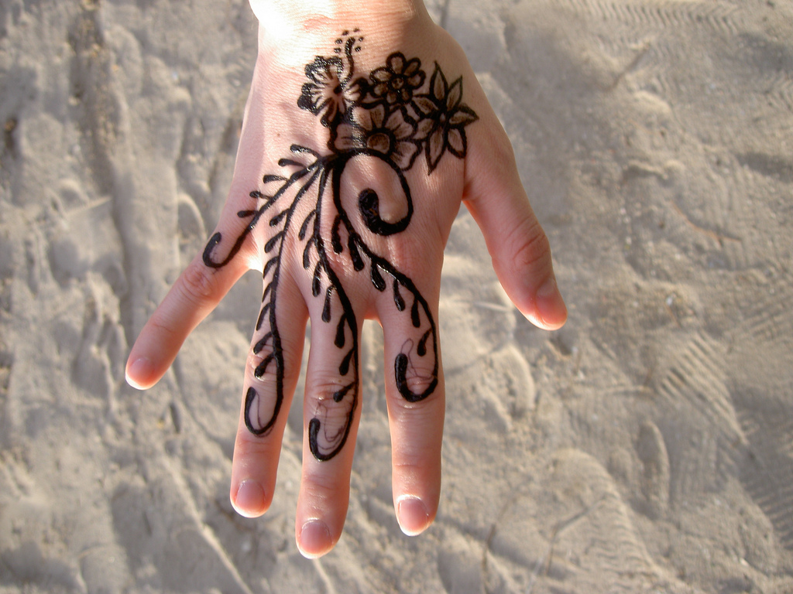
Figure 2: SuzyQuozy's henna in Borocay

On January 11, 2013, I entered the search terms of “henna” and “Philippines” into flicker.com, which produced one hundred forty-one returns. Of these returns, I counted images that appeared to be of or by tourists in vacation areas. I found four images of temporary tattoos that I could determine with reasonable certainty was of natural henna. There were twenty-one vacation images that seemed ‘probably’ to be ‘black henna,’ but there was not sufficient detail to be certain. There were seventy vacation images that had characteristics of body art made with PPD. The remaining images were mistagged, or otherwise had nothing to do with people on vacation getting temporary tattoos. Twenty-eight were tagged as being taken in Borocay. Four were in Cebu, three in Iloilo city, and the rest were on other beaches. The dates ranged between 2003 and 2012, with the images most uploaded in 2007, 2008, 2010, and 2011.
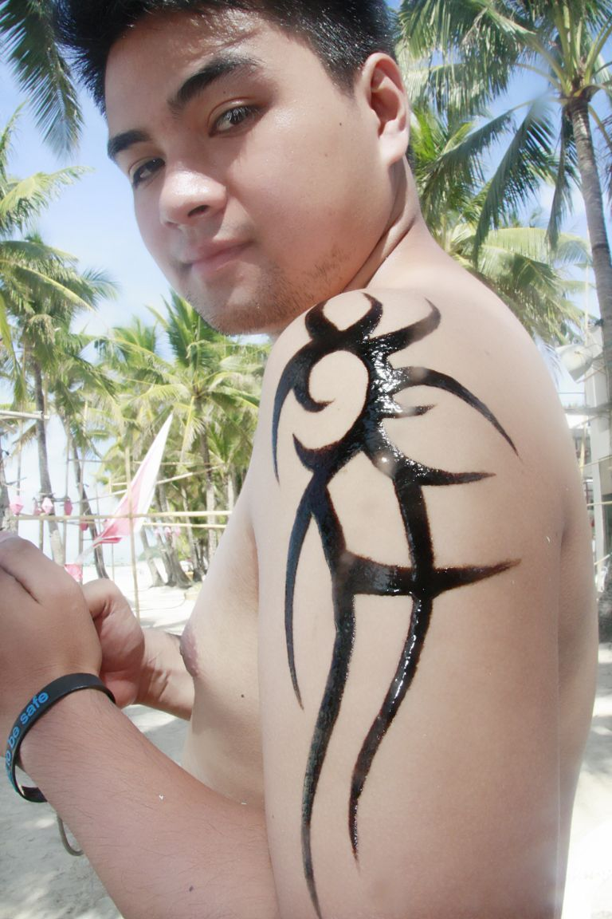
Temporary tattoo done on the beach in Borocay

Images separation from their context, uploaded, and tagged on flicker.com limits what can and cannot be done in terms of charting and mapping, as the random deposition of fossils limits what can be charted and mapped in paleontology. It is possible to demonstrate that people are being painted with PPD in a particular tourist venue at a particular place in time. It is possible to count these places year by year. By gradually assembling all of the mentions of ‘black henna’ in tourist locations, a series of maps can be constructed. Though limited by the inequality of people’s access to the Internet technology required to take and upload images, as well as people’s willingness to discuss their vacation and show off pictures online, these maps should mirror the epidemiology of black henna in tourism.

Navigating Around FUDD, Trolls, Sockpuppets, and Internet Jackholes
When the Internet was initially developed, trust and reciprocity among the users (a small closed academic community using ARPANET between UCLA and Stanford in 1969) could be assumed. The open network structures of TCP/IP (Transmission Control Protocol/Internet Protocol) were developed in the 1970s and DARPAnet migrated its hosts from NCP to TCP/IP in 1983. These protocols were based on the social construction that information “wants to be free” and that the assumption that people using the network could be trusted. The network architecture is a “dumb network,” which is to say, “all intelligence is in clients and servers, and the network itself does not need to know anything about the contents of the bits.” The dumb network allows misinformation to be transmitted as easily as information; inevitably, as the World Wide Web expanded, users who could not be trusted were included with those who could.
Untrustworthy information is an obstacle for any sort of research, from faulty measuring devices to prevaricating interviewees. Misinformation on the Internet is neither more nor less difficult to identify than misinformation in other forms. If there is a large enough body of information for comparison, misinformation will usually appear ‘odd,’ and ‘oddness’ is a cue to double check the source, whether it be from malfunctioning scientific instrument or a bored, rebellious adolescent posting under a pseudonym.
Various sorts of misinformants on the World Wide Web are popularly termed ‘FUDD’s (a person who posts to instigate Fear, Uncertainty, Doubt, and Disinformation), ‘trolls’ (a person who writes intentionally provocative, inflammatory, or off topic posts to elicit an emotional response in social threads), ‘sockpuppets’ (assuming a false identity to mislead others), and ‘Internet jackholes’ (people who find the combination of anonymity and audience an irresistible invitation to misbehavior and rudeness). These disinformants post in threaded discussions about henna and ‘black henna,’ but since their memes are simply a reaction against more dominant or credible memes, their veracity, or lack of it, is irrelevant. They are the adverse part of the discourse and have their own position within the discursive field, or memeplex. Discursive positions often rise from, and give rise to, conflicting or contentious positions. Given that much of this research project method is discursive analysis, the fact that many statements oppose other statements is not, in itself, problematic. Memes do not have to be factual or even useful to be prolific replicators, and this project deals with the replication and evolution of memes. Genuine misinformation on black henna can be crosschecked with published medical papers.
Methodology Part 2: Methods of Web Memetics
Security and Research
For this large online webpage search project, I installed a firewall, security and virus software on my research instrument. Malware can infect a computer from an apparently innocent webpage. I created a nearline file backup, in anticipation of a hard drive crash, so I could quickly and cleanly retrieve information. Offline backups are an advantage if backup and access cannot be kept secure locally or must be accessed from different location.
Managing Relevant Web Pages by Bookmarking and Tagging
I constructed searchable documents to manage the positive returns of the black henna meme and related research subjects. As searches returned URLs, I recorded each page, copied relevant texts and listed keywords to separate areas of probable meme environments, such as news periodicals, government publications, medical publications, and tourism boards. I separated personal pages from official pages to compare discourse between formal and informal pronouncements. I tagged gender and age when mentioned, so I could compare understandings of temporary tattoos and injuries on infants, adolescents, and adults for discourse about vulnerability, choice, and parental responsibility. I tagged pages for countries and cities when mentioned, such as Mexico, Spain, Zanzibar, and Key West, to compare for discursive elements of tourism, Orientalism, and perceived threat when abroad. I entered more than a thousand URLs into the research account, and an additional thousand sources from LexisNexis, online academic journals, and PubMed and tagged them methodically, adjusting as necessary.

Searching the Archive, Constructing the Database
My third task was to search for web pages. I followed Schifman and Thelwall’s first step in Web Memetics: “Gather as many URLs of pages mentioning the memes as possible, using a combination of search engine queries. This assesses the Web presence of the memes, and the URL list is used for subsequent analysis.” From 2003 to 2013, the dominant search engine has been Google, though running parallel searches in other Bing or Ask engines occasionally reveal other sites. Google handles directly or indirectly through purchased content, 83% of all online searches. I ran each search until returns were saturated and only reduntant pages followed.
A challenge for this project was to collect web pages that returned ‘black henna’ while avoiding semantic and search engine bias when possible, to organize the returns and avoid data overload, and keep up with the rapid growth and decay of websites. On December 7, 2010, a Google search of “black henna” returned the potential of 1,420,000 pages. On January 11, 2013, Google returned 2,210,000 pages for “black henna.” Each page of Google returns has ten URLs listed. The top-ranked pages had the most relevant content as determined by Google algorithms and the greatest linkage in the web. The search “black henna” had the largest number of returns, with a broad range of artist and vendor sites, news sites, information sites, plus government and scholarly papers. The higher-ranked pages have the most relevant content, according to Google algorithms, and have the deepest linkage through other web sites. The lower ranked pages have less relevant content and fewer linkages through the web. In the December 7, 2010, search for “black henna,” page 70 was the last one of the list, concluding with the statement “In order to show you the most relevant results, we have omitted some entries very similar to the 692 already displayed.” To find the remaining 1,419,308 sites and review their content, subtler, more targeted searches were necessary.
Any body of data must be kept to a manageable project size. Conveniently, Google search returns have the page title and about twenty of words of text with each return, so one can quickly eliminate false returns to reduce the number of URLs in the data body. For “black henna,” false returns would be “the girl in Henna Province in China wore black shoes,” any woman in Finland named “Henna” with some combination of the word “black,” or the concert tour schedule of a rock music group called “Black Henna.” I also passed over returns that were relevant but outside of this project, such as “black henna dye for hair.” I found it was possible to review about fifty Google search returns per hour, saving relevant pages, copying and pasting potentially useful text for further examination and tagging, passing over irrelevant material and obvious false returns.

Varying the Search Terms
I ran searches weekly, because I found that though the top one through five pages tended to remain constant, the returns in the deeper pages (pages ten through fifty of a search) varied week to week and month to month. I varied search terms frequently, beginning with general searches using the word pairs most frequently connected with’ black henna.’ “Black henna” by itself is productive but has many false returns, such as the afore-mentioned black hair dye, rock band, fingernail polish color, other fashion accessories called “black henna,” and random convergences of the separate words ‘black’ and ‘henna’. Some of the more productive search terms, based on characterizations of ‘black henna’ were:
- ‘Henna Stone’ is solid para-phenylenediamine used to create ‘black henna.’
- ‘Chemical henna’ refers to a mixture of PPD hair dye or non-polar solvents with henna powder to create ‘black henna.’
- ‘Henna allergy’ returns question/answer sites where people ask why they have an uncomfortable reaction to henna, with commentary following, often revealing a location and date for ‘black henna’ incident and black henna memes.
- ‘Henna itch’ returns question/answer sites where people ask why they have an uncomfortable reaction to henna, with commentary following, often revealing a location and date for ‘black henna’ incidents and black henna memes.
- ‘Mehndi allergy’ and ‘black mehndi’ returned material similar to the above, with ‘mehndi’ being the Hindi word for Henna.

I searched word pairs by country, place and activity and common words used in cultural blogs: these narrowed searches returned fewer but more relevant results that would not have been included in the top 1,000 returns in the more general searches. The choices of these pairs were based on news reports, medical papers, and personal communications I had received indicating ‘black henna’ activity. I did not include the word ‘black’ in many of these searches, because people often reported simply ‘henna’ and it is possible to make the determination of ‘black or ‘natural’ henna through context. In these searches, I hoped to find personal narratives of ‘black henna’ experience, to illuminate the geographic location, date, and black henna memes.
As an example, a Google search of “Henna Philippines” returned 1,150,000 pages on January 11, 2013, the most relevant to the search being in the top five pages. This directory returned 292 results, with the most relevant results placed at the top of the listings. One return was Sulit.com.ph, which had a business directory for henna artists in the Philippines. Many of the artists in this directory displayed ‘black henna’ work; others advertised face painting and other children’s party services. Several Youtube videos were returned in the search. These were created by both artists and patrons having ‘black henna’ on the beaches in the Philippines. Six blog reports returned describing ‘black henna’ allergic reactions. In these, the writers narrated their own injuries, or a parent narrated their children’s injuries. The individual narratives of producing and consuming ‘black henna’ were useful for determining the evolution and variants of henna memes, and the understandings of trust and the ‘dangerous other’ in the third zone of tourism.
Narrowing the search to tourist destinations in the Philippines, on January 11, 2013, a search for “Puerto Galera henna” returned a site stating, “You cannot claim that you have been to Puerto Galera if you have not gotten a Henna Tattoo.” A Google image search of ‘Puerto Galera henna’ returned forty images of identifiably black henna and ten images of identifiably natural henna on people, all of whom appeared to be on vacation.
After broad searches for “black henna” in a country, I narrowed the search field by requesting specific resorts and beaches identified in the initial returns. The more specific searches were often more productive because the number of returns for a whole country contain a great deal of ‘noise’ or irrelevant returns. From these returns, I could collect dates and locations to map the epidemiology of ‘black henna’ in third spaces of tourism, and the development of the discourses of ‘black henna.’ I proceeded methodically through tourist destinations:
- “Henna Bali,” and “Bali Tattoo” returned ‘black henna’ vendors, hotels where people can get ‘black henna tattoos in Bali, as well question/answer tourism sites where people asked where in Bali they can purchase a ‘black henna’ tattoo. The discussion scripts included posts for people’s reasons for preferring ‘black henna,’ or, if they had an uncomfortable reaction to a ‘black henna’ tattoo, a description of the event. The commentary often revealed locations and dates for black henna incident as well as black henna memes from both consumer and provider perspectives.
- “Henna Egypt,” with variants of Morocco, Kenya, Tunisia, Zanzibar and other frequently visited African tourist countries returned hotel and vacation package promotions that included ‘black henna’ artists, photographs of ‘black henna’ tattoos. In the returns of tourist visits to these areas, people described the incident, evidencing the black henna memes of a tourist encounter with a cultural experience in a distant country, and, in some instances, their feelings about the injuries that followed.
- “Henna Mexico,” with variants of popular tourist destinations return in Mexico, returned cruise, hotel, and vacation package promotions that included ‘black henna’ artists, photographs of ‘black henna’ tattoos. In the returns of tourist visits to these areas, people described the incident, evidencing the black henna memes of tourist encounters, expectations of safety in package tours, and in some instances, their feelings about the injuries that followed.
- “Henna Florida,” with variants ‘Key West’, ‘Panama City’, and ‘Spring Break’ returned news articles on injuries, the prevalence of ‘black henna’ in seasonal shops, and vacationers’ blogs with photographs of body art, some of which included discussions of subsequent injuries. These also return Florida Department of Environmental Health official warnings about ‘black henna.’ Key West was a location of some of the earliest use of ‘black henna’ in USA, so early returns from Key West evidenced some of the early formations of black henna memes.
- “Henna North Carolina,” with variants of other coastal states in the USA hosting tourist beaches returned news articles on injuries, natural henna artists objecting to the use of ‘black henna’ in seasonal shops, ‘black henna’ artists claiming the right to freedom of expression and choice through ‘black henna,’ legislation on henna in the states. The returns included vacationers’ blogs with photographs of ‘black henna’ body art, some of which included preference for ‘black henna’ and others including discussions of subsequent injuries.
- “Henna Goa,” with variants Taj Mahal, and other popular South Asian tourist destinations often return narratives of first-hand encounters with itinerant henna artists. The English-language western tourists’ narratives included orientalist black henna memes, and if there was an injury resulting, this was often be narrated in a discourse of vulnerability and blame.
- “Somali henna” and “Sudanese henna” have very complex returns at the time of this research, because they include narratives of preferring and defending PPD ‘black henna’ use among ethnic Somali and Sudanese henna artists, in Somalia and Sudan as well as migrant communities such as the Twin Cities, Portland, and San Diego. This area includes an increasing social and legal conflict over ‘black henna’ use in migrant communities and ethnic economic zones in the USA. There is a similar conflict with Francophone African migrants applying ‘black henna’ in Montreal, though their narratives largely fall outside of this English-language project.
- “Carnival Cruise henna” returns tourist forums where people asked how much henna tattoos cost on board and when the ships dock at tourist ports. They also narrate frustration when they have allergic reactions from ‘black henna,’ and feel that their sense of safety on the cruise line has been betrayed.
- “Black Henna Craigslist” returned vendors selling ‘black henna’ products in the USA and some threaded discussions from clients. These discussions evidence the memes of desire for, warnings about, and defense of ‘black henna’ within the US informal economy. “Black Henna Ebay” returns similar pages of people selling ‘black henna.’ The ‘black henna’ sellers on Ebay praise and defend their products, and evidence the countries of production.
- “Black Temporary tattoo” returned galleries of temporary body art. These galleries often included the place of the gallery, date the art was created, and discussions among the artist, the clients, and people who argued against ‘black henna.’
- “Henna alaikum,” “henna insha’Allah”and “henna pbuh” returned posts from Muslima message boards with pictures of and commentary on ‘black henna.’ The message boards often had scripts to automatically include the date and location of commentary.
- “Black Henna Bollywood” and “mehndi black Bollowood” also returned posts from South Asian community message boards, with pictures of and commentary on ‘black henna.’ The message boards often had scripts to automatically include the date and location of commentary.
- “Henna black indo pak” and “Henna Pakistan” returned posts from vendors selling henna and black henna. These also returned Pakistani diaspora social network message boards, with pictures of and commentary on ‘black henna.’ The message boards often had scripts to automatically include the date and location of commentary.
- “Mehndi Desi” and “Henna ABCDesi” returned South Asian social networking boards serving American Indian women, where there were often discussions of US law and henna and the problems of chemicals in henna, ‘black henna,’ and the cultural contexts of ‘black henna.’

Varying the Search Products
Varying Google search products, such as Google Scholar, Google Groups, Google Image Search, Google Blog search, Google News Archive, and Google Web History yielded additional relevant urls that would not have reached the top of the search engines because the pages were not deeply linked in the World Wide Web. I used Google Alerts for several years to monitor henna and ‘black henna’ in the news. Google News carries black henna stories from online editions of newspapers around the world. News pages are often disabled after some months though I was able to retrieve older stories through Lexis Nexis. Bing did not seem to produce significantly different results from Google, nor did Yahoo, Ask, and AltaVista.
Google Blog search was the most useful product for finding personal narratives with black henna memes. Google Scholar yielded listings of published academic and medical articles with mentions of ‘black henna;’ most of these papers are usually old enough to have been released for free access, or, if recent, have only abstracts. The academic papers not available online were acessible through Kent State University electronic library journals and interlibrary loan. The formal and informal pronouncements of these different sources often carried contrasting black henna memes. Google Images returned 625,000 images of black henna on December 7, 2010.
I attempted thorough cross searching to mitigate Google rankings of the most accessed pages, but several kinds of pages are be missing from these searches. There may be information on ‘black henna’ in the Dark Web, deliberately private, passworded, or coded pages that are intentionally inaccessible. There may be information on black henna in obscure pages, with high privacy settings. Internet access is still unevenly distributed around the world, through infrastructure, culture, literacy, and language, so there is surely much information that I could not access. However, this work is based on the English language online memetic replication of black henna memes; memes that are inaccessible have little chance to replicate.
As a comparison to online resources and to recover material that had been abandoned, or occurred before there was a large consumer base of home computers, I searched Lexis/Nexis periodical news publications for mentions of henna. I also searched PubMed for medical papers on henna that influenced the discussion of henna online through people’s visits to their doctors and quotes in news articles.
Large Sites with Internal or Proprietary Search Engines
An internal search of YouTube for black henna (YouTube being a site where people can upload and share their videos, with commentary scripts) yielded videos of artists working in black henna and people who had been injured by it, followed by commentary, and people warning against black henna.
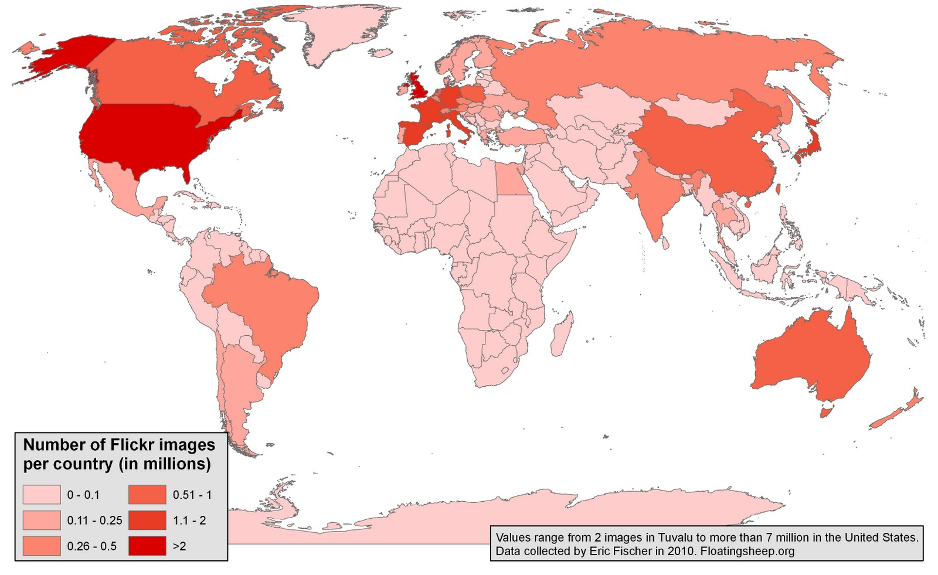
2010 map: a visualization of all 34 million geotagged Flickr images, showing their unequal distribution across the globe.
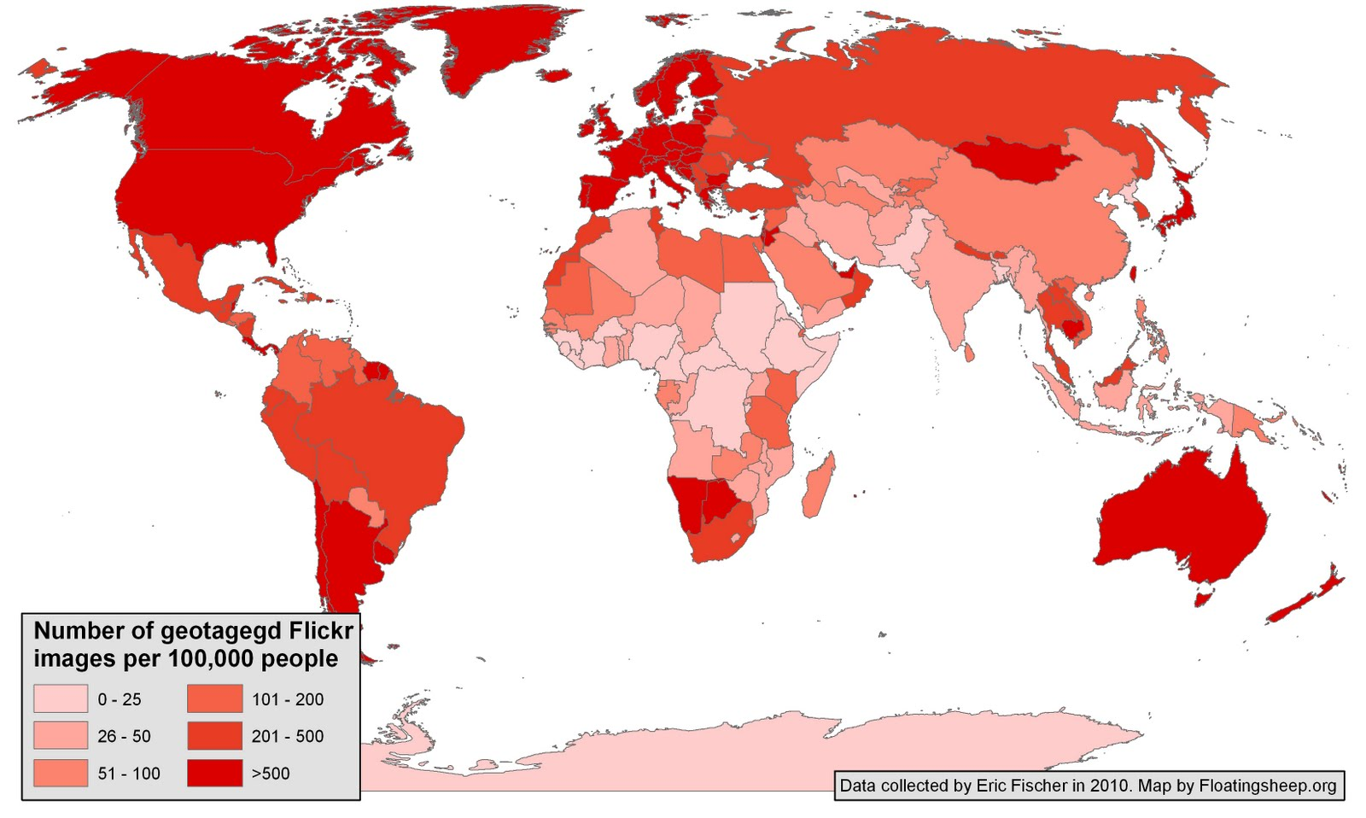
Geotagged Flickr Images per 100,000 people
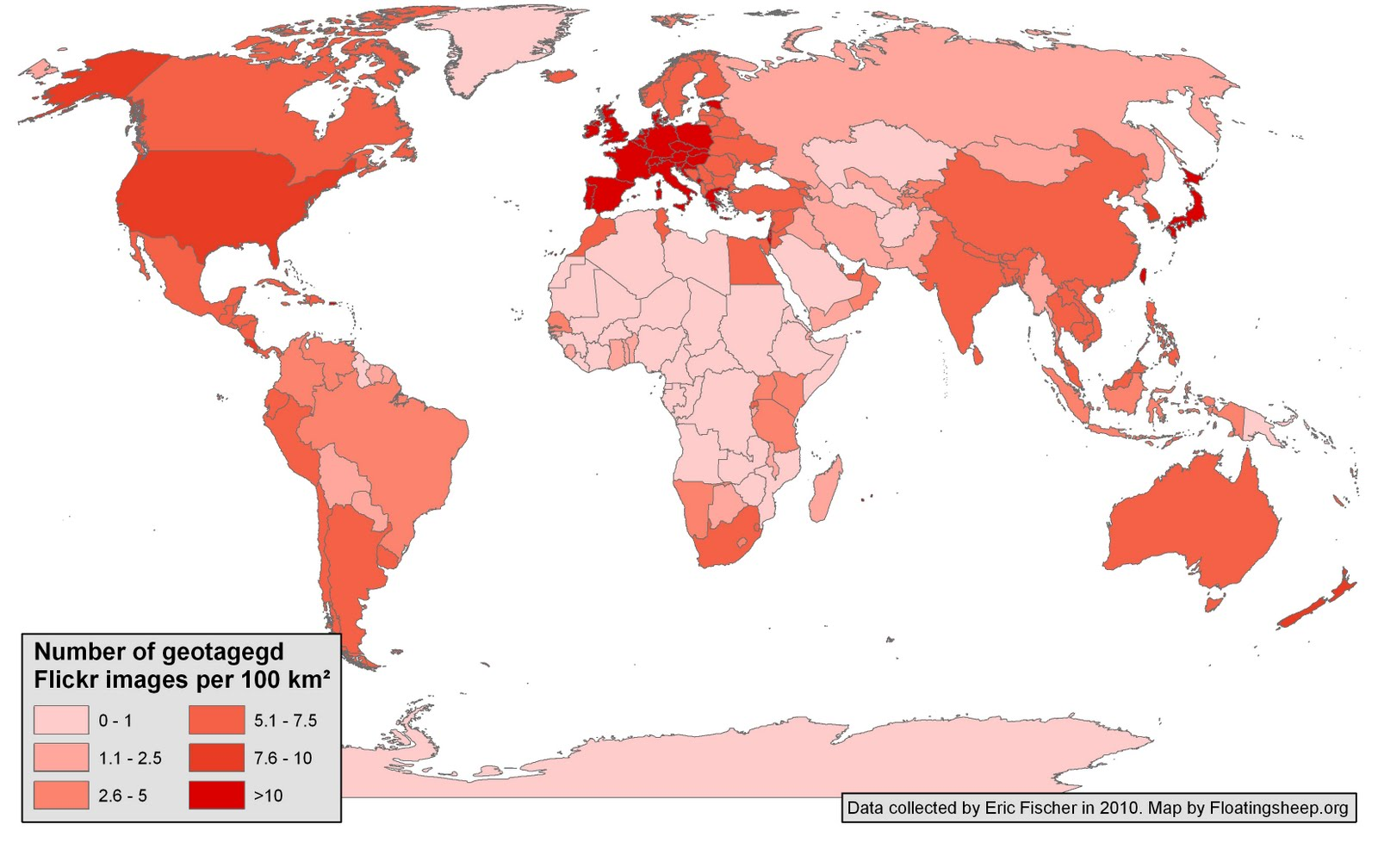
Number of Geotagged Flickr Images per 100 km.

The geographies of Flickr are very uneven, as shown in the following three maps from floatingsheep.org. Any attempt to interpret the results of black henna from a numerical count of flickr images would be misleading. There are areas of people who take a proportionately higher number of pictures than other areas. There are areas which people are inclined to photograph more than other areas. There are areas of black henna activity that are not, according to these maps, frequently photographed, such as Pakistan, the Arabian Peninsula, North Africa, and East Africa.
An internal search of Flickr (a social networking image site where people upload and share their pictures and commentary) for ‘henna’ is useful for finding images of black henna with date and location. As of January 13, 2013, there were 164,691 images tagged as henna within flickr.com. Flickr is a productive site for searching black henna in areas of tourism because people are inclined to take pictures as mementoes of their vacations. Many galleries are full of images from people’s travels that they have uploaded to share with their friends and families.
Even when adjusted for population and area, these maps show the unequal geographies of flickr, so it cannot be assumed that a count of returns on black henna would be a quantitatively accurate reflection of black henna incidence. If flickr returns 80 images of black henna on a beach in country A, and 20 in country B, there are not necessarily four times as many vendors applying black henna in country A than country B. There may simply have been more people who had flickr accounts, and who were keen to share their vacation experience in country A with their friends. It is possible to say that both countries A and B had vendors applying black henna to people in areas of tourism, not how many artists there were, nor how many customers they served. Based on the limitations of the information, mapping the occurrence of black henna in zones of tourism for this work will be a “some or none” map, not a choropleth map showing a progression or comparison among areas.
Some proprietary search engines, such as that used by lipstickpanda.com return relevant material that is not ranked on linkages, filling in some pages missed by Google algorithms. Bing did not seem to produce significantly different results from Google, nor did Yahoo, Ask, and AltaVista.
I continued searching variants and bookmarking until there were a total of 750 relevant URLS accumulated on Delicious, in addition to the printed pages from previous years of collection. There is no certain way to determine when data construction is complete, but if the searches have been randomized as above, and the base is as full as can be managed in a reasonable amount of time, trimming and tagging can begin.

Quantitative Tags: When, Where, and What, Place, Date, and Action
The time frame of this study, beginning in the 1900s, and focusing on the period following 1996, precludes the use of precisely timed and geotagged information, as used by FloatingSheep.org sI I created quantitative tags by hand for as many web pages as possible to construct a progressive epidemiological tree of the discussion of para-phenylenediamine black henna. I tagged the originating date of the page if it could be determined.
Forums, social media, periodical news publications, medical journal articles and blogs usually contain dates of posts and responses. These groups are particularly useful for identifying the evolution of meme organisms within network environments, making it possible to see the organisms’ different attributes that are cooperating or conflicting and which contribute to the success or failure of the meme organisms to replicate in their different environments.
Some scripts noted geographic location, others implied location, in others, location was entirely absent. When I could, I tagged the location of the page based on Top Level Domains, TLDs, language or other identifiers of origin if I could make the determination with reasonable certainty. A URL ending in .uk generally indicates that the url is based in England, and .eu indicates that the page is based in the European Union, though that is not always proof of origin. A person can purchase a URL from a cheaper host with broader copyright permissions, such as .ru, whether or not they are actually in Russia. TLD is an indication but not proof of an origin. I relied more on text references to place names, contact phone number area codes or postal contact addresses when they are included in the website.
I tagged pages when I could determine black henna economic activity, such as ‘black henna’ production, ‘black henna’ product sales, or ‘black henna’ application. When I was able to find web pages with ‘black henna’ economic activity with location and date, I tagged them to construct a chart of the geographic spread black henna memes. In some web pages there was further information about the venue, such as mention of a shop, salon, hotel, mall kiosk, beachfront table, fair, private appointment, boardwalk, or festival booth. I used this quantitative information on black henna to construct the activity of black henna within formal and informal economies.

Tags for Blended Quantitative and Quantitative Analysis: Who and How, Culture and Place
I noted whether pages were static or interactive. Static pages present the page author’s meme organisms and broadcast them to anonymous viewers. In interactive pages, viewers post and respond, often evidencing cooperating or conflicting meme organisms; these qualitative tags led to potential for discourse analysis and viewing memetic evolution. Establishing the ethnic/religious/cultural affiliation of the author of the page or post is complex and subjective but crucial in discourse analysis and analyzing the meme organisms and network environment. After rough tagging of social self-identified groups, such as tags for “Muslima” (a female adherent of Islam), “Desi” (a person born in South Asia, often in diaspora), “ABC Desi” (American Born Confused Desi, presumed by Desi to be culturally conflicted), “US Anglo,” “Somali,” “Sudanese,” “Canadian Desi,” “Moroccan,” “UK Anglo” and more, to establish country of origin and ethnicity/religion affiliation; I tagged more subtle bridged and blended affiliations for tracking meme organisms (cultural ideas) replicating, evolving, or failing to replicate through network environments (social groups.) Cultural organization and tagging (the identification of network environments) was the most complex and nuanced part of this project, because a person may belong to several groups at once and address more than one presumed audience in any given post and over a series of posts, and may have blended, conflicting, cooperating, and evolving meme organisms sequentially or all at once.

Authority, Authenticity, Formality, Informality, Gender and Age
I tagged the author’s position within scale of authority when I could determine their physical and social place with some certainty by Top Level Domain extension, overt cultural statement, or circumstantial evidence. The estimation of ‘voice’ included presumed platforms of authority (such as the extension of .gov or an educational institution, news organization or law firm) or informality (such as a blog), claims of experience (such as from a professional artists’ page) or newbie status (a novice on a forum), assumption of authority or authenticity based on the cultural background of speaker, and pronouncements framed in the authenticity of culture context.
I tagged the gender and age of the subject or author when they were mentioned on the page. In some instances, I was able to track how gender and age elicited differing cultural memes for henna desirability, appropriateness, vulnerability, and culpability.

Intention, Pronouncement and Audience
I tagged the purpose of a page if such could be determined. Professional artists’ promotional pages, vendor pages, personal blogs, social network pages, information pages, and forums all have different purposes, which frame the motive and intended result of the page. Authors of pages or posts are influenced by the presumption of an audience and will code their pronouncements to the people to whom they believe may be addressing. In static web pages, the audience is anonymous. A vendor’s page created for the purpose of selling ‘black henna’ often replicate black henna meme organisms of desire for and defense of ‘black henna’ to encourage people to purchase the product. Artists’ pages built to promote their natural henna work often replicate black henna warning meme organisms to defend their own practices and engage trust from potential patrons.
Blogs, social networks, and forums contained opinions and first-person narratives that people felt an urge to share. The bloggers and group members described both positive and negative engagements with ‘black henna.’ I compared these pronouncements for replication, evolution, content and function of black henna memes organisms. In threaded discussions, the writers were often familiar with the readers, and coded their remarks based on the assumptions of shared (or contrasting) experience, cultural understanding or expertise.

Tagging Qualitative Personal Narratives of Events
Blogs, forums, and personal webpages contained personal narrations of the authors’ henna or ‘black henna’ experience. Some of these narratives contained the geographic location and date of the incident, and there was usually some reference to the culture affiliation, gender and age of the author. They often narrated the authors’ feelings prior to and after the event, framed in meme organisms of tourism, orientalism, cultural expectations, desire to connect with other people, desire to experience a novelty, or to be rebellious. The authors narrated henna and the experience in terms of their own memeplex, their comprehension of the event in their own cultural and experiential context. When there was an adverse reaction to the ‘black henna’ event, they expressed their feelings of vulnerability, betrayal, culpability, or self-blame. They often included a call to action based on their understanding of the event, such as ‘there should be a law,’ or ‘people should be warned.’ Many of the scripts allowed further commentary by other people reading the narrative. All of these features were rich sources of meme organisms acting and replicating within their network environments. Because the narratives had a place, time, cultural affiliation, gender and age, the black henna meme organisms could be tagged and potentially correlated with similarly tagged narratives in their social groups, their network environments.
I revised the tags regularly as nuances, discoveries, connections, and changes evolved during the research process. It was my experience that I rarely identified all potential tags in the first reading of a page and that regular re-readings were beneficial. I searched for geographic, chronological, gender, and culture tags. I followed Coscia’s work on meme organisms to discover which black henna meme organisms were succeeding or failing from cooperating, evolving, or conflicting in network environments. Reviewing and revising the tags was the most time consuming and sensitive process of the research, looking for black henna meme organisms and their differential replications and evolutions.
Paull (2009) suggests imaging memetic evolution through a temporal meme map, and offers steps to create one:

“Steps in Creating a Meme Map
- Identify the Meme Birth Event, Meme Developmental Events, and Meme Gestational Events of interest.
- Draw a figure-8 diagram (the skeleton/framework/scaffolding).
- Place the Meme Birth Event at the choke point.
- Populate the Meme Gestational Zone and the Meme Development Zone with Meme Events.
- The Meme Map will ultimately be a function of the choice of the meme and/or the Meme Birth Event.”
Chronological sorting within network environments revealed the originating field, gestation, and evolution of meme organisms over space and time. It was often possible to identify some origins, evolutions, and variations of memes as they competed within their environments. Schifman and Thelwal graphically displayed similar information as branched cluster analysis charts of semantic variants. These methods can show the progression of henna memes as an epidemiological tree through social, official, and geographic groups. In this work, the evolution of meme organisms shows the boundaries and conflicts of understandings of black henna between different social groups, or network environments.
Tagging semantic phrases and following meme organisms’ dispersion chronologically in formal pronouncements (news, government or medical articles) and comparing them with informal pronouncements (personal webpages, forums and blogs) show flows of meme organisms in networks, as well as cases in which replication was partial or resisted. The groupings of these tags also show the boundaries where black henna meme organisms replicate, where black henna meme organisms evolve, and where black henna meme organisms cooperate or conflict in network environments.
The chronological sequence of meme organism evolution showed how some memes might have been strongly broadcast from a single source, termed a meme fountain, describing the effect of meme replication through a popular, influential or widely imitated person. A graphic visualization of the epidemiological spread of a semantic phrase being replicated from one webpage to another could take the form of a branching or starburst pattern from a central source, and boundaries beyond which there was no replication. I found boundaries forming at the perimeters of language, social class, religious, cultural prejudices, and infrastructure barriers, but the material was too large and disperse for me to construct epidemiological tree charts with any certainty.
If all web pages created were still in existence, it might be possible to construct visualizations similar to Schifman and Thelwall’s meme graphs and Paull’s Meme Maps. It would be ideal to be able to map the origins and spread of black henna memes as they spread globally over seventeen years years, but the base material is too uneven and fragmented to claim a complete and accurate event sequence. If maps and charts can be constructed with the caveat that they represent information available and do not claim to be all possible incidences, I believe there is still much to be learned from visualizing black henna meme organisms chronologically and geographically. That which is still available should be roughly representative of the dimensions of ‘black henna’ memes online cultural and social network evolution, as an archaeological sort of correspondence.
I constructed diagrams of henna meme organisms and black henna meme organisms to illustrate how they replicated through different network environments, showing how their attributes differed as they evolved, and which attributes assisted or prevented replication. The memes evolved differently and at different rates in periodical news publications, medical papers, forums and blogs, law and policy. I compared the meme organisms in different network environments to visualize the flows and boundaries of their reproduction.
As the injuries from ‘black henna’ were reported when tourists returned to their donor countries, new evolutions of memes reproduced linked to meme organisms of parental responsibility, social duty, culpability, economic status, cultural and racial bias, as well as moral judgments. Black henna meme organisms evolved differently in each network environment. I compared these both by time and focus, as different perspectives on ‘black henna’ took separate though interlocking paths.
I was able to use Google trend searches to produce data graphics showing an annual pulse of inquiries about henna and ‘black henna,’ similar to those for beaches, and vacations. There appeared to be an annual memetic pulse or surging of the black henna meme, which mirrors and slightly follows the summer pulse (not the winter pulse) of vacation and beach queries. I adjusted the henna pulse by through “henna” + “tattoo” to filter out returns from Finnish women named Henna. The “henna” + “tattoo” query had the largest proportion of origination in the Philippines in March 2013. Google trend searches for the memetic pulses of “mehndi” showed a South Asian pulse to be distinctly different form the “henna tattoo” pulse, peaking each year at the Hindu holiday Diwali. Similarly, the pulse of “Eids + henna” had a very different pulse from “henna tattoo,” with a coupled pulse for the Muslim holidays “Eid al-Adha” and ‘Eid al-Fitr.” Google trend searches also produce choropleth maps of the regions originating the searches and CSV files with more comprehensive detail.
Newspaper articles, blogs, forums, and medical journal articles often mentioned the age and gender of the person who has a black henna temporary tattoo. It was also usually possible to determine the gender of the henna and black henna artists. I compared these, noting the meme organisms applied to and applied by those who created henna and black henna, and the age and gender of their clients, as well as attitudes towards the differing genders of both artist and client.
By sorting online memes from English language web pages, periodical publications, and medical journals, constructing maps, diagrams of meme organisms, charts and graphs, it was possible to visualize the birth, pulse, replication, and global evolution of English language black henna memes online, which should have some resemblance to the real world evolution in time and space of English language understandings of black henna.
Through analysis of web memetics and meme organisms evolving in network environments, I was able to identify social and geographic areas populated by differently evolved black henna meme organisms, and to predict areas where one may expect to find epidemics of PPD sensitization and allergy to chemical hair dye. This method of approaching cultural geography through online analysis of meme organisms in network environments may be useful for tracking and predicting the spread and effects of other movements of other rapidly globalizing and evolving memes organisms.

Methodology Part 3: Definitions and Diagrams
To aid clarity in this research, I offer some definitions of terminology that are similar to, but not identical to those of other memetic theorists, such as Blackmore, Schifman, Coscia, and Paull. I have created graphic visualizations that will appear in chapters four and five to assist in understanding the complexity of henna memes as they replicate, evolve, collaborate, and compete in network environments, and co-evolve with their network environments.
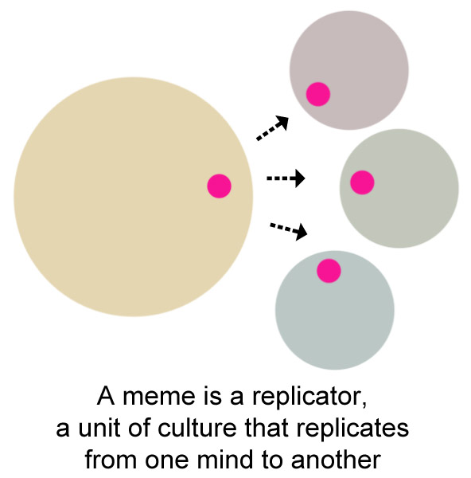
A meme.

A meme is a unit of culture that replicates from one mind to another. A meme may also replicate through representation of minds, such as books, photographs, and artifacts..
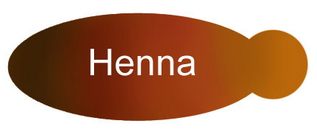
A meme may be a generalized, uncomplicated unit of culture.

In the case of henna the meme may simply meme signify a reddish brown dye from the henna plant that stains keratin.
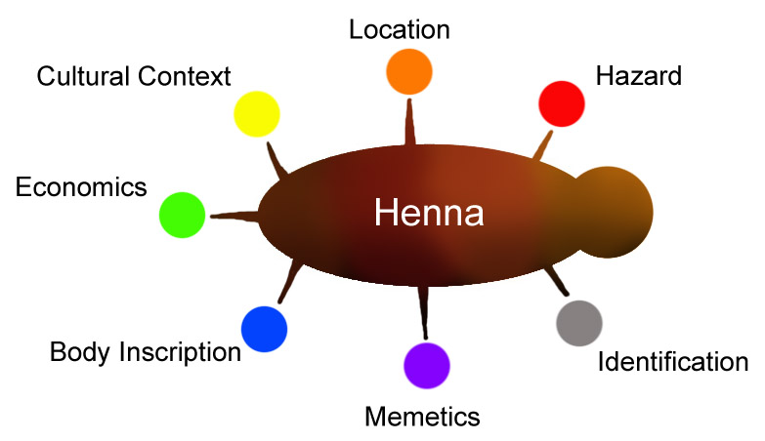
A meme organism is a meme with its attributes.

Meme organisms replicate more successfully than undifferentiated memes because their attributes make connections the other memes in a person’s mind, the memeplex. Meme organisms with different attributes may compete or collaborate with each other.
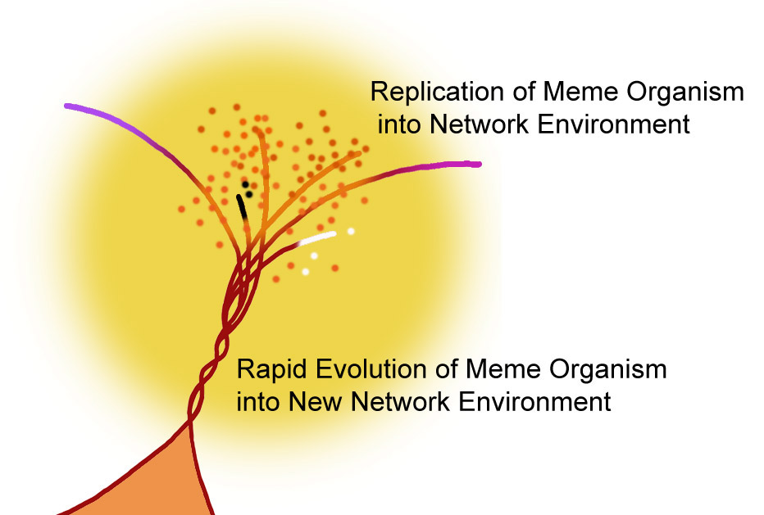
A meme may replicate and evolve rapidly as it enters a new mind or cultural group, a network environment.
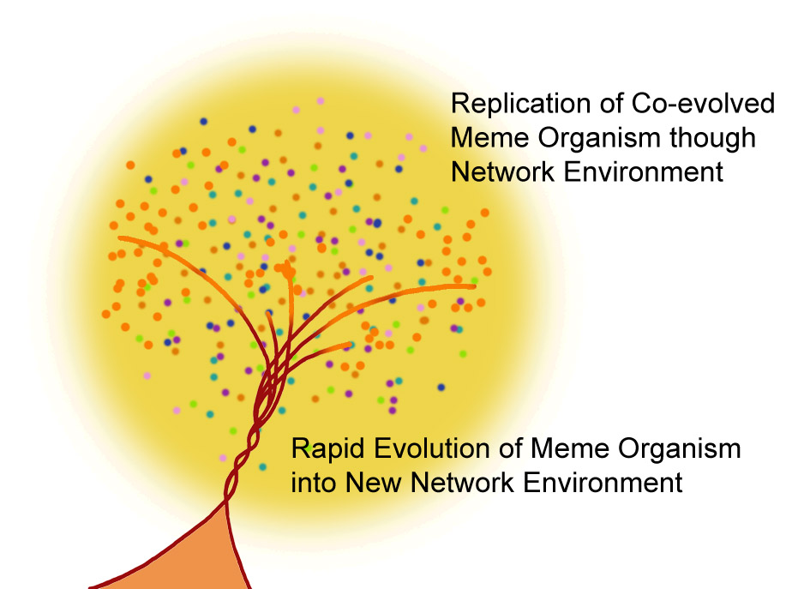
When the network environment, or cultural group, has co-evolved with the meme organism to the point that the entire network environment carries the same or similar version of a meme organism, that version is regarded by that cultural group as ‘truthy.’

When a meme organism replicates from one person to another, it most commonly replicates through that person’s social contacts through communication. This communicative group becomes the network environment of the meme organism. As this meme organism replicates, its attributes evolve, and there is a period of rapid evolution as it adapts to the new network environment. The new network environment, in turn, co-evolves with the new meme organism, because the network environment simultaneously produces and consumes the meme organism, the unit of culture. Some attributes may be rejected, other attributes may be transformed, and others remain. The most successfully evolved meme organism proliferates to the extent of its resource base, a group of people’s minds.
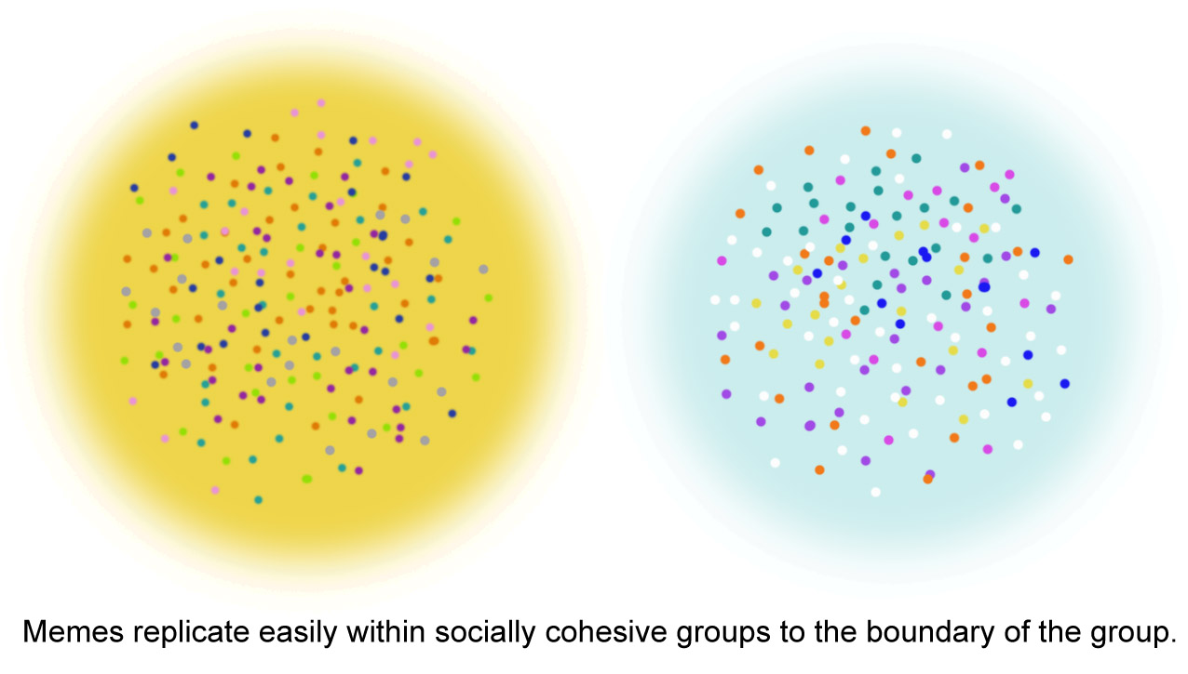
Different network environments contain differently evolved meme organisms, achieved by the same process. One network environment (cultural group) may view a meme organism differentially co-evolved in another network environment’s meme as ‘False.’

In chapter four, I will assemble memes from different network environments to examine the replication and evolution of henna meme organisms and the co-evolution of the network environment in producing differing and conflicting truths about ‘black henna.’

Coscia, M., 2013. “Competition and Success in the Meme Pool: a Case Study on Quickmeme.com” Association for the Advancement of Artificial Intelligence
Taylor, S., Zook,M., and Graham, M. 2012. "The Technology of Religion: Mapping Religious Cyberscapes." Professional Geographer 64, no. 4: 602-617. Academic Search Complete, EBSCOhost (accessed January 2, 2013).
Coscia, M., 2013. “Competition and Success in the Meme Pool: a Case Study on Quickmeme.com” Association for the Advancement of Artificial Intelligence
Blackmore, S. 2008. Susan Blackmore: Memes and "temes" Filmed Feb 2008 • Posted Jun 2008 • TED2008 http://www.ted.com/talks/susan_blackmore_on_memes_and_temes.html (accessed January 4, 2013)
Blute, M. 2005. Memetics and evolutionary social science. Journal of Memetics - Evolutionary Models of Information Transmission. 6
Schifman, L., Thelwal, M. 2009. Assessing global diffusion with Web memetics: The spread and evolution of a popular joke. Journal of the American Society for Information Science and Technology Volume 60, Issue 12, pages 2567–2576
Zipes, Jack. 2008. "What Makes a Repulsive Frog So Appealing: Memetics and Fairy Tales." Journal of Folklore Research 45, no. 2: 109-143. Academic Search Complete, EBSCOhost (accessed December 27, 2012).
Paull, John. 2009. "Meme Maps: A Tool for Configuring Memes in Time and Space." European Journal of Scientific Research 31, no. 1: 11-18. Academic Search Complete, EBSCOhost (accessed December 27, 2012).
Misturelli, F., and Heffernan, C. 2009. "Never the Twain Shall Meet: A Memetic Analysis of Poverty Perceptions." Development Policy Review 27, no. 2: 167-183. Academic Search Complete, EBSCOhost (accessed December 27, 2012).
Marsden, Paul. 2001. "Is Suicide Contagious? A Case Study in Applied Memetics." Journal of Memetics - Evolutionary Models Of Information Transmission 5, no. 1: N.Pag. Academic Search Complete, EBSCOhost (accessed December 27, 2012).
Health, C., Bell, C., and Sternberg, E. 2001. "Emotional Selection in Memes: The Case of Urban Legends." Journal of Personality & Social Psychology 81, no. 6: 1028-1041. Academic Search Complete, EBSCOhost (accessed December 27, 2012).
Schmidt, WP., Aunger, R., Coombes, Y., Maina, PM., Matiko, CN., Biran, A., and Curtis, V. 2009. "Determinants of handwashing practices in Kenya: the role of media exposure, poverty and infrastructure." Tropical Medicine & International Health 14, no. 12: 1534-1541. Academic Search Complete, EBSCOhost (accessed December 27, 2012).
Coscia, M., 2013. “Competition and Success in the Meme Pool: a Case Study on Quickmeme.com” Association for the Advancement of Artificial Intelligence
Floating Sheep. 2012. “FAQ.” Floatingsheep.org. http://www.floatingsheep.org/p/faq.html (accessed Janurary 2, 2013) “There is an increasing amount of data on the Internet that is geo-coded to a particular spot on the earth. This has huge implications for how we interact with our surroundings and each other. “This site is dedicated to mapping and analyzing user generated geocoded data. The results provide one glimpse of what internet users (in the aggregate) think about particular places. Where are people posting placemarks about swine flu? Which places are considered to be "fun" by the collective intelligence of the Internet users? “We view this new cloud of user generated data as cyberscape which provides an additional layer for human interaction. In addition to our five senses we can now access cyberscapes of information (see our visualization below) as a digital sixth sense. We can look around a physical corner and see what online information has been tied to that location. Since a large amount of this information is created by users we are no longer limited to the stale monotony (or security) of business directories or phonebooks. People can document their memories, feelings, biases and reactions to places and share them with the world. “But as these cyberscapes become crowded, the process of sorting the worthwhile from the mundane becomes ever more valuable. Thus, code (such as the Google search algorithm) enters as an actor which decides how to rank and order the cyberscapes we use. Some things are emphasized and others moved to the periphery. And through this process new places – digiplaces – are created in which we become aware of our physicality and the information about it in a simultaneous and mutually reinforcing way. “How can I make my own maps like these? “The short answer is that you can't. Or at least you can't unless you are willing to devote a lot of time and effort (as we have) to assemble the data. We're always looking for suggestions so please let us know what you'd like to see. “Who are you? The founders of this website are Dr. Matthew Zook (an Associate Professor at the University of Kentucky, USA) and Dr. Mark Graham (a Research Fellow at the Oxford Internet Institute, UK). We've been researching and publishing on this particular topic for more than four years.
Zook, M. A., and Graham, M. 2007. "Mapping DigiPlace: geocoded Internet data and the representation of place." Environment & Planning B: Planning & Design 34, no. 3: 466-482. Academic Search Complete, EBSCOhost (accessed January 2, 2013).
Schifman, L., Thelwal, M. 2009. Assessing global diffusion with Web memetics: The spread and evolution of a popular joke. Journal of the American Society for Information Science and Technology Volume 60, Issue 12, pages 2567–2576
Blackmore, S. 2000. The Meme Machine. Oxford: Oxford University Press, USA, page 43.
Schifman, L., Thelwal, M. 2009. “Assessing global diffusion with Web memetics: The spread and evolution of a popular joke.” Journal of the American Society for Information Science and Technology Volume 60, Issue 12, pages 2567–2576
Taylor, S., Zook, M., and Graham, M. 2012. "The Technology of Religion: Mapping Religious Cyberscapes." Professional Geographer 64, no. 4: 602-617. Academic Search Complete, EBSCOhost (accessed January 2, 2013).
Graham, Mark, and Matthew Zook. 2011. "Visualizing Global Cyberscapes: Mapping User-Generated Placemarks." Journal Of Urban Technology 18, no. 1: 115-132. Academic Search Complete, EBSCOhost (accessed January 7, 2013).
Paull, John. 2009. "Meme Maps: A Tool for Configuring Memes in Time and Space." European Journal Of Scientific Research 31, no. 1: 11-18. Academic Search Complete, EBSCOhost (accessed December 27, 2012).
Schifman, L., Thelwal, M. 2009. Assessing global diffusion with Web memetics: The spread and evolution of a popular joke. Journal of the American Society for Information Science and Technology Volume 60, Issue 12, pages 2567–2576
Coscia, M., 2013. “Competition and Success in the Meme Pool: a Case Study on Quickmeme.com” Association for the Advancement of Artificial Intelligence
Blackmore, S. 2000. The Meme Machine. Oxford: Oxford University Press, USA
Zook, Matthew A., and Mark Graham. 2007. "Mapping DigiPlace: geocoded Internet data and the representation of place." Environment & Planning B: Planning & Design 34, no. 3: 466-482. Academic Search Complete, EBSCOhost (accessed January 1, 2013).
Taylor, S., Zook, M., and Graham, M.. 2012. "The Technology of Religion: Mapping Religious Cyberscapes." Professional Geographer 64, no. 4: 602-617. Academic Search Complete, EBSCOhost (accessed January 1, 2013).
Kellerman, A. 2012. The Internet on Earth: A Geography of Information. Wiley. Page 3
Pimple, K. 1996. "The Meme-ing of Folklore." Journal of Folklore Research 33, no. 3: 236-240. Academic Search Complete, EBSCOhost (accessed January 1, 2013).
Tresilian, Nicholas. 2008. "The swarming of the memes." Technoetic Arts: A Journal of Speculative Research 6, no. 2: 115-126. Academic Search Complete, EBSCOhost (accessed January 1, 2013).
Aunger. R. Reprint edition.2010. The Electric Meme: A New Theory of How We Think. Free Press age 31
Blute, M. 2005. Memetics and evolutionary social science. Journal of Memetics - Evolutionary Models of Information Transmission, 6.
Centola, D. 2010. "The Spread of Behavior in an Online Social Network Experiment." Science 329, no. 5996: 1194-1197. Academic Search Complete, EBSCOhost (accessed January 1, 2013).
Roche, MM. (2010). Historical research and archival sources. In I. Hay (Ed.) Qualitative Research Methods in Human Geography. (pp. 173 - 190). New York, NY, United States: Oxford University Press
Maira, S. 2000 Henna and Hip Hop: The Politics of Cultural Production and the Work of Cultural Studies The Johns Hopkins University Press. Journal of Asian American Studies 3.3 (2000) 329-369
Internet Archive Wayback Machine. “Universal Access to all knowledge.” Archive.org. http://archive.org/web/web.php (accessed January 6, 2013) “Browse through over 150 billion web pages archived from 1996 to a few months ago. To start surfing the Wayback, type in the web address of a site or page where you would like to start, and press enter. Then select from the archived dates available. The resulting pages point to other archived pages at as close a date as possible. Keyword searching is not currently supported.”
Facebook. “Welcome to Facebook.” facebook.com. https://www.facebook.com/ (accessed January 6, 2013)
Asarraf, S. Uploaded to Shay’s Photostream September 25, 2008. Untitled. http://www.flickr.com/photos/shayassaraf/3062238354/ )(accessed January 6, 2013
Fluffy Volkswagen. Uploaded to Fluffyvolkswagen’s Photostream July 25, 2010. Henna Body Art. Dún Laoghaire, Ireland. http://www.flickr.com/photos/fluffyvolkswagen/4942473529/ (accessed January 6, 2013) My sister getting some Henna Body Art on her hand and arm!!! Got it done myself. So pretty!!! At the Festival of World Cultures this year :)
Alva, D. Uploaded to Danny Alva’s Photostream October 27, 2006. Henna. My hand. http://www.flickr.com/photos/dannyalva/293323432/ (accessed January 6, 2013)
Desdemona’s Designs. Uploaded February 26, 2005 to Desdemona’s Designs Photostream. Hawaiian Baby Belly. Design from my book "Aloha". 2007http://www.flickr.com/photos/desdemonasdesigns/2541630303/in/photostream/ (accessed January 7, 2013)
Forde. R. “Christmas Cookies, Stockings and Black Henna, Part 3.” Posted to Storytelling, exploring, and radical hospitality. December 29, 2011. http://rachelforde.blogspot.com/2011/12/christmas-cookies-stockings-and-black_29.html (accessed January 6, 2013) Christmas Cookies, Stockings and Black Henna, Part 3 “Day 3 was a bit different from the other days. We didn't visit anyone at home; instead, we all met late in the morning outside Suuqa Karmel, the largest of the 3 Somali malls in South Minneapolis. I got there first; even though it was December 18, it was almost 50 degrees outside, so I didn't mind standing out in the sun for a few minutes, reading my Kindle. “Suuqa Karmel was an old Midwest Machinery warehouse that was bought in 1997 by the...ahem...controversial Basim Sabri, a Palestinian immigrant who renovated the building along the lines of an indoor, Middle-Eastern marketplace. He divided the building into stalls, where local Somalis--mostly women--opened their small, start-up businesses selling everything from prayer rugs and hijabs to perfume, bed sheets and tea sets. There is a mosque on the upper level, and a branch of Franklin Bank, one of the local banks that caters to the Somali population by offering Shariah-compatible services. “We wandered around there for an hour and a half or so. Me and Sarah, another IV volunteer, stopped in at the Islamic Bookstore for some Somali grammar guides and dictionaries, and eventually, most of the group made their way over to stall #110, where I found five of us girls in line for henna. I hung back for a while; the tattoos were huge and only $5 apiece, a price that screams "hair dye in a tube." I'd seen pictures online of where people got henna tattoos using "black henna," which is not actual henna at all. These unlucky souls found out too late that they were allergic to the chemicals used in it, and erupted in painful rashes that left permanent (though lovely) paisley-shaped scars all over their feet and hands, but gosh darnit, the girl was so good at what she did that I was mesmerized. I went for it. She had me sign my name in a notebook and date it (for liability reasons, I guess), picked up her tube, and started work on my right hand. She was a genius. She had no pattern to work off of, but each one of us who got the tattoos got a unique design, and I'm pretty sure she was making it up as she went along. "You're not allergic, are you?" she asked. I looked at my hand. She was already halfway done; it seemed a little superfluous to ask. Then again, if I knew I was allergic and let her get this far, I'd deserve whatever flaming eruption I got. When she finished, a short five minutes later, I was free to go, and spent the next twenty minutes with my fingers spread out, letting the black paste air dry.
Mountain Mehndi. A Guide to Safe, Natural Body Art﻿﻿: PPD "Black Henna" http://www.mountainmehndi.com/a_guide_to_safe_henna_black_henna_warning (accessed January 6, 2013)
Top Cat. “Henna beats fingernails any day,” posted to blog January 19, 2009. We Bought a Sailboat. http://www.urbancats.com/?p=335 (accessed January 6, 2013) A girls night out and what fun it was. First we ate sambousas and drank mango and guava juice. I didn’t know you can get sambousas made from fish. Then we found the best henna person in the city to make designs for us. One of the aspects of Egyptian culture I enjoyed the most was the community of women. Sitting together in the henna shop at the Somali mall in Minneapolis felt a bit like a community of women. I’m a little worried that I may be allergic to black henna — my wrists and hands are itchy. That’s bad. But check out the cool designs. If you look closely you can see my red hands. I thought it was from the heater but now I’m not sure.
Yuuki. “Boracay Horror: Henna Tattoo,” posted to The Food, The Places, and the Bad Trips. April 22, 2012. http://www.foodplacebadtrips.com/boracay-horror-henna-tattoo/ (accessed January 6, 2013) “When in Boracay, you must try everything available and we just did that. One of the most available activity (can be seen in every nook and corner) is henna tattooing or if you want a permanent one. “But we just went for the henna tattoo. We went out quite early one of the days we were at Bora and looked for the open henna tattoo booth (at 7 am). We bargained at the price and got 100-150 pesos depending on the design. We are quite satisfied with the final outcome. “After a few days it became itchy with small rashes, but I just shrug it off. I had my henna tattoo on my whole right arm and since I’m medyo balbon so it’s not noticeable. “But lo after a week and it started to fade, the itchiness increased and so with the rashes. And the rashes followed the design of my henna tattoo. It looked hideous now. “I asked my nephew if his henna tattoo was gone and if he experienced the same. He had the same reaction and his rashes looked like a dragon. “I told this to another cousin, luckily she didn’t go for the henna tattoo because she was looking for the brown one. We had the black one and she said it was actually banned in Dubai. Why wasn’t I aware of that? “Now I want to know if you have the same experience as we have or our skin is just sensitive? “For now I can say, NO TO HENNA TATTOO IN BORACAY!
Forde. R. Posted to blog Thursday, December 29, 2011. Storytelling, exploring, and radical hospitality. http://rachelforde.blogspot.com/2011/12/christmas-cookies-stockings-and-black_29.html (accessed January 6, 2013)
Snappy Saff. Uploaded to Snappy Saff’s Photostream September 10, 2010. Wedding Henna. Black henna. http://www.flickr.com/photos/snappysaffs/6782975213/ (accessed January 6, 2013)
Top Cat. Posted to blog January 19, 2009. We Bought a Sailboat. Henna beats fingernails any day. http://www.urbancats.com/?p=335 (accessed January 6, 2013)
Yuuki. “Boracay Horror: Henna Tattoo,” posted to The Food, The Places, and the Bad Trips April 22, 2012. http://www.foodplacebadtrips.com/boracay-horror-henna-tattoo/ (accessed January 6, 2013)
Doryll Medroso. Henna. November 7, 2009. Doryll Medroso’s photostream. http://www.flickr.com/photos/doryllmedroso/4101774237/ (accessed January 7, 2013)
SuzyQuzy. Uploaded to SuzyQuzy’s Photostream album Borocay or Bust Novembrer 4 2009. http://www.flickr.com/photos/falkflicks/4099983566/in/photostream/ (accessed January 7, 2013) last day in boracay after a day of fun in the sun we get a massage and then we get a henna tattoo and see the sun set. it's our last night in boracay - the pen marks wash off but the henna stays on for a long time; as of today i'm so over my hand henna and am so ready for it to be all gone - LOL. what was completely normal in Boracay is completely abnormal here in conservative korea
SuzyQuzy. Last Day in Borocay. Borocay or Bust. SuzyQuzy’s photostream album. Uploaded to Flickr November 4 2009, http://www.flickr.com/photos/falkflicks/4099983566/in/photostream/ (accessed January 7, 2013) last day in boracay after a day of fun in the sun we get a massage and then we get a henna tattoo and see the sun set. it's our last night in boracay the pen marks wash off but the henna stays on for a long time; as of today i'm so over my hand henna and am so ready for it to be all gone - LOL. what was completely normal in Boracay is completely abnormal here in conservative korea
SuzyQuzy. Last Day in Borocay. November 4 2009, Borocay or Bust. SuzyQuzy’s Photostream album. http://www.flickr.com/photos/falkflicks/4099228295/in/photostream/ (accessed January 7, 2013)
SuzyQuzy. Uploaded to SuzyQuzy’s Photostream album Borocay or Bust Novembrer 4 2009. http://www.flickr.com/photos/falkflicks/4099228295/in/photostream/ (accessed January 7, 2013)
Joane. “Boracay Henna Tattoo. Happy Birthday Joel.” posted to TripAdvisor Slideshow. http://tripwow.tripadvisor.com/slideshow-photo/boracay-henna-tattoo-manila-philippines.html?sid=13386872&fid=upload_12949839423-tpfil02aw-14492 (accessed January 6, 2013).
Joane. Boracay Henna Tattoo uploaded to TripAdviser Slideshow. Happy Birthday Joel. http://tripwow.tripadvisor.com/slideshow-photo/boracay-henna-tattoo-manila-philippines.html?sid=13386872&fid=upload_12949839423-tpfil02aw-14492 (accessed January 6, 2013)
Borgman, C. 2007. Scholarship in the Digital Age: Information, Infrastructure, and the Internet. The MIT Press. Pages 3 - 4
ibid, page 5
Deleon. N. 2011. Report: Number Of Malware-Infected Web Sites Has Doubled In Past Year. TechCrunch. http://techcrunch.com/2011/03/08/report-number-of-malware-infected-web-sites-has-doubled-in-past-year/ “A new Dasient report says that the number of Web sites infected with malware has doubled in the past year. That means we’re now just short of 1.2 million Web sites out there infected with malware. Wonderful. “Big deal, you say. Some 1.2 million Web sites out of the entirety of the Web can’t be so bad, right? Well, that means that in about three months of Web surfing the average person now has a 95 percent chance of running into malware.
Schifman, L., Thelwal, M. 2009. Assessing global diffusion with Web memetics: The spread and evolution of a popular joke. Journal of the American Society for Information Science and Technology Volume 60, Issue 12, page 2569.
Sanjib K. Deka, Narendra Lahkar, (2010) "Performance evaluation and comparison of the five most used search engines in retrieving web resources", Online Information Review, Vol. 34 Iss: 5, pp.757 - 771
“Beware of Henna Tattoo Allergy,” posted to Anything Under the Sun. http://ingbieku.blogspot.com/2011/02/beware-of-henna-allergy.html (accessed January 11, 2013) “It was the summer of 2009 when we went to Boracay (a well known beach in the Philippines). There were a lot of activities for summer and the kids decided to get a henna tattoo. Since we knew that they are temporary, we did let them have one. One decided to have a tattoo with a 3 stars and a sun design. It actually represents the Philippine flag. “The two of them had a tattoo with the same artist. I washed the tattoo 1 hour after it was done as per the instruction given. After washing it.. it was noticeable that one got reddish and warm to touch. He also complained that it started to feel itchy. I knew that there was something wrong so I immediately went to a pharmacy to ask if there was something I can apply. They gave me a topical cream (with steroids) for the inflammation. “After 1 week the wounds started showing with fluid discharge. With the look of it, I was crying without him seeing because I was terrified. He met his dermatologist as soon as the wounds started to appear.
Puerto Galera Board: A Slice of Affordable Heaven. “Get a Henna Tattoo in Puerto Galera.” PuertoGaleraBoard.com. .http://www.puertogaleraboard.com/henna-tattoo.php (accessed January 11, 2013) Get a Henna Tattoo in Puerto Galera “Henna Tattoo is a favorite activity among backpackers to Puerto Galera. For those of you who are not too familiar, Henna Tattoo is the painless variation of skin art. With hip drawings on the skin minus the shooting pain of needle pierced on, Henna Tattoo became a top favorite among tourists. “If you want your own Henna Tattoo, you will not have a difficult time having them while you are on vacation at Puerto Galera. That is because the long strait of beach is coupled with Henna Tattoo stops where skin artists are just waiting to make that mark. Upon entry, you will be asked to choose your own design. If there is a line, which usually is the case during peak season, you will have to wait for your turn before your chosen design is inked to your skin. “When your turn finally comes, the artist will draw the design on the your preferred body part to have your tattoo on. That drawing will be his guide as he applies henna, a special ink that gets absorbed to the skin and rinses off after two weeks or so. When the application is done, you usually have to wait for a few minutes to dry off the ink and your are ready to go. That is, of course, after you have paid for your Henna Tattoo. “Having a Henna Tattoo does not only hurts less but also costs less. The price starts at 100, depending on how simple or elaborate your chosen design is. Then again, that amount may vary according to the season. If you visit Puerto Galera during the peak season, prices naturally goes high, including for Henna Tattoos. As it becomes in demand, tattoo artists decide to take advantage and earn more than they usually do. During the lean season, when a smaller crowd piles up to get Henna Tattoos, you can get yours at a bargain price. “Henna Tattoo shops are found all around in Puerto Galera islands. If you want the best value for your money, you could compare the offers on a number of shops and decide on the one you think is giving you the most for less. “And oh, take extra precaution on allergies. If you think your skin is too delicate and sensitive, opt for other forms of skin art, not Henna Tattoo. The ink could irritate your skin, leaving a mark of an ugly Puerto Galera experience. Avoid having that to make the most of your precious vacation money!
Fischer, E. 2010. Mapping Flickr. Floating Sheep.org. http://www.floatingsheep.org/2010/07/mapping-flickr.html (accessed January 13, 2013)
Graham, M. 2010. More Flickr Mapping. Floating Sheep.org http://www.floatingsheep.org/2010/09/more-flickr-mapping.html (accessed January 13, 2013)
Ibid.
Schifman, L., Thelwal, M. 2009. Assessing global diffusion with Web memetics: The spread and evolution of a popular joke. Journal of the American Society for Information Science and Technology Volume 60, Issue 12, pages 2567–2576
Blackmore, S. 2000. The Meme Machine. Oxford: Oxford University Press, USA, page 163
Schifman, L., Thelwal, M. 2009. Assessing global diffusion with Web memetics: The spread and evolution of a popular joke. Journal of the American Society for Information Science and Technology Volume 60, Issue 12, pages 2567–2576
Paull, John. 2009. "Meme Maps: A Tool for Configuring Memes in Time and Space." European Journal Of Scientific Research 31, no. 1: 11-18. Academic Search Complete, EBSCOhost (accessed December 27, 2012).
Google Trends. “Google Trends.” Google.com. http://www.google.com/trends/ (accessed March 5, 2013) Google trends displays dynamic charts of search terms used over a horizontal time axis dating from 2004 and vertical axis of search volume, as well as a global map of search origins, and similar searches.
Google Trends. “Interest over time: black henna.” Google.com. http://www.google.com/trends/explore#q=black%20henna&cmpt=q (accessed March 5, 2013) This chart shows annual peaks in searches for Black Henna in July and August of each year since 2005, and the origin of searches being in USA, Canada, England, Australia, and India.
Google Trends. “Interest over time: Vacation” Google.com. http://www.google.com/trends/explore#q=vacation (accessed March 5, 2013) This chart shows two peaks per year, one in January and the other in June or July.
Google Trends. ”Interest over time: henna tattoo.” Google.com. http://www.google.com/trends/explore#q=henna%20tattoo&cmpt=q accessed March 19, 2013.
Google Trends. “Interest over time: Mehndi.” Google.com http://www.google.com/trends/explore#q=mehndi (accessed March 19, 2013) This chart shows queries originating in India and Pakistan.
Google Trends. “Interest over time: Henna + Eid.” Google.com. http://www.google.com/trends/explore#q=Eid%20%2B%20henna&cmpt=q (accessed March 19, 2013).

